

Part 1: TITLE, AUTHORS, APPROVALS, etc

Code assigned: | 2022.006B
Short title: Create a new family (Arenbergviridae) and a new genus (Wroclawvirus) with a single species (Caudoviricetes)

Author(s) and email address(es)
Lood C, Lavigne R, Turner D, Moraru C, Adriaenssens EM, Kropinski AM, Drulis-Kawa Z. | cedric.lood@kuleuven.be; rob.lavigne@kuleuven.be; Dann2.Turner@uwe.ac.uk; liliana.cristina.moraru@uol.de; evelien.adriaenssens@quadram.ac.uk; Phage.Canada@gmail.com; zuzadrulis@gmail.com
Author(s) institutional address(es) (optional)

KU Leuven, Belgium [CL, RL]
University of the West of England, Bristol, UK [DT]
Carl von Ossietzky Universität Oldenburg, Germany [CM]
Quadram Institute Bioscience, UK [EMA]
University of Guelph, Canada [AMK]
University of Wrocław, Poland [ZD-K]
Corresponding author
Andrew M. Kropinski
List the ICTV Study Group(s) that have seen this proposal

Bacterial Viruses Subcommittee, Caudoviricetes Study Group

ICTV Study Group comments and response of proposer

ICTV Study Group votes on proposal

Study Group | Number of members
Study Group | Votes support | Votes against | No vote
Authority to use the name of a living person

Is any taxon name used here derived from that of a living person (Y/N) | N

Taxon name | Person from whom the name is derived | Permission attached (Y/N)

Submission dates
Date first submitted to SC Chair | April 2022
Date of this revision (if different to above)
ICTV-EC comments and response of the proposer

Part 2: NON-TAXONOMIC PROPOSAL

Text of proposal

Part 3: TAXONOMIC PROPOSAL
Name of accompanying Excel module
2022.006B.N.v1.Arenbergviridae_nf.xlsx
Abstract

The genome of Pseudomonas myophage vB_PaeM_PA5oct possesses no DNA homologs. At the protein level again, this virus is unique. We have therefore decided to create a new genus (Wroclawvirus) and family (Arenbergviridae) for viruses of this type.

Text of proposal
Species demarcation criteria: Two phages are assigned to the same species if their genomes are more than 95% identical over their genome length for isolates.
These values can be calculated by a number of tools, such as BLASTn [1] – usually calculated using intergenomic distance calculator VIRIDIC [2].

Genus demarcation criteria: In search for criteria that create cohesive and distinct genera that are reproducible and monophyletic, the Bacterial Viruses Subcommittee has established 70% nucleotide identity of the genome length as the cut-off for genera. Genus-level groupings should always be monophyletic in the signature genes, as tested with a phylogenetic tree. [8]

Family demarcation criteria: The family is represented by a cohesive and monophyletic group in the main predicted proteome-based clustering tools (ViPTree, GRAViTy dendrogram, vConTACT2 network). Members of the family share a significant number of orthologous genes (the number will depend on the genome sizes and number of coding sequences of members of the family). [8]

Supporting evidence
Proposals:
- Create a new genus, Wroclawvirus, with a single species
- Create a new family, Arenbergviridae

- Create a new genus, Wroclawvirus, with a single species
Origin of the name of this taxon: This taxon is named after the city of Wrocław in Poland where the first virus of this type was isolated. Pronunciation: vrowt·swaaf; ˈvrɔt͡swaf.

Historical aspects: Pseudomonas phage PA5oct was isolated from a sewage sample from an irrigated field near Wrocław, Poland against Pseudomonas aeruginosa. The phage has a head of about 131 nm in diameter and a tail of 136 × 19 nm [11]. Its 287 kb long terminally redundant (39080 bp) genome contains 461 coding regions including four non-coding RNAs (ncRNAs) and 93 virion-associated proteins [13]. PA5oct upregulates specific bacterial operons during infection including operons pncA-pncB1-nadE involved in NAD biosynthesis, psl for exopolysaccharide biosynthesis and nap for periplasmic nitrate reductase production. It also downregulates theT4P gene products suggesting mechanisms of superinfection exclusion.

vB_PaeM_MIJ3 is a novel jumbo phage infecting Pseudomonas aeruginosa which was isolated from equine livery yard runoff in Leicestershire, United Kingdom [10]. The average overall length of the phage from the top of the capsid to the base plate is 258 nm, with an average head height of 130 nm and 118 nm width. The phage tail has a height of 140 nm and length of 28 nm. It has a contractile tail with a collar, and a spiky baseplate attached to thin long kinked fibers. MIJ3 encodes a FtsH-like protein, and a putative tRNAIle lysidine synthase, TilS. Both of these proteins are also encoded by Pseudomonas phage vB_PaeM_MIJ3. The tRNAIle lysidine synthase catalyzes the following reaction:

[tRNAIle2]-cytidine34 + L-lysine + ATP →[tRNAIle2]-lysidine³⁴ + AMP + diphosphate + H₂O

Electron micrograph:
(Phage PA5oct TEM micrograph; scale bar 100nm, provided by ZD-K)

Genome summary:

Phage name | INSDC | Size (Kb) | GC% | Protein | tRNA | Overall % DNA sequence identity (*) | Overall % homologous proteins (**)
Pseudomonas phage vB_PaeM_PA5oct | MK797984.1 | 286.78 | 33.3 | 445 | 12 | 100 | 100
Pseudomonas phage vB_PaeM_MIJ3 | LR588166.1 | 288.17 | 33.3 | 417 | 12 | 97.8 | 97.1
(*) determined using BLASTn [1] or VIRIDIC [2]
(**) determined using CoreGenes 3.5 [5]

VIRIDIC heat map: VIRIDIC (Virus Intergenomic Distance Calculator; VIRIDIC (Virus Intergenomic Distance Calculator; [2]; http://rhea.icbm.uni-oldenburg.de/VIRIDIC/) computes pairwise intergenomic distances/similarities amongst phage genomes. The black box delineates strains. N/A

ViPTree analysis: ViPTree analysis (https://www.genome.jp/viptree/; [3]) is based upon Rohwer and Edwards (2002) famous Phage Proteomic Tree [4]. The phages of interest are indicated with red stars.

vConTACT v.2.0: is a network-based application utilizing whole genome gene-sharing profiles for virus taxonomy that integrates distance-based hierarchical clustering and confidence scores for all taxonomic predictions [16-18]. Using vConTACT2 (v0.9.19), the members of Arenbergviridae cluster at the proteins level with Escherichia phage 121Q, Escherichia phage PBECO4, Cronobacter phage vB_CsaM_GAP32, and Enterobacter phage vB_KleM-Rak2 [13].

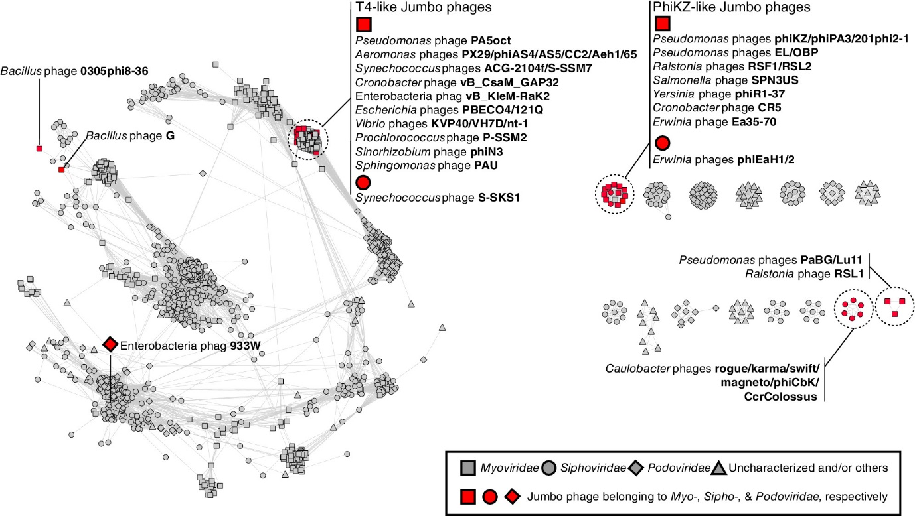
Figure 1: from [13], Protein-sharing network of PA5oct and other jumbo phages.

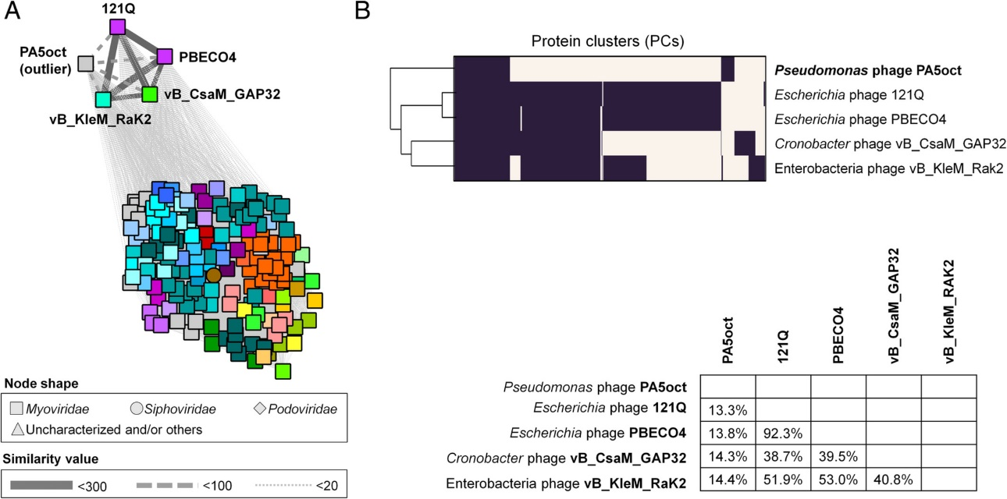
Figure 2: from [13], gene content-based analysis of PA5oct and its relatives.
Phylogeny: The phylogenetic tree was constructed using the portal proteins from PA5oct and related phages with phylogeny.fr in “one click” mode [6]. "The "One Click mode" targets users that do not wish to deal with program and parameter selection. By default, the pipeline is already set up to run and connect programs recognized for their accuracy and speed (MUSCLE for multiple alignment and PhyML for phylogeny) to reconstruct a robust phylogenetic tree from a set of sequences." It also includes the use of Gblocks to eliminate poorly aligned positions and divergent regions. "The usual bootstrapping procedure is replaced by a new confidence index that is much faster to compute. See: Anisimova M., Gascuel O. Approximate likelihood ratio test for branches: A fast, accurate and powerful alternative [7] for details." The members of the Wroclawvirus are indicated with a blue rectangle.
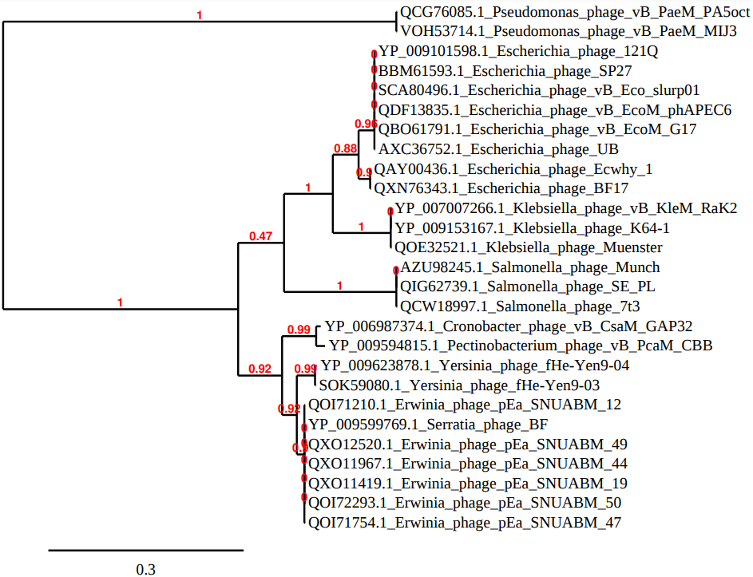
- Create a new family, Arenbergviridae

Origin of the name of this taxon: This taxon is named after the address where the genome of phage PA5oct was characterized (Kasteelpark Arenberg 21, Leuven, Belgium) in the Division of Animal and Human Health Engineering, KU Leuven. The phage was isolated in Wroclaw, Poland where its biology was investigated.

Rationale: These two phages are the only representatives of the Wroclawvirus,and are so similar that vB_PaeM_MIJ3 should be considered a strain of PA5oct. There are no close relatives based upon DNA (BLASTN), protein (ViPTree) or phylogenetic analysis, and we have chosen to create a new family for this genus. Importantly, while there appears to be some protein-level homology (between 13-14%) with the isolates Escherichia phage 121Q, Escherichia phage PBECO4, Cronobacter phage vB_CsaM_GAP32, and Enterobacter phage vB_KleM-Rak2, we propose that this family is clearly separated by the following features:
- no DNA similarity to these four phages;
- the presence of very long terminal repeats (~39kbp) in PA5oct as opposed to circularly permuted in the other phages;
- genome sizes (~286 kbp in PA5oct vs ~350 kbp for the other phages);
- Outlier clustering of PA5oct in both the gene-sharing network, and the terminase phylogeny;
- the presence of a tRNA(Ile)-lysidine synthetase in PA5oct.
The chosen names honour the collaborative research undertaken by the two PIs, Rob Lavine (KU Leuven) and Zuzanna Drulis-Kawa (University of Wrocław).
References
- Sayers EW, Beck J, Bolton EE, Bourexis D, Brister JR, Canese K, Comeau DC, Funk K, Kim S, Klimke W, Marchler-Bauer A, Landrum M, Lathrop S, Lu Z, Madden TL, O'Leary N, Phan L, Rangwala SH, Schneider VA, Skripchenko Y, Wang J, Ye J, Trawick BW, Pruitt KD, Sherry ST. Database resources of the National Center for Biotechnology Information. Nucleic Acids Res. 2021 Jan 8;49(D1):D10-D17. doi: 10.1093/nar/gkaa892. PMID: 33095870
- Moraru C, Varsani A, Kropinski AM. VIRIDIC-A Novel Tool to Calculate the Intergenomic Similarities of Prokaryote-Infecting Viruses. Viruses. 2020 Nov 6;12(11):1268. doi: 10.3390/v12111268. PMID: 33172115; PMCID: PMC7694805. http://kronos.icbm.uni-oldenburg.de/viridic/
- Nishimura Y, Yoshida T, Kuronishi M, Uehara H, Ogata H, Goto S. ViPTree: the viral proteomic tree server. Bioinformatics. 2017; 33(15):2379-2380. doi:10.1093/bioinformatics/btx157. PubMed PMID: 28379287. https://www.genome.jp/viptree/
- Rohwer F, Edwards R. The Phage Proteomic Tree: a genome-based taxonomy for phage. J Bacteriol. 2002 Aug;184(16):4529-35. PubMed PMID: 12142423
- Turner D, Reynolds D, Seto D, Mahadevan P. CoreGenes3.5: a webserver for the determination of core genes from sets of viral and small bacterial genomes. BMC Res Notes. 2013;6:140. doi: 10.1186/1756-0500-6-140. PMID: 23566564.
- Dereeper A, Guignon V, Blanc G, Audic S, Buffet S, Chevenet F, Dufayard JF, Guindon S, Lefort V, Lescot M, Claverie JM, Gascuel O. Phylogeny.fr: robust phylogenetic analysis for the non-specialist. Nucleic Acids Res. 2008;36(Web Server issue):W465-9. doi: 10.1093/nar/gkn180. Epub 2008 Apr 19. PMID: 18424797.
- Anisimova M, Gascuel O. Approximate likelihood-ratio test for branches: A fast, accurate, and powerful alternative. Syst Biol. 2006;55(4):539-52. PMID: 16785212. DOI: 10.1080/10635150600755453.
- Turner D, Kropinski AM, Adriaenssens EM. A Roadmap for Genome-Based Phage Taxonomy. Viruses. 2021 Mar 18;13(3):506. doi: 10.3390/v13030506. PMID: 33803862; PMCID: PMC8003253.
- O'Leary NA, Wright MW, Brister JR, Ciufo S, Haddad D, McVeigh R, et al. Reference sequence (RefSeq) database at NCBI: current status, taxonomic expansion, and functional annotation. Nucleic Acids Res. 2016;44(D1):D733-45. doi: 10.1093/nar/gkv1189. PMID: 26553804.
- Imam M, Alrashid B, Patel F, Dowah ASA, Brown N, Millard A, Clokie MRJ, Galyov EE. vB_PaeM_MIJ3, a Novel Jumbo Phage Infecting Pseudomonas aeruginosa, Possesses Unusual Genomic Features. Front Microbiol. 2019 Nov 28;10:2772. doi: 10.3389/fmicb.2019.02772. PMID: 31849908; PMCID: PMC6892783.
- Drulis‐Kawa, Z. , Olszak, T. , Danis, K. , Majkowska‐Skrobek, G. , and Ackermann, H.W. (2014) A giant Pseudomonas phage from Poland. Arch Virol 159: 567–572.
- Olszak T., Danis-Wlodarczyk K., Arabski M., Gula G., Maciejewska B., Wasik S., Lood C., Higgins G., Harvey B.J., Lavigne R., Drulis-Kawa Z. Pseudomonas aeruginosa PA5oct jumbo phage impacts planktonic and biofilm population and Reduces Its Host Virulence. Viruses, 2019 Nov 23;11(12):1089. doi: 10.3390/v11121089.
- Lood C, Danis-Wlodarczyk K, Blasdel BG, Jang HB, Vandenheuvel D, Briers Y, Noben JP, van Noort V, Drulis-Kawa Z, Lavigne R. Integrative omics analysis of Pseudomonas aeruginosa virus PA5oct highlights the molecular complexity of jumbo phages. Environ Microbiol. 2020 Jun;22(6):2165-2181. doi: 10.1111/1462-2920.14979. Epub 2020 Mar 25. PMID: 32154616; PMCID: PMC7318152.

