

Part 1: TITLE, AUTHORS, APPROVALS, etc

Code assigned: | 2022.004B
Short title: Create ten new species in the genus Alexandravirus (Caudoviricetes)

Author(s) and email address(es)
Tolstoy I, Turner D, Moraru C, Kropinski AM | tolstoy@ncbi.nlm.nih.gov; Dann2.Turner@uwe.ac.uk;liliana.cristina.moraru@uol.de; Phage.Canada@gmail.com
Author(s) institutional address(es) (optional)

NCBI, Bethesda, Maryland, SA [IT]
University of the West of England, Bristol, UK [DT]
Carl von Ossietzky Universität Oldenburg, Germany [CM]
University of Guelph, Canada [AMK]
Corresponding author
Andrew M. Kropinski
List the ICTV Study Group(s) that have seen this proposal

Bacterial Viruses Subcommittee, Caudoviricetes Study Group

ICTV Study Group comments and response of proposer

ICTV Study Group votes on proposal
Study Group | Number of members
Study Group | Votes support | Votes against | No vote
Authority to use the name of a living person

Is any taxon name used here derived from that of a living person (Y/N) | N

Taxon name | Person from whom the name is derived | Permission attached (Y/N)

Submission dates
Date first submitted to SC Chair | April 2022
Date of this revision (if different to above)
ICTV-EC comments and response of the proposer

Part 2: NON-TAXONOMIC PROPOSAL

Text of proposal

Part 3: TAXONOMIC PROPOSAL
Name of accompanying Excel module
2022.004B.N.v1.Alexandravirus_10nsp.xlsx
Abstract

To add ten (10) new species to the genus Alexandravirus. The phages of this taxon are infectious for Erwinia strains.

Text of proposal
Species demarcation criteria: Two phages are assigned to the same species if their genomes are more than 95% identical over their genome length for isolates.
These values can be calculated by a number of tools, such as BLASTn [1] – usually calculated using intergenomic distance calculator VIRIDIC [2].

Genus demarcation criteria: In search for criteria that create cohesive and distinct genera that are reproducible and monophyletic, the Bacterial Viruses Subcommittee has established 70% nucleotide identity of the genome length as the cut-off for genera. Genus-level groupings should always be monophyletic in the signature genes, as tested with a phylogenetic tree. [8]

Supporting evidence

Historical aspects: This taxon was created by Taxonomy Proposal 2019.070B with two species. We now add an addition ten.

Electron micrograph: N/A

Genome summary:

Phage name | INSDC | Size (Kb) | GC% | Protein | Overall % DNA sequence identity (*) | Overall % homologous proteins (**)
Erwinia phage vB_EamM_Alexandra | MH248138.1 | 266.53 | 50.1 | 345 | 100 | 100
Erwinia phage pEa_SNUABM_22 | MZ443785.1 | 265.15 | 49.6 | 342 | 76.8 | 93.0
Erwinia phage pEa_SNUABM_16 | MZ443782.1 | 266.84 | 49.6 | 344 | 77.0 | 93.3
Erwinia phage pEa_SNUABM_35 | MZ443788.1 | 261.72 | 49.2 | 336 | 79.2 | 92.7
Erwinia phage pEa_SNUABM_2 | MZ443786.1 | 265.44 | 49.4 | 336 | 78.3 | 92.5
Erwinia phage pEa_SNUABM_32 | MZ443774.1 | 265.89 | 49.2 | 336 | 67.9 | 90.7
Erwinia phage pEa_SNUABM_3 | MZ443770.1 | 266.18 | 49.5 | 339 | 68.1 | 91.6
Erwinia phage pEa_SNUABM_30 | MZ443778.1 | 259.77 | 49.3 | 330 | 67.0 | 88.7
Erwinia phage pEa_SNUABM_33 | MZ443779.1 | 263.24 | 49.3 | 340 | 68.5 | 91.3
Erwinia phage pEa_SNUABM_1 | MZ443776.1 | 266.94 | 49.4 | 337 | 69.2 | 91.0
Erwinia phage pEa_SNUABM_17 | MZ443777.1 | 263.92 | 49.0 | 330 | 69.1 | 89.6
(*) determined using BLASTn [1] or VIRIDIC [2]
(**) determined using CoreGenes 3.5 [5]

VIRIDIC heat map: VIRIDIC (Virus Intergenomic Distance Calculator; VIRIDIC (Virus Intergenomic Distance Calculator; [2]; http://rhea.icbm.uni-oldenburg.de/VIRIDIC/) computes pairwise intergenomic distances/similarities amongst phage genomes. The black box delineates strains. N/A

Phylogeny: The phylogenetic tree was constructed using the portal proteins from Alexandra and related phages with phylogeny.fr in “one click” mode [6]. "The "One Click mode" targets users that do not wish to deal with program and parameter selection. By default, the pipeline is already set up to run and connect programs recognized for their accuracy and speed (MUSCLE for multiple alignment and PhyML for phylogeny) to reconstruct a robust phylogenetic tree from a set of sequences." It also includes the use of Gblocks to eliminate poorly aligned positions and divergent regions. "The usual bootstrapping procedure is replaced by a new confidence index that is much faster to compute. See: Anisimova M., Gascuel O. Approximate likelihood ratio test for branches: A fast, accurate and powerful alternative [7] for details." The members of the genus Alexandravirus are indicated with a blue rectangle.

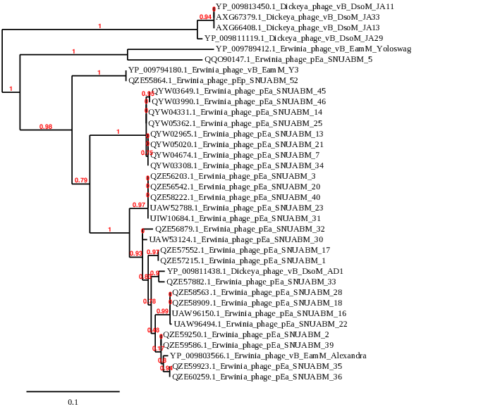

References
- Sayers EW, Beck J, Bolton EE, Bourexis D, Brister JR, Canese K, Comeau DC, Funk K, Kim S, Klimke W, Marchler-Bauer A, Landrum M, Lathrop S, Lu Z, Madden TL, O'Leary N, Phan L, Rangwala SH, Schneider VA, Skripchenko Y, Wang J, Ye J, Trawick BW, Pruitt KD, Sherry ST. Database resources of the National Center for Biotechnology Information. Nucleic Acids Res. 2021 Jan 8;49(D1):D10-D17. doi: 10.1093/nar/gkaa892. PMID: 33095870
- Moraru C, Varsani A, Kropinski AM. VIRIDIC-A Novel Tool to Calculate the Intergenomic Similarities of Prokaryote-Infecting Viruses. Viruses. 2020 Nov 6;12(11):1268. doi: 10.3390/v12111268. PMID: 33172115; PMCID: PMC7694805. http://kronos.icbm.uni-oldenburg.de/viridic/
- Nishimura Y, Yoshida T, Kuronishi M, Uehara H, Ogata H, Goto S. ViPTree: the viral proteomic tree server. Bioinformatics. 2017; 33(15):2379-2380. doi:10.1093/bioinformatics/btx157. PubMed PMID: 28379287. https://www.genome.jp/viptree/
- Rohwer F, Edwards R. The Phage Proteomic Tree: a genome-based taxonomy for phage. J Bacteriol. 2002 Aug;184(16):4529-35. PubMed PMID: 12142423
- Turner D, Reynolds D, Seto D, Mahadevan P. CoreGenes3.5: a webserver for the determination of core genes from sets of viral and small bacterial genomes. BMC Res Notes. 2013;6:140. doi: 10.1186/1756-0500-6-140. PMID: 23566564.
- Dereeper A, Guignon V, Blanc G, Audic S, Buffet S, Chevenet F, Dufayard JF, Guindon S, Lefort V, Lescot M, Claverie JM, Gascuel O. Phylogeny.fr: robust phylogenetic analysis for the non-specialist. Nucleic Acids Res. 2008;36(Web Server issue):W465-9. doi: 10.1093/nar/gkn180. Epub 2008 Apr 19. PMID: 18424797.
- Anisimova M, Gascuel O. Approximate likelihood-ratio test for branches: A fast, accurate, and powerful alternative. Syst Biol. 2006;55(4):539-52. PMID: 16785212. DOI: 10.1080/10635150600755453.
- Turner D, Kropinski AM, Adriaenssens EM. A Roadmap for Genome-Based Phage Taxonomy. Viruses. 2021 Mar 18;13(3):506. doi: 10.3390/v13030506. PMID: 33803862; PMCID: PMC8003253.
- O'Leary NA, Wright MW, Brister JR, Ciufo S, Haddad D, McVeigh R, et al. Reference sequence (RefSeq) database at NCBI: current status, taxonomic expansion, and functional annotation. Nucleic Acids Res. 2016;44(D1):D733-45. doi: 10.1093/nar/gkv1189. PMID: 26553804.
- Olsen NS, Hendriksen NB, Hansen LH and Kot W. A New High-Throughput Screening Method for Phages: Enabling Crude Isolation and Fast Identification of Diverse Phages with Therapeutic Potential. Phage (New Rochelle) 1 (3), 137-148 (2020) https://www.liebertpub.com/doi/10.1089/phage.2020.0016

