
This Word module should be used for all taxonomic proposals.
Please complete Part 1 and:
either Part 3 for proposals to create new taxa or change existing taxa
or Part 2 for proposals of a general nature.
Submit the completed Word module, together with the accompanying Excel module named in Part 3, to the appropriate ICTV Subcommittee Chair.
The Word module explains and justifies your proposal. The Excel module is a critical document that will be used to implement the proposed taxonomic changes once they are approved and ratified. If proposals presented in the Word module are not presented accurately in the Excel module, the taxonomic changes cannot proceed.
For guidance, see the notes written in blue, below, and the Help Notes in file Taxonomic_Proposals_Help_2019.
Part 1: TITLE, AUTHORS, etc

Code assigned: | 2019.063B
Short title: Create one new subfamily (Langleyhallvirinae) including three new genera in the family Siphoviridae
Author(s) and email address(es):
List authors in a single line Archives of Virology citation format (e.g. Smith AB, Huang C-L, Santos, F) |  | Provide email address for each author in a single line separated by semi-colons
Kropinski AM, Adriaenssens EM |  | Phage.Canada@gmail.com; Evelien.Adriaenssens@quadram.ac.uk
Author(s) institutional address(es) (optional):
Provide institutional addresses, each on a single line followed by author(s) initials (e.g. University of Woolloomooloo [SAB, HCL])
University of Guelph, Canada [AMK]
Quadram Institute Bioscience, UK [EMA]

Corresponding author
Andrew M. Kropinski
List the ICTV study group(s) that have seen this proposal:
A list of study groups and contacts is provided at http://www.ictvonline.org/subcommittees.asp . If in doubt, contact the appropriate subcommittee chair (there are six virus subcommittees: animal DNA and retroviruses, animal ssRNA-, animal ssRNA+, fungal and protist, plant, bacterial and archaeal) |  | Bacterial and Archaeal Viruses Subcommittee  Caudovirales Study Group
ICTV Study Group comments (if any) and response of the proposer:
Date first submitted to ICTV:
Date of this revision (if different to above):

ICTV-EC comments and response of the proposer:

Part 2: NON-STANDARD
Template for any proposal regarding ICTV procedures, rules or policy, not involving the creation of new taxonomy.
Text of proposal:

Part 3: PROPOSED TAXONOMY

Name of accompanying Excel module: 2019.063B.N.v1.Langleyhallvirinae_1subfam3gen.xlsx
The taxonomic changes you are proposing should be presented on an accompanying Excel module, 2019_TP_Template_Excel_module. Please enter the file name of the completed module in this box.
Supporting material:
additional material in support of this proposal
Please explain the reasons for the taxonomic changes you are proposing and provide evidence to support them. The following information should be provided, where relevant:
- Species demarcation criteria: Explain how new species differ from others in the genus and demonstrate that these differences meet the criteria previously established for demarcating between species. If no criteria have previously been established, and if there will now be more than one species in the genus, please state the demarcation criteria you are proposing.
- Higher taxa:
  - There is no formal requirement to state demarcation criteria when proposing new genera or other higher taxa. However, a similar concept should apply in pursuit of a rational and consistent virus taxonomy.
  - Please indicate the origin of names assigned to new taxa at genus level and above.
  - For each new genus a type species must be designated to represent it. Please explain your choice.
- Supporting evidence: The use of Figures and Tables is strongly recommended (note that copying from publications will require permission from the copyright holder). For phylogenetic analysis, please provide a tree where branch length is proportional to genetic distance, generated using an appropriate algorithm (Neighbour-Joining, Maximum Likelihood, or Bayesian) and provide evidence of the reliability of the branching (e.g., by bootstrapping).
Please refer to the Help Notes file (Taxonomic_Proposals_Help_2019) for more information.

References:
1: Sayers EW, Agarwala R, Bolton EE, Brister JR, Canese K, Clark K, et al. Database resources of the National Center for Biotechnology Information. Nucleic Acids Res. 2019;47(D1):D23-D28.

2: Tolstoy I, Kropinski AM, Brister JR. Bacteriophage Taxonomy: An Evolving Discipline. Methods Mol Biol. 2018;1693:57-71.

3: O'Leary NA, Wright MW, Brister JR, Ciufo S, Haddad D, McVeigh R, et al. Reference sequence (RefSeq) database at NCBI: current status, taxonomic expansion, and functional annotation. Nucleic Acids Res. 2016;44(D1):D733-45.

4: Agren J, Sundström A, Håfström T, Segerman B. Gegenees: fragmented alignment of multiple genomes for determining phylogenomic distances and genetic signatures unique for specified target groups. PLoS One. 2012;7(6):e39107.

5: Chan PP, Lowe TM. tRNAscan-SE: Searching for tRNA Genes in Genomic Sequences. Methods Mol Biol. 2019;1962:1-14.

6: Turner D, Reynolds D, Seto D, Mahadevan P. CoreGenes3.5: a webserver for the determination of core genes from sets of viral and small bacterial genomes. BMC Res Notes. 2013;6:140.

7: Darling AE, Mau B, Perna NT. progressiveMauve: multiple genome alignment with gene gain, loss and rearrangement. PLoS One. 2010;5(6):e11147.

8: Dereeper A, Guignon V, Blanc G, Audic S, Buffet S, Chevenet F, Dufayard JF, Guindon S, Lefort V, Lescot M, Claverie JM, Gascuel O. Phylogeny.fr: robust phylogenetic analysis for the non-specialist. Nucleic Acids Res. 2008;36(Web Server issue):W465-9.

9: Anisimova M, Gascuel O. Approximate likelihood-ratio test for branches: A fast, accurate, and powerful alternative. Syst Biol. 2006;55(4):539-52.
Species demarcation criteria We have chosen 95% DNA sequence identity as the criterion for demarcation of species in this new genus. Each of the proposed species differs from the others with more than 5% at the DNA level as confirmed with the BLASTN algorithm.

Source of the name of this taxon: The name of the subfamily Langleyhallvirinae is derived from the name of the building at the University of Pittsburgh which houses the Pittsburgh Bacteriophage Institute, a joint venture of Dr. Graham Hatfull and the late Dr. Roger Hendrix, both of the Department of Biological Sciences at the University of Pittsburgh.

History: All of the following phages are classified in the Actinobacteriophage Database in Cluster DN/ Subcluster DN1 and indeed phylogenetic analysis of the large subunit terminase protein groups them. But, DNA sequence relationships reveal three subgroups.

Proposal A. To create a new genus – Getalongvirus – containing four species in the subfamily Langleyhallvirinae

History: Phage Getalong was isolated in 2016 from a soil sample using Gordonia terrae 3612 as the host bacterium. It was identified by Rodney King (Western Kentucky University, USA) as part of the Science Education Alliance-Phage Hunters Advancing Genomics and Evolutionary Science Program. The genome of temperate Gordonia phage Getalong has 10 bp 3’-cohesive termini (CTCGGGGCAT). It is classified in the Actinobacteriophage Database in Cluster DN/Subcluster DN1 (https://phagesdb.org/phages/Getalong/).

GenBank Summary:

Phage name | RefSeq No. | INSDC | Size (Kb) | GC% | Protein | tRNA | Overall DNA sequence identity (**) | % common proteins (***)
Gordonia phage Getalong |  | MH779504.1 | 56.21 | 62.8 | 104 | 0 | 100 | 100
Gordonia phage Asapag |  | MK376961.1 | 55.12 | 63.1 | 99 | 0 | 70.5 | 71.1
Gordonia phage Kenna |  | MK279906.1 | 53.22 | 63.0 | 98 | 0 | 69.9 | 76.0
Gordonia phage BENtherdunthat |  | MG099939.1 | 54.87 | 63.4 | 102 | 0 | 69.5 | 74.0
** Determined using BLASTn at NCBI
*** determined using CoreGenes3.5 (http://binf.gmu.edu:8080/CoreGenes3.5/)

Gordonia phage Lutum is a strain of Kenna

BLASTN homologs: The next most closely related phage is Gordonia phage Phistory which shares 58.3% identity with Getalong [1-3]. BLASTN tree: “BLAST computes a pairwise alignment between a query and the database sequences searched. It does not explicitly compute an alignment between the different database sequences (i.e., does not perform a multiple alignment). For purposes of this sequence tree presentation an implicit alignment between the database sequences is constructed, based upon the alignment of those (database) sequences to the query. It may often occur that two database sequences align to different parts of the query, so that they barely overlap each other or do not overlap at all. In that case it is not possible to calculate a distance between these two sequences and only the higher scoring sequence is included in the tree.”

Electron micrograph: None available for Getalong. Electron micrograph of negatively stained Gordonia phage Kenna. Limited permission was granted by The Actinobacteriophages Database, funded by the Howard Hughes Medical Institute, to use this electron micrograph for this taxonomy proposal; it cannot be reused without permission of The Actinobacteriophages Database.

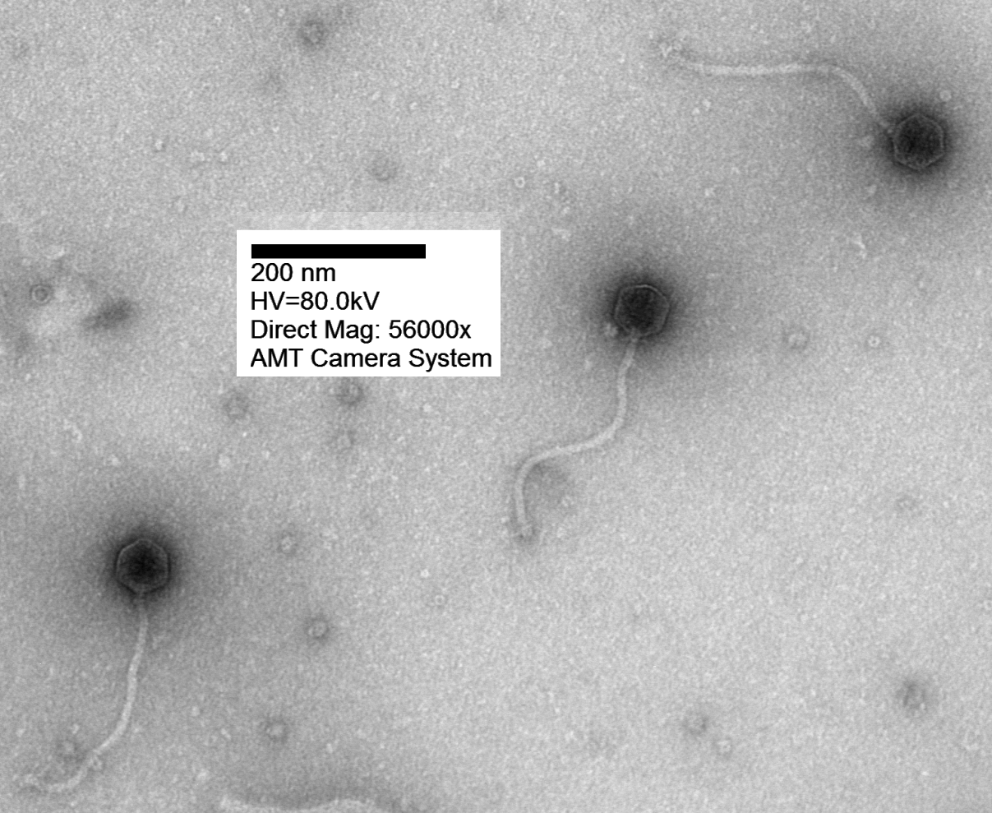

Phylogeny: The phylogenetic tree was constructed using the large subunit terminase protein homologs of Getalong and related phages with phylogeny.fr in “one click” mode [8]. "The "One Click mode" targets users that do not wish to deal with program and parameter selection. By default, the pipeline is already set up to run and connect programs recognized for their accuracy and speed (MUSCLE for multiple
alignment and PhyML for phylogeny) to reconstruct a robust phylogenetic tree from a set of
sequences." It also includes the use of Gblocks to eliminate poorly aligned positions and divergent
regions. "The usual bootstrapping procedure is replaced by a new confidence index that is much
faster to compute. See: Anisimova M., Gascuel O. Approximate likelihood ratio test for branches:
A fast, accurate and powerful alternative [9] for details."

Proposal B. To create a new genus – Horusvirus – containing a single species in the subfamily Langleyhallvirinae

History: Phage Horus was isolated in 2016 from a soil sample using Gordonia terrae 3612 as the host bacterium. It was identified by Peter Said (Durham Technical Community College, USA) as part of the Science Education Alliance-Phage Hunters Advancing Genomics and Evolutionary Science Program. The genome of temperate Gordonia phage Lucky10 have 10 bp 3’-cohesive termini (CTCGGGGCAT). It is classified in the Actinobacteriophage Database in Cluster DN/Subcluster DN1 (https://phagesdb.org/phages/Horus/).

GenBank Summary:

Phage name | RefSeq No. | INSDC | Size (Kb) | GC% | Protein | tRNA
Gordonia phage Horus |  | MH651176.1 | 55.67 | 63.0 | 103 | 1

BLASTN homologs: The next most closely related phage is Gordonia phage Phistory which shares 65.7% identity with Horus [1-3]. BLASTN tree: “BLAST computes a pairwise alignment between a query and the database sequences searched. It does not explicitly compute an alignment between the different database sequences (i.e., does not perform a multiple alignment). For purposes of this sequence tree presentation an implicit alignment between the database sequences is constructed, based upon the alignment of those (database) sequences to the query. It may often occur that two database sequences align to different parts of the query, so that they barely overlap each other or do not overlap at all. In that case it is not possible to calculate a distance between these two sequences and only the higher scoring sequence is included in the tree.”

Electron micrograph: Electron micrograph of negatively stained Gordonia phage Horus. Limited permission was granted by The Actinobacteriophages Database, funded by the Howard Hughes Medical Institute, to use this electron micrograph for this taxonomy proposal; it cannot be reused without permission of The Actinobacteriophages Database.

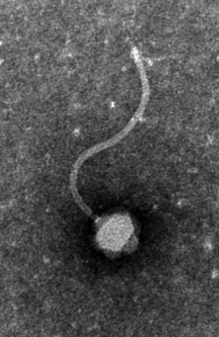

Phylogeny: The phylogenetic tree was constructed using the large subunit terminase protein homologs of Horus and related phages with phylogeny.fr in “one click” mode [8]. "The "One Click mode" targets users that do not wish to deal with program and parameter selection. By default, the pipeline is already set up to run and connect programs recognized for their accuracy and speed (MUSCLE for multiple
alignment and PhyML for phylogeny) to reconstruct a robust phylogenetic tree from a set of
sequences." It also includes the use of Gblocks to eliminate poorly aligned positions and divergent
regions. "The usual bootstrapping procedure is replaced by a new confidence index that is much
faster to compute. See: Anisimova M., Gascuel O. Approximate likelihood ratio test for branches:
A fast, accurate and powerful alternative [9] for details."

Proposal C. To create a new genus – Phistoryvirus – containing a single species in the subfamily Langleyhallvirinae

History: Phage Phistory was isolated in 2016 from a soil sample using Gordonia terrae 3612 as the host bacterium. It was identified by Peter Said (Durham Technical Community College, USA) as part of the Science Education Alliance-Phage Hunters Advancing Genomics and Evolutionary Science Program. The genome of temperate Gordonia phage Phistory has 10 bp 3’-cohesive termini (CTCGGGGCAT). It is classified in the Actinobacteriophage Database in Cluster DN/Subcluster DN1 (https://phagesdb.org/phages/Horus/).

GenBank Summary:

Phage name | RefSeq No. | INSDC | Size (Kb) | GC% | Protein | tRNA
Gordonia phage Phistory |  | MH651185.1 | 53.09 | 63.0 | 106 | 0

BLASTN homologs: The next most closely related phage is Gordonia phage Horus which shares 68.6% identity with Horus [1-3]. BLASTN tree: “BLAST computes a pairwise alignment between a query and the database sequences searched. It does not explicitly compute an alignment between the different database sequences (i.e., does not perform a multiple alignment). For purposes of this sequence tree presentation an implicit alignment between the database sequences is constructed, based upon the alignment of those (database) sequences to the query. It may often occur that two database sequences align to different parts of the query, so that they barely overlap each other or do not overlap at all. In that case it is not possible to calculate a distance between these two sequences and only the higher scoring sequence is included in the tree.”

Electron micrograph: None available

Phylogeny: The phylogenetic tree was constructed using the large subunit terminase protein homologs of Phistory and related phages with phylogeny.fr in “one click” mode [8]. "The "One Click mode" targets users that do not wish to deal with program and parameter selection. By default, the pipeline is already set up to run and connect programs recognized for their accuracy and speed (MUSCLE for multiple
alignment and PhyML for phylogeny) to reconstruct a robust phylogenetic tree from a set of
sequences." It also includes the use of Gblocks to eliminate poorly aligned positions and divergent
regions. "The usual bootstrapping procedure is replaced by a new confidence index that is much
faster to compute. See: Anisimova M., Gascuel O. Approximate likelihood ratio test for branches:
A fast, accurate and powerful alternative [9] for details."

