
This Word module should be used for all taxonomic proposals.
Please complete Part 1 and:
either Part 3 for proposals to create new taxa or change existing taxa
or Part 2 for proposals of a general nature.
Submit the completed Word module, together with the accompanying Excel module named in Part 3, to the appropriate ICTV Subcommittee Chair.
For guidance, see the notes written in blue, below, and the help notes in file Taxonomic_Proposals_Help_2018.
Part 1: TITLE, AUTHORS, etc

Code assigned: | 2019.001B |  | (to be completed by ICTV officers)
Short title: (e.g. “6 new species in the genus Zetavirus”)
Create in the family Siphoviridae, one new genus, Montyvirus, containing four new species and one existing species moved from the genus Woesvirus
Author(s):
Andrew M. Kropinski, University of Guelph
Evelien M. Adriaenssens, University of Liverpool
Corresponding author with e-mail address:
Andrew M. Kropinski Phage.Canada@gmail.com
List the ICTV study group(s) that have seen this proposal:
A list of study groups and contacts is provided at http://www.ictvonline.org/subcommittees.asp . If in doubt, contact the appropriate subcommittee chair (there are six virus subcommittees: animal DNA and retroviruses, animal ssRNA-, animal ssRNA+, fungal and protist, plant, bacterial and archaeal) |  | Bacterial and Archaeal Viruses Subcommittee
ICTV Study Group comments (if any) and response of the proposer:
Date first submitted to ICTV: |  |  | 28 February 2019
Date of this revision (if different to above):

ICTV-EC comments and response of the proposer:

Part 2: NON-STANDARD
Template for any proposal regarding ICTV procedures, rules or policy, not involving the creation of new taxonomy.
Text of proposal:

Part 3: PROPOSED TAXONOMY

Name of accompanying Excel module: 2019.001B.A.v1.Montyvirus.xlsx
The taxonomic changes you are proposing should be presented on an accompanying Excel module, 2017_TP_Template_Excel_module. Please enter the file name of the completed module in this box.
Supporting material:
additional material in support of this proposal
Please explain the reasons for the taxonomic changes you are proposing and provide evidence to support them. The following information should be provided, where relevant:
- Species demarcation criteria: Explain how new species differ from others in the genus and demonstrate that these differences meet the criteria previously established for demarcating between species. If no criteria have previously been established, and if there will now be more than one species in the genus, please state the demarcation criteria you are proposing.
- Higher taxa:
  - There is no formal requirement to state demarcation criteria when proposing new genera or other higher taxa. However, a similar concept should apply in pursuit of a rational and consistent virus taxonomy.
  - Please indicate the origin of names assigned to new taxa at genus level and above.
  - For each new genus a type species must be designated to represent it. Please explain your choice.
- Supporting evidence: The use of Figures and Tables is strongly recommended (note that copying from publications will require permission from the copyright holder). For phylogenetic analysis, try to provide a tree where branch length is related to genetic distance.

Species demarcation criteria We have chosen 95% DNA sequence identity as the criterion for demarcation of species in this new genus. Each of the proposed species differs from the others with more than 5% at the DNA level as confirmed with the BLASTN algorithm.

Source of the name of this taxon: It is derived from the name of the first isolated member, Gordonia phage Monty.

History: When original created (2016.054a-dB) the genus Woesvirus contained three species: Gordonia virus Hotorobo, Gordonia virus Monty and Gordonia virus Woes. We now realize that phage Woes and phage Monty, only share 56.6% DNA sequence identity and therefore should be placed in separate genera. This is in line with the Actinobacteriophage Database which placed phage Monty in Subcluster CS2 and phage Woes in CS3. At this time we do not choose to create a subfamily.

Phage Monty was isolated in 2014 by Matthew Montgomery as part of the Phage Hunters Integrating Research and Education program in Pittsburgh, PA, USA using Gordonia terrae 3612 as the host bacterium. The genome has 191 bp direct terminal repeats. The average size is 76.4 kb, 59.0 mol%G+C, encoding 1 tRNA and 106 proteins.

GenBank Summary:

Phage name | RefSeq No. | INSDC | Size (Kb) | GC% | Protein | tRNA | Overall DNA sequence identity
Monty | NC_030924.1 | KU998241 | 75.7 | 58.9 | 105 | 1 | 100%
Flakey |  | MG770211 | 76.9 | 58.9 | 107 | 1 | 93
BirksAndSocks |  | MG099940 | 77.4 | 58.9 | 110 | 1 | 86
SteveFrench |  | MG770214 | 75.7 | 59.2 | 103 | 1 | 78
Gordonia phages Hotorobo, Boneham and Adgers should be considered as strains within this genus

BLASTN homologs: See above

Electron micrograph: Electron micrograph of negatively stained Gordonia phage Monty (http://phagesdb.org/phages/Monty/) - Limited permission was granted by The
Actinobacteriophages Database, funded by the Howard Hughes Medical Institute, to use this
electron micrograph for this taxonomy proposal; it cannot be reused without permission of The
Actinobacteriophages Database.
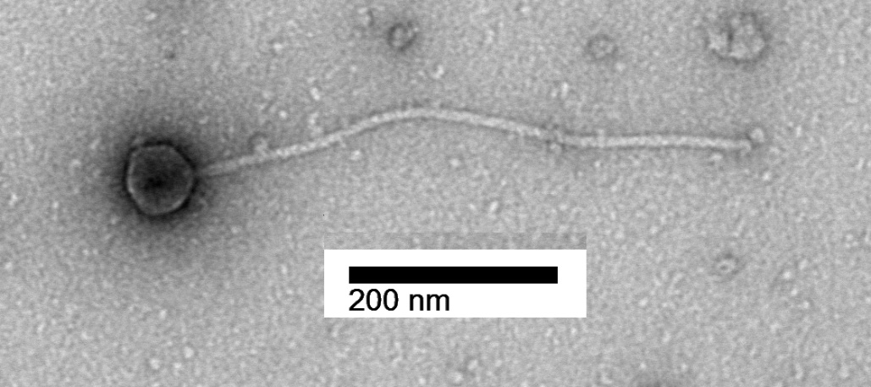

Phylogeny: The phylogenetic tree was constructed, using phylogeny.fr, using the major capsid protein homologs of these and related phages.

References:
1: Pope WH, Davis JP, O'Shea S, Pfeiffer AC, Rich AN, Xue JC, Shedlock KA,
Stanton AC, Furbee EC, Grubb SR, Warner MH, Montgomery MT, Garlena RA, Russell
DA, Jacobs-Sera D, Hatfull GF. Genome Sequences of Gordonia Phages Hotorobo,
Woes, and Monty. Genome Announc. 2016 Aug 11;4(4).

