This Word module should be used for all taxonomic proposals.
Please complete Part 1 and:
either Part 3 for proposals to create new taxa or change existing taxa
or Part 2 for proposals of a general nature.
Submit the completed Word module, together with the accompanying Excel module named in Part 3, to the appropriate ICTV Subcommittee Chair.
For guidance, see the notes written in blue, below, and the help notes in file Taxonomic_Proposals_Help_2018.
Part 1: TITLE, AUTHORS, etc

Code assigned: | 2018.117B |  | (to be completed by ICTV officers)
Short title: To create one new species, Escherichia virus Golestan within the K1gvirus genus (new name Kagunavirus), Guernseyvirinae subfamily, and family Siphoviridae
(e.g. “6 new species in the genus Zetavirus”)
Author(s):
Mahsa Yazdi – University of Isfahan (Iran)
Majid Bouzari - University of Isfahan (Iran)
Ezzat Allah Ghaemi - Golestan University of Medical Sciences (Iran)
Evelien Adriaenssens - University of Liverpool (UK)
Andrew Kropinski - University of Guelph (Canada)
Corresponding author with e-mail address:
Majid Bouzari bouzari@sci.ui.ac.ir
List the ICTV study group(s) that have seen this proposal:
A list of study groups and contacts is provided at http://www.ictvonline.org/subcommittees.asp . If in doubt, contact the appropriate subcommittee chair (there are six virus subcommittees: animal DNA and retroviruses, animal ssRNA-, animal ssRNA+, fungal and protist, plant, bacterial and archaeal) |  | Bacterial and Archaeal Viruses Subcommittee
ICTV Study Group comments (if any) and response of the proposer:
Date first submitted to ICTV: |  |  | June 2018
Date of this revision (if different to above):

ICTV-EC comments and response of the proposer:

Part 3: PROPOSED TAXONOMY

Name of accompanying Excel module: 2018.117B.N.v2.Kagunavirus_sp
The taxonomic changes you are proposing should be presented on an accompanying Excel module, 2017_TP_Template_Excel_module. Please enter the file name of the completed module in this box.
Supporting material:
additional material in support of this proposal
Please explain the reasons for the taxonomic changes you are proposing and provide evidence to support them. The following information should be provided, where relevant:
- Species demarcation criteria: Explain how new species differ from others in the genus and demonstrate that these differences meet the criteria previously established for demarcating between species. If no criteria have previously been established, and if there will now be more than one species in the genus, please state the demarcation criteria you are proposing.
- Higher taxa:
  - There is no formal requirement to state demarcation criteria when proposing new genera or other higher taxa. However, a similar concept should apply in pursuit of a rational and consistent virus taxonomy.
  - Please indicate the origin of names assigned to new taxa at genus level and above.
  - For each new genus a type species must be designated to represent it. Please explain your choice.
- Supporting evidence: The use of Figures and Tables is strongly recommended (note that copying from publications will require permission from the copyright holder). For phylogenetic analysis, try to provide a tree where branch length is related to genetic distance.

Species demarcation criteria We have chosen 95% DNA sequence identity as the criterion for demarcation of species in this new genus. Each of the proposed species differs from the others with more than 5% at the DNA level as confirmed with the BLASTN algorithm.

Source of the name of this taxon: Based on the name of the type isolate, Escherichia phage vB_EcoS_Golestan.

Escherichia phage vB_EcoS-Golestan was isolated from sewage in Gorgan, Iran, using uropathogenic Escherichia coli (Accession No.: MG041766) as the host. The relatedness of the phage to phages taxa was confirmed using BLASTn, BLASTp (1); progressiveMauve (2) (Fig.2); EasyFig (3) (Fig.3), and by One Click phylogenetic analysis at phylogeny.fr (4) of the annotated major capsid and DNA polymerase proteins (Fig.4). Accordingly, as illustrated in Fig 4, The species has closely (88% identity; Table 1) relatively with the members of the Kagunavirus genus, (renamed from K1gvirus, see proposal 2018.007B.N.v2.rename136gen6sp). The characteristics of members of the new species of this genus are listed in Table 1.
Therefore, we propose a new species, Escherichia virus Golestan, within the genus Kagunavirus (renamed from K1gvirus in proposal 2018.007B.N.v2.rename136gen6sp), Guernseyvirinae subfamily, in the family Siphoviridae.

Table 1. Properties of the phages belonging to the genus K1gvirus (new name Kagunavirus)
phage |  | Genome length (bp) | Genome (mol% G+C) | No. CDS | No. tRNAs | DNA (% sequence identity) *
  GenBank Accession No.
Escherichia phage K1G** | GU196277 | 43587 | 51.1% | 49 | 0 | 100
Escherichia phage K1H** | GU196278 | 41632 | 51.2% | 47 | 0 | 97
Escherichia phage K1ind1** | GU196279 | 42292 | 51.3% | 47 | 0 | 94
Escherichia phage K1ind2** | GU196280 | 42765 | 51.3% | 45 | 0 | 94
Escherichia phage vB_EcoS-Golestan | MG099933 | 44829 | 50.6% | 78 | 0 | 88
* Determined using BLASTn; ** member of a species previously recognized by ICTV.

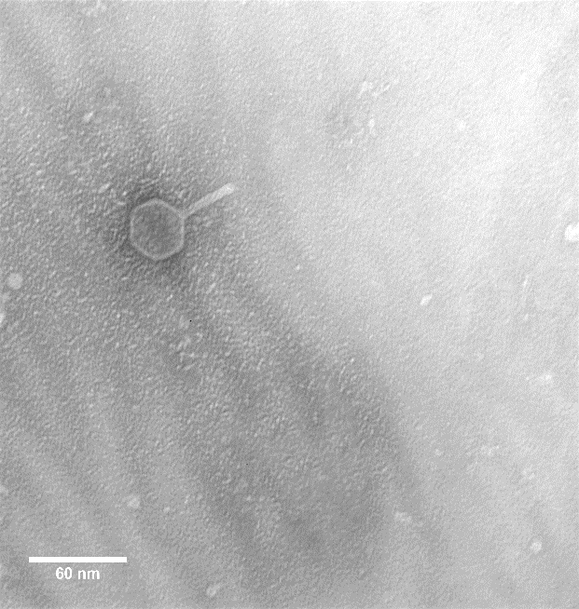
Fig.1. Electron micrograph of negatively stained (2% uranyl acetate) Escherichia phage vB_EcoS-Golestan.

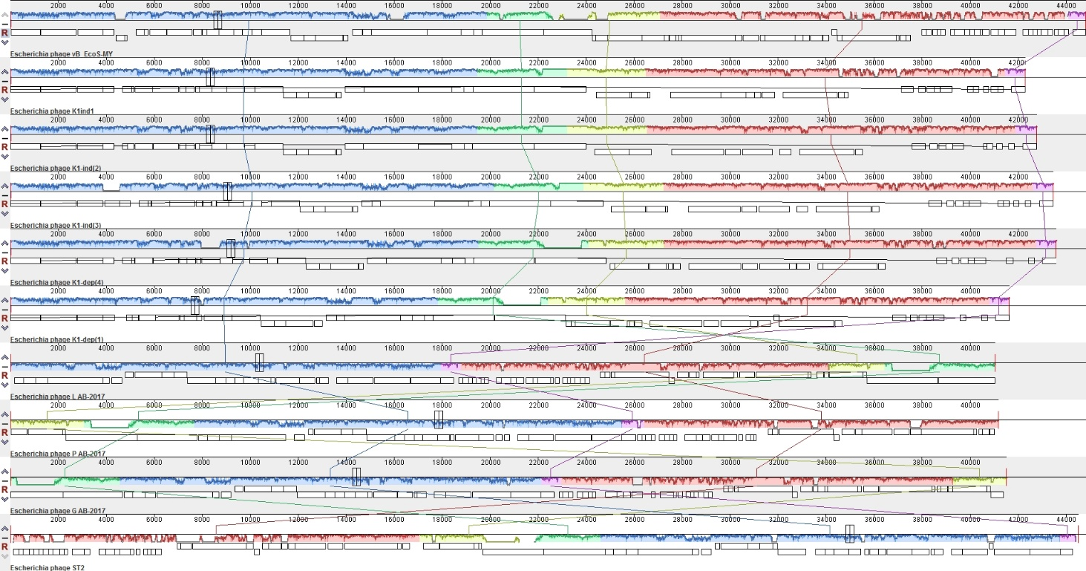
Fig. 2. Progressive Mauve alignment of the annotated genomes of members of the Kagunavirus genus (renamed from K1gvirus) from top to bottom: Escherichia phages vB_EcoS-Golestan, K1ind1, K1ind2, K1ind3, K1dep4 (K1G), K1dep1(K1H), LAB-2017, PAB-2017, G AB-2017, and ST2. Colored blocks indicate the regions of 1 to 1 best alignment with rearrangement breakpoints in a different random color. The degree of sequence similarity between regions is given by a similarity plot within the colored blocks with the height of the plot proportional to the average nucleotide identity.

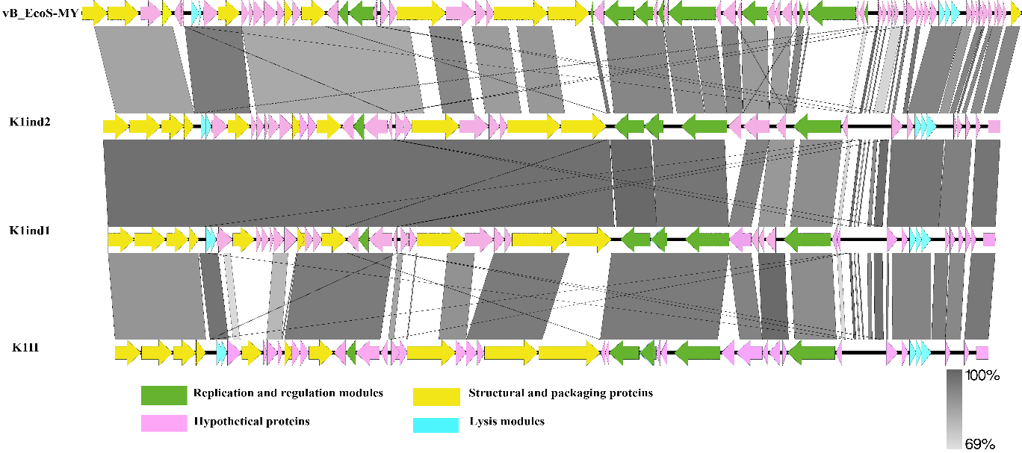

Fig.3. Synteny plot of Escherichia phage vB_EcoS-Golestan in comparison with Escherichia phages K1ind2, K1ind1 and K1H within Kagunavirus genus visualized with EasyFig (3). The scale bar shows the level of nucleotide identity.
- Major capsid protein
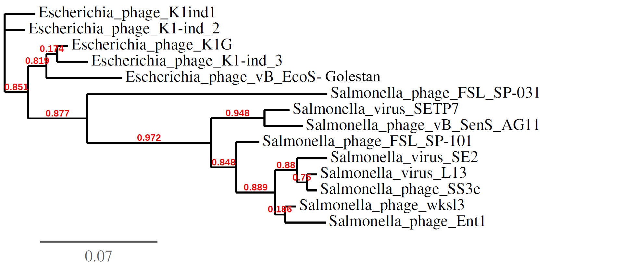
- DNA polymerase
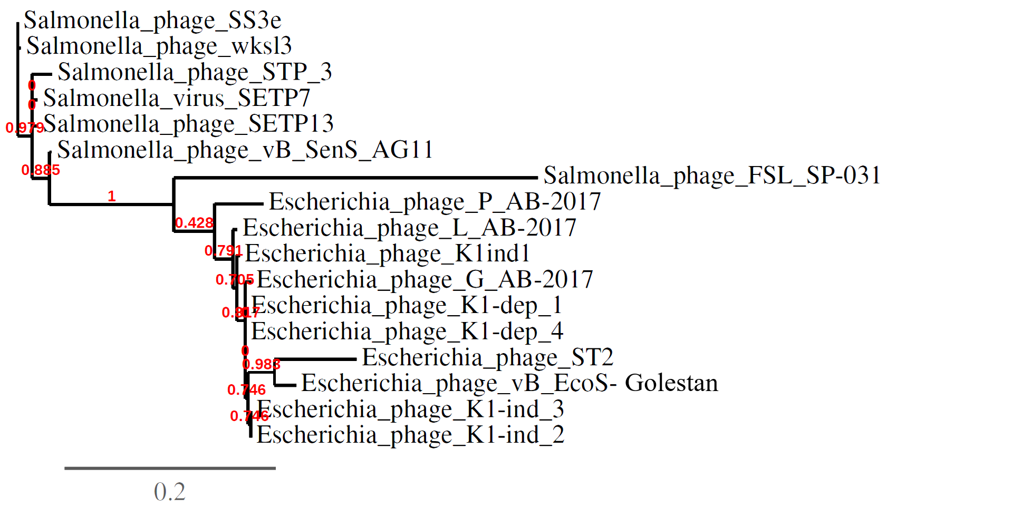
Fig. 4. Phylogenetic analysis of the (A) major capsid protein, (B) DNA polymerases of phages belonging to the Guernseyvirinae subfamily constructed using “one click” at phylogeny.fr (4). "The "One Click mode" targets users that do not wish to deal with program and parameter selection. By default, the pipeline is already set up to run and connect programs recognized for their accuracy and speed (MUSCLE for multiple alignment and PhyML for phylogeny) to reconstruct a robust phylogenetic tree from a set of sequences." It also includes the use of Gblocks to eliminate poorly aligned positions and divergent regions. "The usual bootstrapping procedure is replaced by a new confidence index that is much faster to compute. See: Anisimova M., Gascuel O. Approximate likelihood ratio test for branches: A fast, accurate and powerful alternative (Syst Biol. 2006;55(4):539-52.) for details." Red = Jersyvirus, Blue = K1gvirus, and Green = Sp31virus.

References:
1.Altschul SF, Gish W, Miller W, Myers EW, Lipman DJ. Basic local alignment search tool. Journal of Molecular Biology. 1990;215(3):403-10.
2.Darling AC, Mau B, Blattner FR, Perna NT. Mauve: multiple alignment of conserved genomic sequence with rearrangements. Genome Research. 2004;14(7):1394-403.

3. Sullivan MJ, Petty NK, Beatson SA. Easyfig: a genome comparison visualizer. Bioinformatics.2011; 27:1009–1010.

4.Dereeper A, Guignon V, Blanc G, Audic S, Buffet S, Chevenet F, et al. Phylogeny. fr: robust phylogenetic analysis for the non-specialist. Nucleic Acids Research. 2008;36(suppl_2):W465-W9.

