
This Word module should be used for all taxonomic proposals.
Please complete Part 1 and:
either Part 3 for proposals to create new taxa or change existing taxa
or Part 2 for proposals of a general nature.
Submit the completed Word module, together with the accompanying Excel module named in Part 3, to the appropriate ICTV Subcommittee Chair.
For guidance, see the notes written in blue, below, and the help notes in file Taxonomic_Proposals_Help_2018.
Part 1: TITLE, AUTHORS, etc

Code assigned: | 2018.071B |  | (to be completed by ICTV officers)
Short title: (e.g. “6 new species in the genus Zetavirus”)
To create one (1) new genus, Flaumdravirus, containing two (2) species in the family Myoviridae
Author(s):
Andrew M. Kropinski, University of Guelph, Canada
Evelien M. Adriaenssens, University of Liverpool, UK
Jochen Klumpp, ETH Zurich, Switzerland
Rob Lavigne, KU Leuven, Belgium

Corresponding author with e-mail address:
Andrew M. Kropinski Phage.Canada@gmail.com
List the ICTV study group(s) that have seen this proposal:
A list of study groups and contacts is provided at http://www.ictvonline.org/subcommittees.asp . If in doubt, contact the appropriate subcommittee chair (there are six virus subcommittees: animal DNA and retroviruses, animal ssRNA-, animal ssRNA+, fungal and protist, plant, bacterial and archaeal) |  | Bacterial and Archaeal Viruses Subcommittee
ICTV Study Group comments (if any) and response of the proposer:
Date first submitted to ICTV: |  |  | May 2018
Date of this revision (if different to above):

ICTV-EC comments and response of the proposer:

Part 2: NON-STANDARD
Template for any proposal regarding ICTV procedures, rules or policy, not involving the creation of new taxonomy.
Text of proposal:

Part 3: PROPOSED TAXONOMY

Name of accompanying Excel module: 2018.071B.N.v1.Flandersvirus
The taxonomic changes you are proposing should be presented on an accompanying Excel module, 2017_TP_Template_Excel_module. Please enter the file name of the completed module in this box.
Supporting material:
additional material in support of this proposal
Please explain the reasons for the taxonomic changes you are proposing and provide evidence to support them. The following information should be provided, where relevant:
- Species demarcation criteria: Explain how new species differ from others in the genus and demonstrate that these differences meet the criteria previously established for demarcating between species. If no criteria have previously been established, and if there will now be more than one species in the genus, please state the demarcation criteria you are proposing.
- Higher taxa:
  - There is no formal requirement to state demarcation criteria when proposing new genera or other higher taxa. However, a similar concept should apply in pursuit of a rational and consistent virus taxonomy.
  - Please indicate the origin of names assigned to new taxa at genus level and above.
  - For each new genus a type species must be designated to represent it. Please explain your choice.
- Supporting evidence: The use of Figures and Tables is strongly recommended (note that copying from publications will require permission from the copyright holder). For phylogenetic analysis, try to provide a tree where branch length is related to genetic distance.

Species demarcation criteria We have chosen 95% DNA sequence identity as the criterion for demarcation of species in this new genus. Each of the proposed species differs from the others with more than 5% at the DNA level as confirmed with the BLASTN algorithm.

Source of the name of this taxon: Flaumdravirus is derived from Old German, meaning "waterlogged land" and was once used to indicate the mudflats and salt marshes common to coastal Flanders where the first isolate of this type, Pseudomonas phage vB_PsyM_KIL1, was isolated. [The authors thank Dr. Stuart Siddell for an alternative name to Flandersvirus]

History: “Pseudomonas syringae pv. porri, the causative agent of bacterial blight in leek (Allium porrum), is increasingly frequent causing problems in leek cultivation. Because of the current lack of control measures, novel bacteriophages were isolated to control this pathogen using phage therapy. Five novel phages were isolated from infected fields in Flanders (vB_PsyM_KIL1, vB_PsyM_KIL2, vB_PsyM_KIL3, vB_PsyM_KIL4, and vB_PsyM_KIL5).” [1]. Electron microscopy revealed that they are morphologically identical to Pseudomonas phage PB1 (Pbunavirus). These phages are all lytic.

Electron micrograph: EM picture of KIL1 that was made by Jochen Klumpp (negative staining with 2% uranyl acetate) (kindly provided by Jeroen Wagemans, Laboratory of Gene Technology, KU Leuven, Belgium)

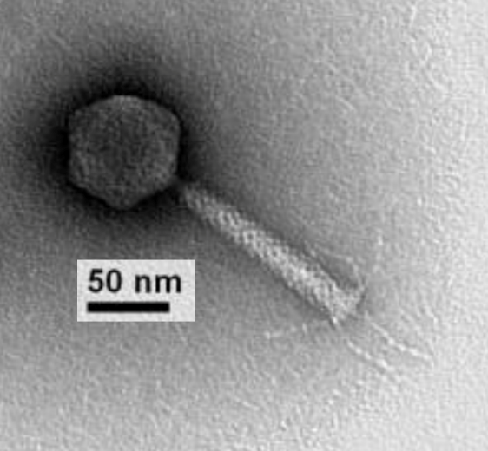

GenBank Summary:

Phage name | RefSeq No | INSDC | Size (Kb) | GC% | Protein | tRNA | Overall DNA sequence identity (*) | % Common proteins (**)
vB_PsyM_KIL1 | NC_030934 | KU130126 | 90.55 | 44.8 | 159 | 5 | 100% | 100%
vB_PsyM_KIL4 |  | KU130129 | 92.82 | 44.9 | 167 | 9 | 93 | 94.3
(*) Determined using BLASTN at NCBI; (**) Determined using CoreGenes 3.5

N.B. Phages vB_PsyM_KIL2, vB_PsyM_KIL3, vB_PsyM_KIL3b and vB_PsyM_KIL5 should be considered as strains in this genus.

BLASTN homologs: A neighbour joining tree was constructed on the basis of the BLASTN analysis at NCBI, indicating a peripheral relationship to several unclassified phages. The closest relative based upon BLASTN analysis is Pseudomonas phage VCM. We do not intend to create a higher taxon at this time.

Phylogeny: The phylogenetic tree was constructed, using phylogeny.fr, using the major capsid protein homologs of KIL1 and related phages.

References:
1: Rombouts S, Volckaert A, Venneman S, Declercq B, Vandenheuvel D, Allonsius CN,
Van Malderghem C, Jang HB, Briers Y, Noben JP, Klumpp J, Van Vaerenbergh J, Maes
M, Lavigne R. Characterization of Novel Bacteriophages for Biocontrol of
Bacterial Blight in Leek Caused by Pseudomonas syringae pv. porri. Front
Microbiol. 2016 Mar 15;7:279.

