
This Word module should be used for all taxonomic proposals.
Please complete Part 1 and:
either Part 3 for proposals to create new taxa or change existing taxa
or Part 2 for proposals of a general nature.
Submit the completed Word module, together with the accompanying Excel module named in Part 3, to the appropriate ICTV Subcommittee Chair.
For guidance, see the notes written in blue, below, and the help notes in file Taxonomic_Proposals_Help_2018.
Part 1: TITLE, AUTHORS, etc

Code assigned: | 2018.068B |  | (to be completed by ICTV officers)
Short title: (e.g. “6 new species in the genus Zetavirus”)
To create one (1) new genus, Chakrabartyvirus, containing a single species in the family Myoviridae
Author(s):
Damian Magill, Queen’s University Belfast, UK
Andrew M. Kropinski, University of Guelph, Canada
Evelien M. Adriaenssens, University of Liverpool, UK
Leonid Kulakov, Queen’s University Belfast, UK
Corresponding author with e-mail address:
Andrew M. Kropinski Phage.Canada@gmail.com
List the ICTV study group(s) that have seen this proposal:
A list of study groups and contacts is provided at http://www.ictvonline.org/subcommittees.asp . If in doubt, contact the appropriate subcommittee chair (there are six virus subcommittees: animal DNA and retroviruses, animal ssRNA-, animal ssRNA+, fungal and protist, plant, bacterial and archaeal) |  | Bacterial and Archaeal Viruses Subcommittee
ICTV Study Group comments (if any) and response of the proposer:
Date first submitted to ICTV: |  |  | May 2018
Date of this revision (if different to above):

ICTV-EC comments and response of the proposer:

Part 2: NON-STANDARD
Template for any proposal regarding ICTV procedures, rules or policy, not involving the creation of new taxonomy.
Text of proposal:

Part 3: PROPOSED TAXONOMY

Name of accompanying Excel module: 2018.068B.N.v1.Chakrabartyvirus
The taxonomic changes you are proposing should be presented on an accompanying Excel module, 2017_TP_Template_Excel_module. Please enter the file name of the completed module in this box.
Supporting material:
additional material in support of this proposal
Please explain the reasons for the taxonomic changes you are proposing and provide evidence to support them. The following information should be provided, where relevant:
- Species demarcation criteria: Explain how new species differ from others in the genus and demonstrate that these differences meet the criteria previously established for demarcating between species. If no criteria have previously been established, and if there will now be more than one species in the genus, please state the demarcation criteria you are proposing.
- Higher taxa:
  - There is no formal requirement to state demarcation criteria when proposing new genera or other higher taxa. However, a similar concept should apply in pursuit of a rational and consistent virus taxonomy.
  - Please indicate the origin of names assigned to new taxa at genus level and above.
  - For each new genus a type species must be designated to represent it. Please explain your choice.
- Supporting evidence: The use of Figures and Tables is strongly recommended (note that copying from publications will require permission from the copyright holder). For phylogenetic analysis, try to provide a tree where branch length is related to genetic distance.

Species demarcation criteria We have chosen 95% DNA sequence identity as the criterion for demarcation of species in this new genus. Each of the proposed species differs from the others with more than 5% at the DNA level as confirmed with the BLASTN algorithm.

Source of the name of this taxon: This genus is named in honour of Dr Ananda M. Chakrabarty (b. 1938; PhD, University of Calcutta, India), Distinguished University Professor Emeritus, University of Illinois College of Medicine at Chicago, who isolated Pseudomonas phage pf16 in 1968 when he was a post-doctoral fellow in the laboratory of Dr Irwin C. Gunsalus (1912-2008).

History: Phage pf16 was isolated by A.M. Chakrabarty and demonstrated to be a generalized transducing virus for the fluorescent pseudomonads [1,2]. Phage pf16 was sequenced by Damian J. Magill et al. [3], revealing that is may possess modified cytosine and/or guanine bases as indicated by its resistance to many restriction endonucleases, plus the presence of a module of six genes directing the metabolism of queuosine. Morphologically it is a myovirus with capsid dimensions of 88 x 82 nm, and
a tail length and width of approximately 148 nm x 20 nm [3].

Electron microscopy: Negatively stained phage pf16 particles (kindly provided by Damian Magill, School of Biological Sciences, The Queen's University of Belfast, Medical Biology Centre, Belfast, Northern Ireland)
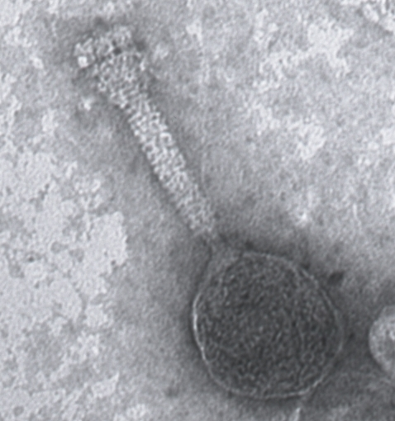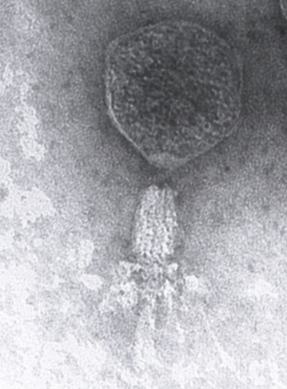

GenBank Summary:

Phage name | INSDC | Size (Kb) | GC% | Protein | tRNA
pf16 | KU873925.1 | 158.14 | 52.7 | 237 | 8

BLASTN homologs: None; genomic orphan/singleton

Phylogeny: The phylogenetic tree was constructed, using phylogeny.fr, using the major capsid protein (gp106) homologs of phage pf16 and related phages.

References:
1: Chakrabarty AM, Gunsalus CF, Gunsalus IC. Transduction and the clustering of genes in fluorescent Pseudomonads. Proc Natl Acad Sci U S A. 1968 May;60(1):168-75.

2: Gunsalus, I. C., C. F. Gunsalus, A. M. Chakrabarty, S. Sikes, and I. P. Crawford. 1968. Fine structure mapping of the tryptophan genes in Pseudomonas putida. Genetics 60:419-435.

3: Magill DJ, Krylov VN, Shaburova OV, McGrath JW, Allen CCR, Quinn JP, Kulakov LA. Pf16 and phiPMW: Expanding the realm of Pseudomonas putida bacteriophages. PLoS One. 2017 Sep 6;12(9):e0184307.

