

The International Committee on Taxonomy of Viruses
Taxonomy Proposal Form, 2024

Part 1a: Details of taxonomy proposals

Title: | Create new family, ‘Usuviridae’, with two genera in the order Methanobavirales (class Caudoviricetes)
Code assigned: | 2024.006A.N.v1.Usuviridae_newfam

Author(s), affiliation and email address(es):
Name | Affiliation | Email address | Corresponding author(s) X
Diana P. Baquero | Institut Pasteur, Université Paris Cité, Archaeal Virology Unit, Paris, France | dp.baquero645@gmail.com
Sofia Medvedeva | Institut Pasteur, Université Paris Cité, Archaeal Virology Unit, Paris, France | sofia.medvedeva@pasteur.fr
Guillaume Borrel | Institut Pasteur, Université Paris Cité, Evolutionary Biology of the Microbial Cell, Paris, France | guillaume.borrel@pasteur.fr
Simonetta Gribaldo | Institut Pasteur, Université Paris Cité, Evolutionary Biology of the Microbial Cell, Paris, France | simonetta.gribaldo@pasteur.fr
Mart Krupovic | Institut Pasteur, Université Paris Cité, Archaeal Virology Unit, Paris, France | mart.krupovic@pasteur.fr | X

Part 1b: Taxonomy Proposal Submission
ICTV Subcommittee:
Animal DNA Viruses and Retroviruses |  | Bacterial viruses
Animal minus-strand and dsRNA viruses |  | Fungal and protist viruses
Animal positive-strand RNA viruses |  | Plant viruses
Archaeal viruses | X | General -

List the ICTV Study Group(s) that have seen or have been involved in creating this proposal:
Optional – complete only if formally voted on by an ICTV Study Group:
Study Group | Number of members
Study Group | Votes in support | Votes against | No vote

Submission date: | 21/06/2024

Part 1c: Feedback from ICTV Executive Committee (EC) meeting
Executive Committee Meeting Decision code: | X
A – Accept
Ac – Accept subject to revision by relevant subcommittee chair. No further vote required
U – Accept without revision but with re-evaluation and email vote by the EC
Uc – Accept subject to revision and re-evaluation and email vote by the EC | X
Ud – Deferred to the next EC meeting, with an invitation to revise based on EC comments
J - Reject
W - Withdrawn

Comments from the Executive Committee:
The GenBank accession number should become public before the online EC vote.

Part 1d: Revised Taxonomy Proposal Submission
Response of proposer:
Both GenBank accession numbers (PP537965 and BK068243) for the viruses classified in this proposal are now public.

Revision date: | 11/09/2024

Part 3: TAXONOMIC PROPOSAL

Name of accompanying Excel module:
2024.006A.N.v1.Usuviridae_newfam.xlsx

Taxonomic changes proposed:
Establish new taxon | X | Split taxon
Abolish taxon |  | Merge taxon
Move taxon |  | Promote taxon
Rename taxon |  | Demote taxon
Move and rename

Is any taxon name used here derived from that of a living person: |  | N
Taxon name | Person from whom the name is derived | Attached X

Abstract of Taxonomy Proposal:
Taxonomic rank(s) affected:
Duplodnaviria, Heunggongvirae, Uroviricota, Caudoviricetes, Methanobavirales

Description of current taxonomy:
Order Methanobavirales (class Caudoviricetes) currently includes 5 families of viruses infecting methanogenic archaea.

Proposed taxonomic change(s):
Create a new family, ‘Usuviridae’ with two genera for classification of viruses infecting human and animal gut associated methanogenic archaea, and include this family into the existing order Methanobavirales.

Justification:
Whole-proteome-based phylogenomic analysis using VipTree placed MSTV1-like viruses in a distinct clade, outside of the recently established families of tailed viruses associated with methanogenic archaea or other archaeal hosts.

- Text of Taxonomy proposal:
Taxonomic rank(s) affected:
Duplodnaviria, Heunggongvirae, Uroviricota, Caudoviricetes, Methanobavirales

Description of current taxonomy:
Order Methanobavirales (class Caudoviricetes) currently includes 5 families of viruses infecting methanogenic archaea.

Proposed taxonomic change(s):
Create a new family, ‘Usuviridae’ with two genera for classification of viruses infecting human and animal gut associated methanogenic archaea, and include this family into the existing order Methanobavirales.

Demarcation criteria:
We propose using 95% sequence identity as a species demarcation threshold, to be consistent with the classification of other bacterial and archaeal viruses in the class Caudoviricetes.

Justification:
Methanobrevibacter smithii PS, the dominant human gut methanogenic archaeon, carries a provirus related to tailed bacterial and archaeal viruses of the class Caudoviricetes (Krupovic et al., 2010). Recently, it has been shown that the provirus is active and spontaneously reactivated in a small subpopulation of cells to release the virus, named Methanobrevibacter smithii tailed virus 1 (MSTV1). The MSTV1 virions were observed by negative stain transmission electron microscopy outside of the cells and by electron cryo-tomography inside the cells. The virions have a siphovirus-like morphology, with an isometric capsid of ~65 nm in diameter and a long, flexible, non-contractile tail of ~270 nm in length (Fig. 1; Baquero et al., 2024).

Searches in a catalogue of 1,167 genomes from the human gastrointestinal tract (GIT) archaeome database revealed that MSTV1 is present in 20% of all available M. smithii genomes (n=465). Given that M. smithii is the most prevalent archaeal species in the human GIT, MSTV1 might be one of the main human-associated archaeal viruses. To gain further insights into the diversity and distribution of MSTV1-like viruses, we explored the recently assembled database of 282 high-quality genomes of (pro)viruses associated with methanogenic archaea discovered in silico (Medvedeva et al., 2023). We identified nine complete and nearly complete MSTV1-like virus genomes sharing <95% average nucleotide identity (ANI) and thus representing different virus species. Four of the viruses were found in the human GIT metagenomes, and the other five were detected as proviruses in the GIT metagenomes of diverse animals, including cows, goats, gorillas and pigs. The predicted hosts of the nine MSTV1-like viruses belong to the order Methanobacteriales.

Whole-proteome-based phylogenomic analysis using VipTree placed MSTV1-like viruses in a distinct clade, outside of the recently established families of tailed viruses associated with methanogenic archaea or other archaeal hosts (Fig. 2). Therefore, we propose to classify MSTV1 and related viruses into a new virus family, named ‘Usuviridae’. Among existing family, ‘Usuviridae’ clusters with members of the Anaerodiviridae (Fig. 2). Thus, we propose including ‘Usuviridae’ into the existing order Methanobavirales.

The genomes of ‘usuvirids’ can be divided into two regions, a conserved part including the structural genes and a hypervariable region including an array of small genes likely implicated in various aspects of virus-host interactions (Fig. 3). The structural module of MSTV1-like viruses includes genes for the hallmark proteins conserved in bacterial and archaeal viruses of the class Caudoviricetes, namely, the HK97-like major capsid protein (MCP), portal protein, large subunit of the terminase (TerL) and several tail components (Fig. 3).

The ‘Usuviridae’ clade splits into human- and animal-associated subclades (Fig. 2). Viruses from the two subclades display distinct neck-tail modules, with the corresponding proteins showing low or no sequence similarity (Fig. 3). Notably, animal GIT-associated viruses vir406, vir075 and vir128 encode a distinct TerL variant (Fig. 3). Phylogenetic analysis of TerL from tailed viruses infecting environmental and host-associated methanogens revealed that TerL proteins of the three viruses fall into a different clade than the other MSTV1-like viruses (Fig. 4), indicating non-orthologous gene replacement and recombination between different groups of viruses of methanogens, likely facilitated by shared environment and host range. Finally, the human and animal GIT-associated viruses differ in their endolysins implicated in digestion of the archaeal cell wall during virion egress at the end of the infection cycle. Whereas MSTV1 and other human-associated ‘usuvirids’ encode PeiW-like endolysins (Peptidase_C71 family; Fig. 3), ‘usuvirids’ recovered from the animal GIT encode PeiR-like endolysins (Peptidase_C39 family; Fig. 3). These differences between human and animal GIT-associated ‘usuvirids’ likely reflect distinct adaptations to the respective hosts and ecological contexts. Thus, we propose to classify the ‘usuvirids’ associated with the human and animal gut associated archaea into distinct genera, ‘Manusuvirus’ and ‘Hewusuvirus’, respectively.

Only two of the MSTV1-like virus genomes could be submitted to GenBank. Thus, only two species, ‘Manusuvirus methanobrevibacteri’ and ‘Hewusuvirus methanobrevibacteri’, will be created at this point in the genera ‘Manusuvirus’ and ‘Hewusuvirus’, respectively.

Etymology:
‘Usuviridae’, after ‘usus’, intestine in Indonesian.
‘Manusuvirus’, after ‘manusia’, human in Indonesian
‘Hewusuvirus’, after ‘hewan’, animal in Indonesian.
‘methanobrevibacteri’, after the host genus name, Methanobrevibacter.

References:
Baquero DP, Medvedeva S, Martin-Gallausiaux C, Pende N, Sartori-Rupp A, Tachon S, Pedron T, Debarbieux L, Borrel G, Gribaldo S, Krupovic M. Stable coexistence between an archaeal virus and the dominant methanogen of the human gut. Nat Commun. 2024 Sep 4;15(1):7702. doi: 10.1038/s41467-024-51946-x.

Krupovic M, Forterre P, Bamford DH. Comparative analysis of the mosaic genomes of tailed archaeal viruses and proviruses suggests common themes for virion architecture and assembly with tailed viruses of bacteria. J Mol Biol. 2010; 397(1):144-60. doi: 10.1016/j.jmb.2010.01.037. PMID: 20109464

Medvedeva S, Borrel G, Krupovic M, Gribaldo S. A compendium of viruses from methanogenic archaea reveals their diversity and adaptations to the gut environment. Nat Microbiol. 2023; 8(11):2170-2182. doi: 10.1038/s41564-023-01485-w. PMID: 37749252

Nguyen LT, Schmidt HA, von Haeseler A, Minh BQ. IQ-TREE: a fast and effective stochastic algorithm for estimating maximum-likelihood phylogenies. Mol Biol Evol. 2015; 32(1):268-74. doi: 10.1093/molbev/msu300. PMID: 25371430

Tables, Figures:
<Start here>
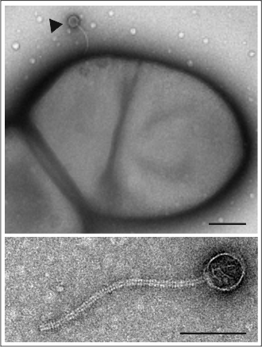
Figure 1. Transmission electron micrographs of MSTV1 virions. The top image displays an MSTV1 virion attached to the M. smithii surface. Scale bar, 200 nm. The bottom image shows MSTV1 virion found in the supernatant of M. smithii cultures. Scale bar, 100 nm.

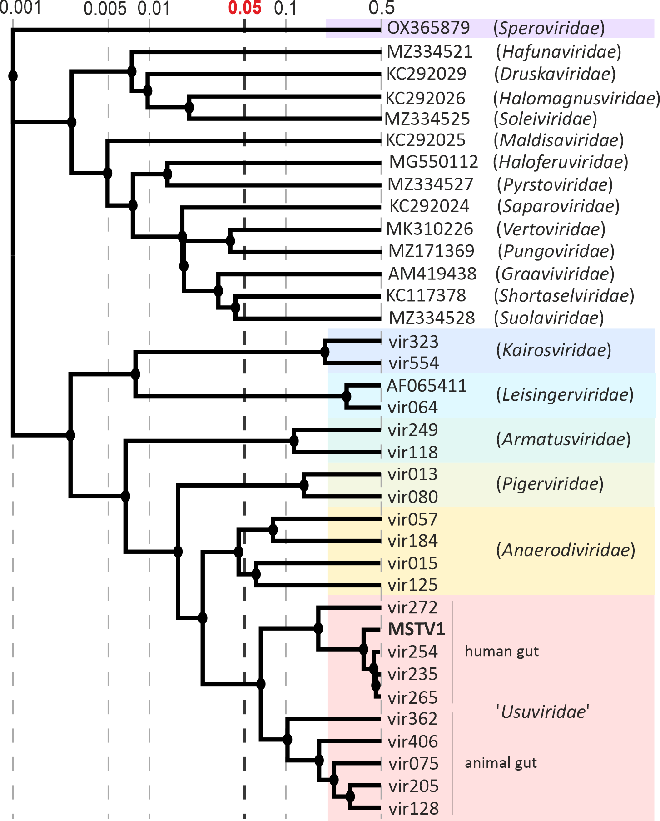

Figure 2. Proteomic tree of head-tailed viruses infecting methanogenic and hyperhalophilic archaea. Families of viruses associated with methanogenic archaea are highlighted with colored background. Branch lengths are log-scaled and the branch length for family-level demarcation is around 0.05. MSTV1 is indicated in bold within the newly proposed virus family ‘Usuviridae’.

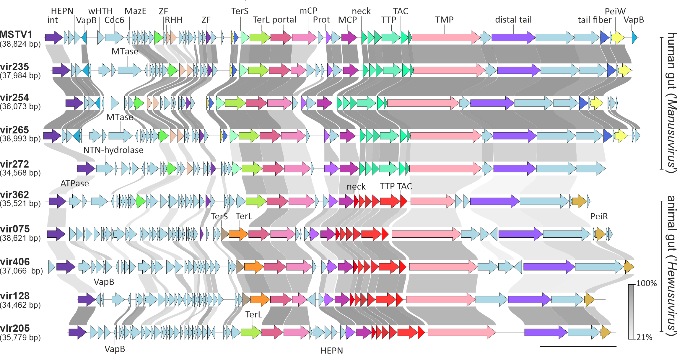
Figure 3. Alignment of MSTV1-like viruses originating from human and animal GIT. ORFs are depicted by arrows that indicate the direction of transcription. Functional annotations are shown above the corresponding ORFs. Homologous genes are depicted with the same colors and are connected by shading in grayscale, with intensity reflecting the amino acid sequence identity. Cdc6: AAA+ ATPase Orc1/Cdc6; HEPN: higher eukaryotes and prokaryotes nucleotide-binding domain-containing protein; int: integrase; MCP: major capsid protein; mCP: minor capsid protein; MTase: methyltransferase; NTN-hydrolase: N‐terminal nucleophile hydrolase; Prot: serine protease; RHH: ribbon-helix-helix protein; TAC: tail assembly chaperone; TerL: terminase large subunit; TerS: terminase small subunit; TMP: tail tape measure protein; TTP: tail tube protein; wHTH: winged helix-turn-helix domain; ZF: zinc finger domain-containing protein.

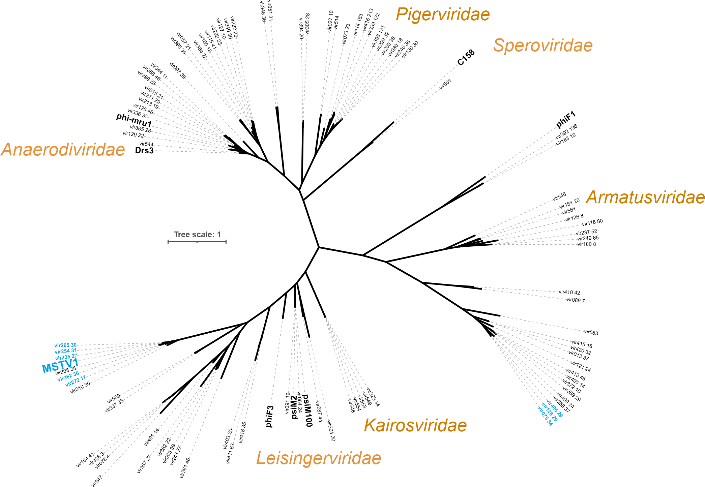
Figure 4. Phylogenetic analysis of TerL proteins encoded by viruses related to Methanobacteriales. MSTV1-like viruses are depicted in blue. The maximum likelihood phylogeny was inferred using IQTree (best model Q.pfam+F+I+R4) (Nguyen et al., 2015). Scale bar represents the number of substitutions per site.

