

Part 1: TITLE, AUTHORS, APPROVALS, etc

Code assigned: | 2022.006M
Short title: Create two new species in the genus Coguvirus, family Phenuiviridae, order Bunyavirales
Author(s) and email address(es)
Di Serio F, Xylogianni E, Navarro B | francesco.diserio@ipsp.cnr.it; eyaxylogian@gmail.com; beatriz.navarro@ipsp.cnr.it
Author(s) institutional address(es) (optional)
Istituto per la Protezione Sostenibile delle Piante, CNR, Italy [FDS, BN]
Agricultural University of Athens, Greece [EX]
Corresponding author
Di Serio F
List the ICTV Study Group(s) that have seen this proposal
ICTV Phenuiviridae Study Group
ICTV Study Group comments and response of proposer
Approved.
ICTV Study Group votes on proposal
Study Group | Number of members
Study Group | Votes support | Votes against | No vote
ICTV Phenuiviridae Study Group | 9 | 0 | 0

Authority to use the name of a living person
Is any taxon name used here derived from that of a living person (Y/N) | N

Taxon name | Person from whom the name is derived | Permission attached (Y/N)

Submission dates
Date first submitted to SC Chair | May 27, 2022
Date of this revision (if different to above)

ICTV-EC comments and response of the proposer

Part 2: NON-TAXONOMIC PROPOSAL
Text of proposal

Part 3: TAXONOMIC PROPOSAL
Name of accompanying Excel module
2022.006M.N.v1.Coguvirus_2nsp2.xlxs
Abstract
Brassica campestris chinensis coguvirus 1 (BCCoV-1) and Yúnnán Paris negative-stranded virus (YPNSV) fulfil the criteria to be classified in the genus Coguvirus (family Phenuiviridae) as representative members of two novel species. Here, it is proposed to create the species Coguvirus campestre and Coguvirus yunnanense in the genus Coguvirus to classify BCCoV1 and YPNSV, respectively.
Text of proposal
Brassica campestris chinensis coguvirus 1 (BCCoV-1) and Yúnnán Paris negative-stranded virus (YPNSV) have been recently identified in China as novel viruses infecting Brassica campestris L. ssp. chinensis (Tang et al., 2021) and Paris polyphylla var. yunnanensis (Chen et al. 2021) plants, respectively. They are negative-sense RNA viruses with a genome composed of two segments: the negative-stranded RNA1, encoding the putative large protein (L) with an RNA-directed RNA polymerase (RdRp) domain, and the ambisense RNA2, encoding the putative movement (MP) and nucleocapsid (NP) proteins. In both BCCoV-1 and YPNSV, the two ORFs in the RNA2 are separated by an intergenic region (IR) rich in A and U nucleotides that adopts a hairpin conformation. This genomic organization is identical to that of other viruses classified in the phenuivirid genus Coguvirus. The last five nucleotides at the 5’ and 3’ termini (ACACA and UGUGU, respectively) of the BCCoV-1 genomic RNA1 (MW291945) and RNA2 (MW291945) are identical to those conserved in all members of the family Phenuiviridae (Fig.1). However, these conserved terminal sequences were not reported at the 5’ and 3’ ends of the YPNSV genomic RNAs (MT269667; MT269668) (Chen et al., 2021), suggesting that the ends of the genomic segments were not completely determined (Fig. 1). The 5’ and 3’ terminal sequences (approximately 30 nucleotides) of each genomic RNA of BCCoV-1 are complementary to each other, thus allowing the formation of the panhandle structure typical of all members of the order Bunyavirales and likely required for viral replication (Fig. 2) (Navarro et al., 2018a; Zhang et al., 2021). This panhandle structure cannot be formed by the terminal ends reported for YPNSV RNA1 and RNA2, thus further supporting that terminal sequences were not completely determined in this case.
BCCoV1 and YPNSV RdRps showed an amino acid (aa) identity ranging from 38.32 to 56.04% and from 38.1 to 69.73%, respectively, with the three currently classified members of the genus Coguvirus, citrus concave gum-associated virus (CCGaV), citrus virus A (CiVA) and grapevine associated cogu-like virus 1 (GaCLV-1) (Navarro et al., 2018a; 2018b; Chiapello et al., 2019) and with watermelon crinkle leaf-associated virus 1 (WCLaV-1) and watermelon crinkle leaf-associated virus 2 (WCLaV-2) (Xin et al., 2017, Zhang et al., 2021) (Fig. 3A). The latter two viruses have been concurrently proposed to be classified as new members of the genus Coguvirus. The RdRPs of YPNSV and BCCoV-1 contain the typical six motifs (premotif A, motifs A-E) that are highly conserved in the RdRps of members of the order Bunyavirales (Xin et al., 2017; Chen et al. 2021). BCCoV-1 and YPNSV NP aa sequence identity with other coguviruses ranges from 25 to 41.21% and from 27.32 to 61.16%, respectively (Fig.3B). The highest identity values were obtained with the NPs of WCLaV-1 and WCLaV-2.
A maximum likelihood phylogenetic tree was generated using the putative RdRp aa sequences of i) YPNSV and BCCoV-1, ii) the other members of the genus Coguvirus (CCGaV, CiVA, GaCLV-1), iii) the two proposed new members of this genus, WCLaV-1 and WCLaV-2, iv) the members of the genus Laulavirus [Laurel Lake virus (LLV), grapevine associated cogu-like virus 2 (GaCLV-2), grapevine associated cogu-like virus 3 (GaCLV-3) and grapevine associated cogu-like virus 4 (GaCLV-4)], and v) tomato spotted wilt virus (TSWV) as an outgroup. In that tree, BCCoV-1 and YPNSV cluster in the same clade together with the three currently members in the genus Coguvirus (CCGaV, CiVA and GaCLV-1) and the unassigned WCLaV-1 and WCLaV-2 (Fig. 4). High bootstrap values in the phylogenetic tree strongly support the classification of both BCCoV1 and YPNSV in the genus Coguvirus. These data are in agreement with the phylogenetic analysis by Tang et al. (2021) and Chen et al. (2021), in which BCCoV-1 and YPNS also clustered in a clade together with the members of the genus Coguvirus.
Demarcation criterion for the species of the genus Coguvirus has been established as less than 95% identity in the amino acid sequence of the RdRp (TaxoProp 2019.026M). Since BCCoV-1 and YPNSV RdRps showed the highest aa sequence identity of 56.04% and 69.73% with CiVA and WCLaV-2 RdRps, respectively, we propose to classify BCCoV1 and YPNSV in two novel species in the genus Coguvirus. and Coguvirus yunnanense for YPNSV (Yunnan is the Chinese province in which the virus has been identified for the first time and yunnanensis is the variety of the plant species, Paris polyphylla, in which the virus was reported).

Supporting evidence

5’ 3’
YPNSV-RNA1 CUCAAACACU....UUUU-UUCAGUAAAC-GUGGU
YPNSV-RNA2 CUCAACACUU....AAUAGUUGAGAGAUCUGUG-
BCCoV1-RNA1 ACACAAAGACUCCCCAACUUU....AAGUUUGGGGAUCUUUGUGU
BCCoV1-RNA2 ACACAAAGA-UCCCCCUGUUU....AAGCAAGGGGGUCUUUGUGU
CCGaV-RNA1 ACACAAAGACUCCCAAACUUU....AUAGUUUGGGAUCUGUGUGU
CCGaV-RNA2 ACACAAAGA-UCCCAUAACUU....AAGUUAUGGGUUCUAUGUGU
CiVA-RNA1 ACACAAAGACUCCCAAACUUU....AAAGUUUGGGAUCUGUGUGU
CiVA-RNA2 ACACAUAGA-UCCCAUAAUUU....AAGUUAUGGGUUCUAUGUGU
WCLaV-1-RNA1 ACACAAAGACUCCCGUACUUC....UUAAUACGGGAUCUAUGUGU
WCLaV-1-RNA2 ACACAUAGA-ACCCAUAAACU....AGUUAAUGGGAUCUUUGUGU
WCLaV-2-RNA1 ACACAAAGACUCUCAAACACU....UGUGUUUGAGAUCUUUGUGU
WCLaV-2-RNA2 ACACAAAGAUCUCUCAACACA....AGUUGAAGAGAUCUGUGUGU

Figure 1. Alignment of 5′ (left) and 3′ (right) termini of the genomic RNAs of members and two proposed new members (WCLaV-1 and WCLaV-2) of the genus Coguvirus. The conserved nucleotides in all members of the family Phenuiviridae are shown in red.

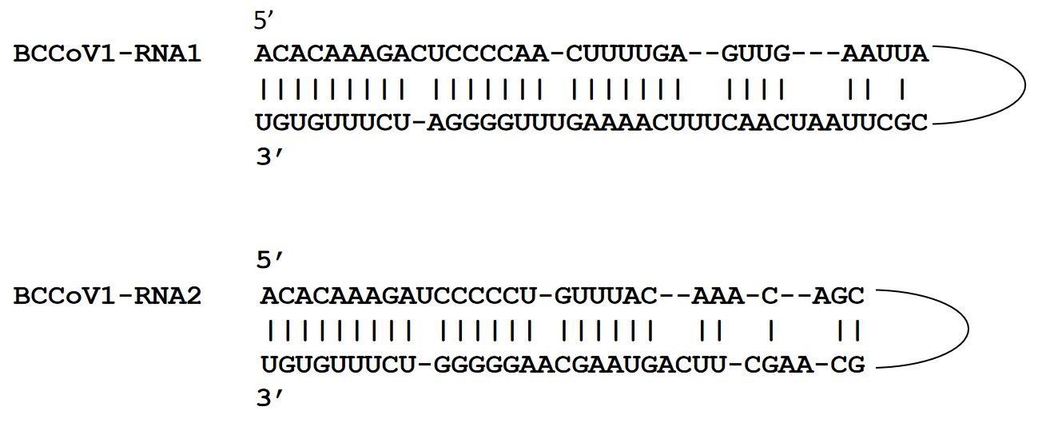
Figure 2. Panhandle structures formed by the 5′ and 3′ termini of BCCoV1 RNA1 and RNA2.
A

B

Figure 3. Amino acid identity matrix (%) of RdRp (panel A) and NP (panel B) calculated for BCCoV1, YPNSV and all the current and proposed members of the genus Coguvirus

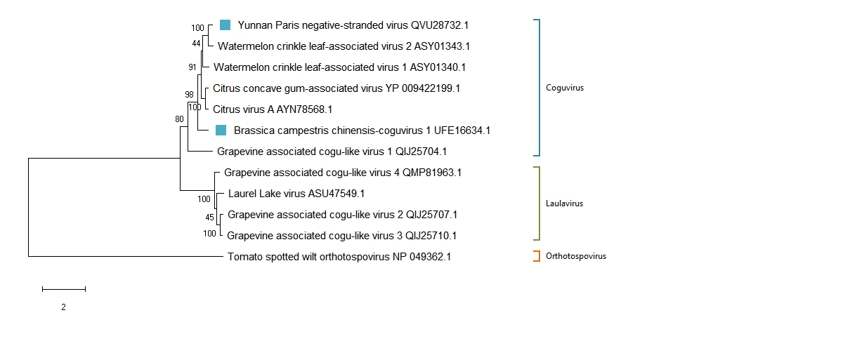

Figure 4. Phylogenetic tree of the RNA-dependent RNA polymerase (RdRp) of BCCoV1, YPNSV, the other members of the genus Coguvirus (CCGaV, CiVA, GaCLV-1), two new proposed members of this genus (WCLaV-1 and WCLaV-2), the members of the genus Laulavirus (LLV, GaCLV-2, GaCLV-3, GaCLV), and TSWV as an outgroup. Maximum likelihood method adopting the LG + G + F amino acid substitution model was used to infer the phylogenetic tree. Bootstrap probability values (1000 replicates) are shown at branch nodes. Tree branches are proportional to the genetic distances, with the scale bar indicating substitutions per amino acid site.

References
Chen Z, Anane RF., Wang Z, Gao L, Chen L, Li S, Wen G, Zhao M. (2021) Complete genome sequence analysis of a novel coguvirus isolated from Paris polyphylla var. yunnanensis. Arch Virol 166:2045–2050. https://doi.org/10.1007/s00705-021-05087-x

Chiapello M, Rodriguez-Romero J, Nerva L, Forgia M, Chitarra W, Ayllón M, Turina M. (2020) Putative new plant viruses associated with Plasmopara viticola‐infected grapevine samples. Ann Appl Biol. 176:180–191. DOI: 10.1111/aab.1253

Tang L, Song L, Ye Z, Lin C, Wang B, Lin J, Gao C, Wang A. (2021) A novel negative-stranded RNA virus of the order Bunyavirales identified in Brassica campestris L. ssp. chinensis. Arch Virol 166:1525–1528. https://doi.org/10.1007/s00705-021-05031-z

Navarro B, Minutolo M, De Stradis A, Palmisano F, Alioto D, Di Serio F. (2018a) The first phlebo‐like virus infecting plants: a case study on the adaptation of negative‐stranded RNA viruses to new hosts. Mol Plant Pathol 19:1075–1089. doi: 10.1111/mpp.12587

Navarro B, Zicca S, Minutolo M, Saponari M, Alioto D, Di Serio F. (2018b) A negative-stranded RNA virus infecting citrus trees: the second member of a new genus within the order Bunyavirales. Front Microbiol 9:2340. doi: 10.3389/fmicb.2018.02340.

Xin M, Cao M, Liu W, Ren Y, Zhou X, Wang X. (2017) Two negative-strand RNA viruses identified in watermelon represent a novel clade in the order Bunyavirales. Front Microbiol 8:1514. doi: 10.3389/fmicb.2017.01514.

Zhang S, Tian X, Navarro B, Di Serio F, Cao M. (2021) Watermelon crinkle leaf-associated virus 1 and watermelon crinkle leaf-associated virus 2 have a bipartite genome with molecular signatures typical of the members of the genus Coguvirus (family Phenuiviridae). Arch Virol. 166:2829-2834. doi: 10.1007/s00705-021-05181-0.

