
This Word module should be used for all taxonomic proposals.
Please complete Part 1 and:
either Part 3 for proposals to create new taxa or change existing taxa
or Part 2 for proposals of a general nature.
Submit the completed Word module, together with the accompanying Excel module named in Part 3, to the appropriate ICTV Subcommittee Chair.
The Word module explains and justifies your proposal. The Excel module is a critical document that will be used to implement the proposed taxonomic changes once they are approved and ratified. If proposals presented in the Word module are not presented accurately in the Excel module, the taxonomic changes cannot proceed.
For guidance, see the notes written in blue, below, and the Help Notes in file Taxonomic_Proposals_Help_2019.
Part 1: TITLE, AUTHORS, etc

Code assigned: | 2019.029M
Short title: Create one new species in the genus Rotavirus, family Reoviridae
Author(s) and email address(es):
List authors in a single line Archives of Virology citation format (e.g. Smith AB, Huang C-L, Santos, F) |  | Provide email address for each author in a single line separated by semi-colons
Bányai K, Kemenesi G, Jakab F​ |  | bkrota@hotmail.com; kemenesi.gabor@gmail.com; jakabf@gamma.ttk.pte.hu
Author(s) institutional address(es) (optional):
Provide institutional addresses, each on a single line followed by author(s) initials (e.g. University of Woolloomooloo [SAB, HCL])
Lendület Pathogen Discovery Research Group, Institute for Veterinary Medical Research, Centre for Agricultural Research, HAS-Centre for Agricultural Research, Budapest, Hungary (BK)
Virological Research Group, Szentágothai Research Centre, University of Pécs, Pécs, Hungary (KG, JF)

Corresponding author
Bányai K, bkrota@hotmail.com
List the ICTV study group(s) that have seen this proposal:
A list of study groups and contacts is provided at http://www.ictvonline.org/subcommittees.asp . If in doubt, contact the appropriate subcommittee chair (there are six virus subcommittees: animal DNA and retroviruses, animal ssRNA-, animal ssRNA+, fungal and protist, plant, bacterial and archaeal) |  | ICTV Reoviridae Study Group
ICTV Study Group comments (if any) and response of the proposer:
Date first submitted to ICTV: |  |  | June 19, 2019
Date of this revision (if different to above):

ICTV-EC comments and response of the proposer:

Part 3: PROPOSED TAXONOMY

Name of accompanying Excel module: 2019.029M.A.v1.Rotavirus_1newsp.xlsx

Supporting material:
additional material in support of this proposal
Rotaviruses (Reoviridae: Rotavirus) are currently classified into nine species (Rotavirus A to Rotavirus I). The criteria to demarcate rotavirus species include serological cross reactivity of the group-specific antigen (VP6), the host range, and the sequence analysis of conserved genome segments (seg 1, seg 6) of member viruses. It has been suggested that a cut-off value of 53% of the VP6 amino acid sequence firmly permits differentiation into the distinct rotavirus species. In a recent study, Bányai et al (2017), reported a novel bat-origin rotavirus from Schreiber's long-fingered bats (Miniopterus schreibersii) captured in Serbia. To determine the whole genome sequence of the identified novel rotavirus, the authors utilized a combination of random RT-PCR and semiconductor sequencing and gene-specific RT-PCR amplification and Sanger sequencing for selected genomic regions.

The genome of “BO4351/Ms/2014 virus” is 18,135 bp in length (range, 3533 bp for segment 1 and 620 bp for segment 11). Terminal sequences at the 5′ ends have conserved nucleotides at positions 1, 2, and 4 and some variations at positions 3, 5, and 6 (segments 1 and 2, GGCACA; segments 3 and 4, GGCATT; segments 5, 7, and 9, GGAAAT; segments 6 and 10, GGCAAA; segment 8, GGAAAA; segment 11, GGAATT), whereas at the 3′ ends the variation was less (TAYACCC) (Table 1).

Each segment has non-translated regions at both 5′ end (length range, 6 to 57 nt) and 3′ end (length range, 20 to 84 nt). Encoded proteins were assigned based on significant hits through the Blast engine and conserved peptide motifs. With this approach we found the equivalents of the major structural (VP1 to VP4, VP6 and VP7) and non-structural (NSP1 to NSP5) proteins of rotaviruses.

Neighbor-joining and maximum-likelihood trees provided similar topologies, clearly distinguishing clade 1 and clade 2 rotaviruses. “BO4351/Ms/2014 virus” consistently clustered with clade 2 rotaviruses.

The greatest nucleotide and amino acid sequence identities for “BO4351/Ms/2014 virus” were seen when compared to reference Rotavirus H viruses (range, 41 (nt%) and 14 (aa%) for NSP4; 63 (nt%) and 64 (aa%) for VP1) (Table 2).

To place “BO4351/Ms/2014 virus”, into the latest rotavirus taxonomic framework, a number of VP6 gene sequences were selected from GenBank to represent a broader genetic diversity of various rotaviruses. In this analysis, again, “BO4351/Ms/2014 virus” was most closely related to the major genetic lineage containing Rotavirus H viruses (49–50%, aa) and showed lower similarity to other clade 2 rotavirusess (rotaviruses B, 39%, rotaviruses G, 39%). The genetic relationship of “BO4351/Ms/2014 virus” to clade 1 rotaviruses was marginal (max. identity with rotaviruses C, 17%) (Fig 1, 2).

Applying the official species demarcation sequence cut-off value, which is 53% identity at the amino acid level (Fig 2), we propose that the novel bat-borne rotavirus represents a new rotavirus species, Rotavirus J.

Table 1 Assignment and some features of the genome segments of the candidate new bat rotavirus, “BO4351/Ms/2014 virus”
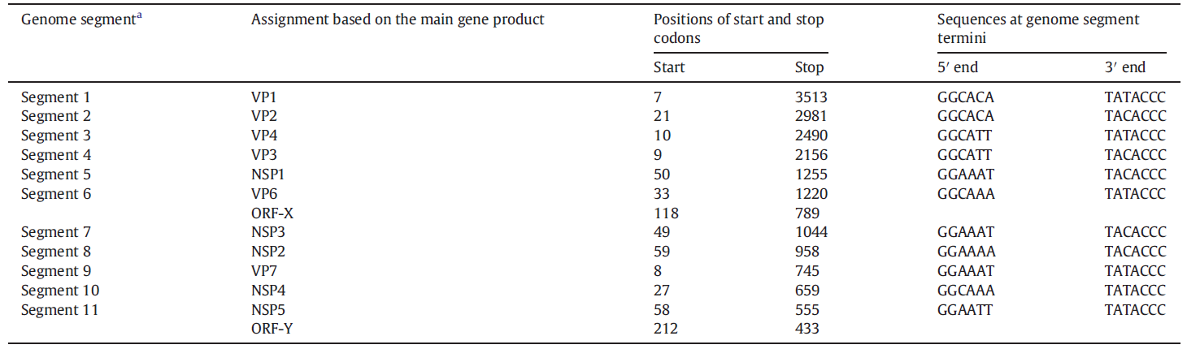

Table 2 Percentile nucleotide (nt) and amino acid (aa) sequence based identities between the novel bat-borne rotavirus, “BO4351/Ms/2014 virus”, and other rotaviruses (RVA, RVB, RVC, RVD, RVF, RVG, RVH, RVI of species Rotavirus A, Rotavirus B, Rotavirus C, Rotavirus D, Rotavirus F, Rotavirus G, Rotavirus H, Rotavirus I, respectively)
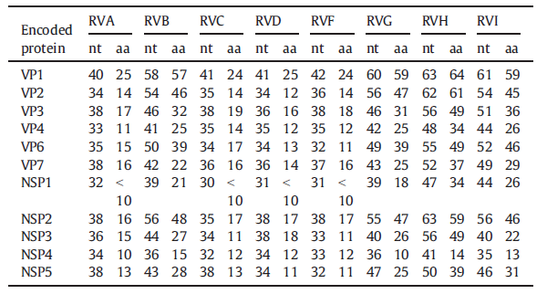

Figure 1 Phylogenetic trees obtained for the genes encoding all major structural proteins (VP1 to VP4, VP6, and VP7) and non-structural proteins (NSP1 to NSP5) with representative rotaviruses (A through I). Color codes are indicated in the box (RVA, RVB, RVC, RVD, RVF, RVG, RVH, RVI of species Rotavirus A, Rotavirus B, Rotavirus C, Rotavirus D, Rotavirus F, Rotavirus G, Rotavirus H, Rotavirus I, respectively)
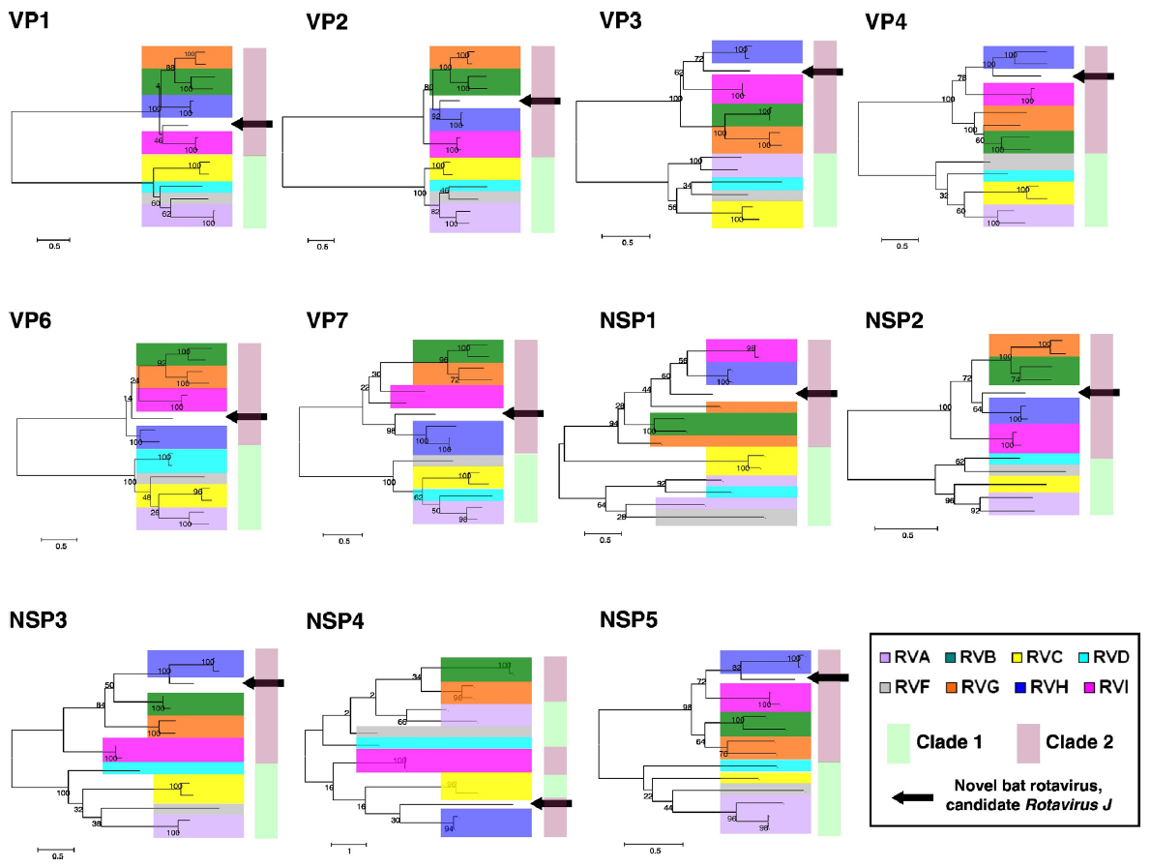

Figure 2 Similarity plot prepared from amino acid sequences of the VP6 protein. Dashed line indicates the rotavirus species demarcation sequence identity cut-off value determined by Matthijnssens et al. (2012). Color codes are indicated below the plot (RVA, RVB, RVC, RVD, RVF, RVG, RVH, RVI of species Rotavirus A, Rotavirus B, Rotavirus C, Rotavirus D, Rotavirus F, Rotavirus G, Rotavirus H, Rotavirus I, respectively)

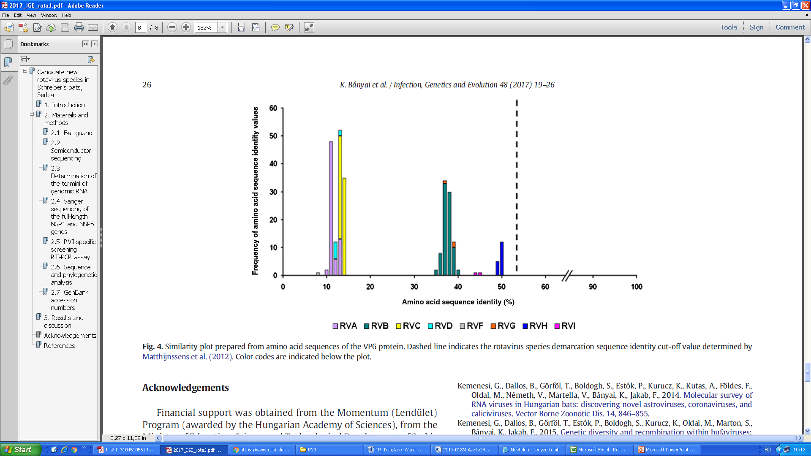

References:
Bányai K, Kemenesi G, Budinski I, Földes F, Zana B, Marton S, Varga-Kugler R, Oldal M, Kurucz K, Jakab F. Candidate new rotavirus species in Schreiber's bats, Serbia. Infect Genet Evol. 2017 Mar;48:19-26. doi: 10.1016/j.meegid.2016.12.002. Epub 2016 Dec 6. PubMed PMID: 27932285.

Matthijnssens J, Otto PH, Ciarlet M, Desselberger U, Van Ranst M, Johne R.
VP6-sequence-based cutoff values as a criterion for rotavirus species
demarcation. Arch Virol. 2012 Jun;157(6):1177-82. doi: 10.1007/s00705-012-1273-3. Epub 2012 Mar 20. PubMed PMID: 22430951.

