
This Word module should be used for all taxonomic proposals.
Please complete Part 1 and:
either Part 3 for proposals to create new taxa or change existing taxa
or Part 2 for proposals of a general nature.
Submit the completed Word module, together with the accompanying Excel module named in Part 3, to the appropriate ICTV Subcommittee Chair.
The Word module explains and justifies your proposal. The Excel module is a critical document that will be used to implement the proposed taxonomic changes once they are approved and ratified. If proposals presented in the Word module are not presented accurately in the Excel module, the taxonomic changes cannot proceed.
For guidance, see the notes written in blue, below, and the Help Notes in file Taxonomic_Proposals_Help_2019.
Part 1: TITLE, AUTHORS, etc

Code assigned: | 2019.019M
Short title: Create one new species (Squirrel respirovirus) in the genus Respirovirus, family Paramyxoviridae

Author(s) and email address(es):
List authors in a single line Archives of Virology citation format (e.g. Smith AB, Huang C-L, Santos, F) |  | Provide email address for each author in a single line separated by semi-colons
Forth LF, Höper D, Beer M |  | leonie.forth@fli.de; dirk.hoeper@fli.de; martin.beer@fli.de
Author(s) institutional address(es) (optional):
Provide institutional addresses, each on a single line followed by author(s) initials (e.g. University of Woolloomooloo [SAB, HCL])
Friedrich-Loeffler-Institut, Institute of Diagnostic Virology, Südufer 10, 17493 Greifswald – Insel Riems [LFF, DH, MB]

Corresponding author
Prof. Martin Beer; martin.beer@fli.de
List the ICTV study group(s) that have seen this proposal:
A list of study groups and contacts is provided at http://www.ictvonline.org/subcommittees.asp . If in doubt, contact the appropriate subcommittee chair (there are six virus subcommittees: animal DNA and retroviruses, animal ssRNA-, animal ssRNA+, fungal and protist, plant, bacterial and archaeal) |  | ICTV Paramyxoviridae Study Group
ICTV Study Group comments (if any) and response of the proposer:
The study group agrees with the classification of this virus as representing a new species in the genus [accession SYZ47181] as application of the published species demarcation criterion that a branch length of >0.03 in a maximum likelihood tree derived from a Clustal W alignment of the amino acid sequences of the RdRP protein of the viruses justifies the classification of these new viruses as members of new species.
Date first submitted to ICTV: |  |  | June 19, 2019
Date of this revision (if different to above):

ICTV-EC comments and response of the proposer:

Part 3: PROPOSED TAXONOMY

Name of accompanying Excel module: 2019.019M.A.v1.1newsp_Squirrel_respirovirus.xlsx
A novel virus, the giant squirrel virus (GSqV), has been isolated, identified and characterized (Forth et al., 2018). GSqV is genetically most closely related to Sendai virus as well human parainfluenza virus 1. While Sendai virus is a member of the species Murine respirovirus in the genus Respirovirus, human parainfluenza virus 1 belongs to the species Human respirovirus 1. The genus Respirovirus additionally includes the species Porcine respirovirus 1, Bovine respirovirus 3 and Human respirovirus 3, thereby consisting of five species to date.

The pairwise full genome sequence identity of GSqV to Sendai virus (NC_001552) and human parainfluenza virus 1 (NC_003461) is 71% and 68%, respectively. The distance of single genes to murine and human respirovirus genes is evenly distributed (Figure 1), excluding the occurrence of a recombination event and substantiating the need of creation of a new species to classify GSqV. Furthermore, GSqV is hypothesized to express an accessory protein that cannot be expressed by murine nor human respiroviruses.

GSqV falls phylogenetically in between the established species Murine respirovirus and Human respirovirus 1 in the genus Respirovirus (Figures 2 and 3) and it is therefore proposed to be assigned to a new species. This species should be named “Squirrel respirovirus”, following the nomenclature for other species in this genus, while leaving the possibility of identification in other squirrel species.

In the 9th ICTV report on Paramyxoviridae published in 2011, no criteria for sequence-based species demarcation in the genus Respirovirus have been suggested. Based on the difference of the full genomes of murine, porcine and human respiroviruses, and GSqV (Table 1), a cut-off criterium of at least 75% sequence identity of the full genome is proposed for the assignment to an already existing species. According to the 9th ICTV report, each virus species in the genus Respirovirus represents a significant pathogen in its respective host. The strong association of disease with high loads of GSqV in the lung supports the designation of the new species as “Squirrel respirovirus”.

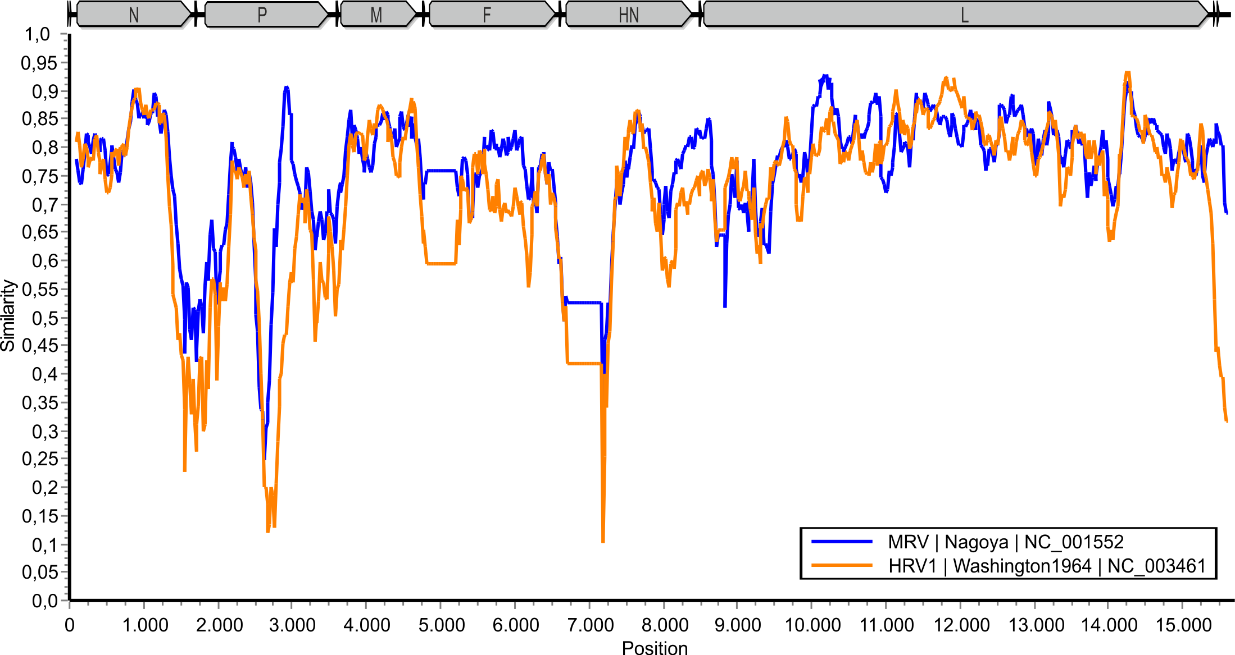
Figure 1. SimPlot analysis of the GSqV genome in comparison to Sendai virus strain Nagoya and human parainfluenza virus 1 strain Washington 1964 shows comparable sequence similarity. Depicted is the sequence identity within a sliding window of 200 nt and a step size of 20 nt. Adopted under CC BY 4.0. from: Forth et al, A Novel Squirrel Respirovirus with Putative Zoonotic Potential, Viruses, 2018 Jul 18; 10(7):373, doi: 10.3390/v10070373.

Figure 2. Phylogenetic tree with selected representatives of each species in the genus Respirovirus. Nucleotide alignment of full genomes was performed with MAFFT v7.308 with subsequent phylogenetic tree construction using RAxML v8.2.7 (model GTR GAMMA, bootstrap support of 1000 replicates). Adapted from: Forth et al, A Novel Squirrel Respirovirus with Putative Zoonotic Potential, Viruses, 2018 Jul 18; 10(7):373, doi: 10.3390/v10070373 under CC BY 4.0.
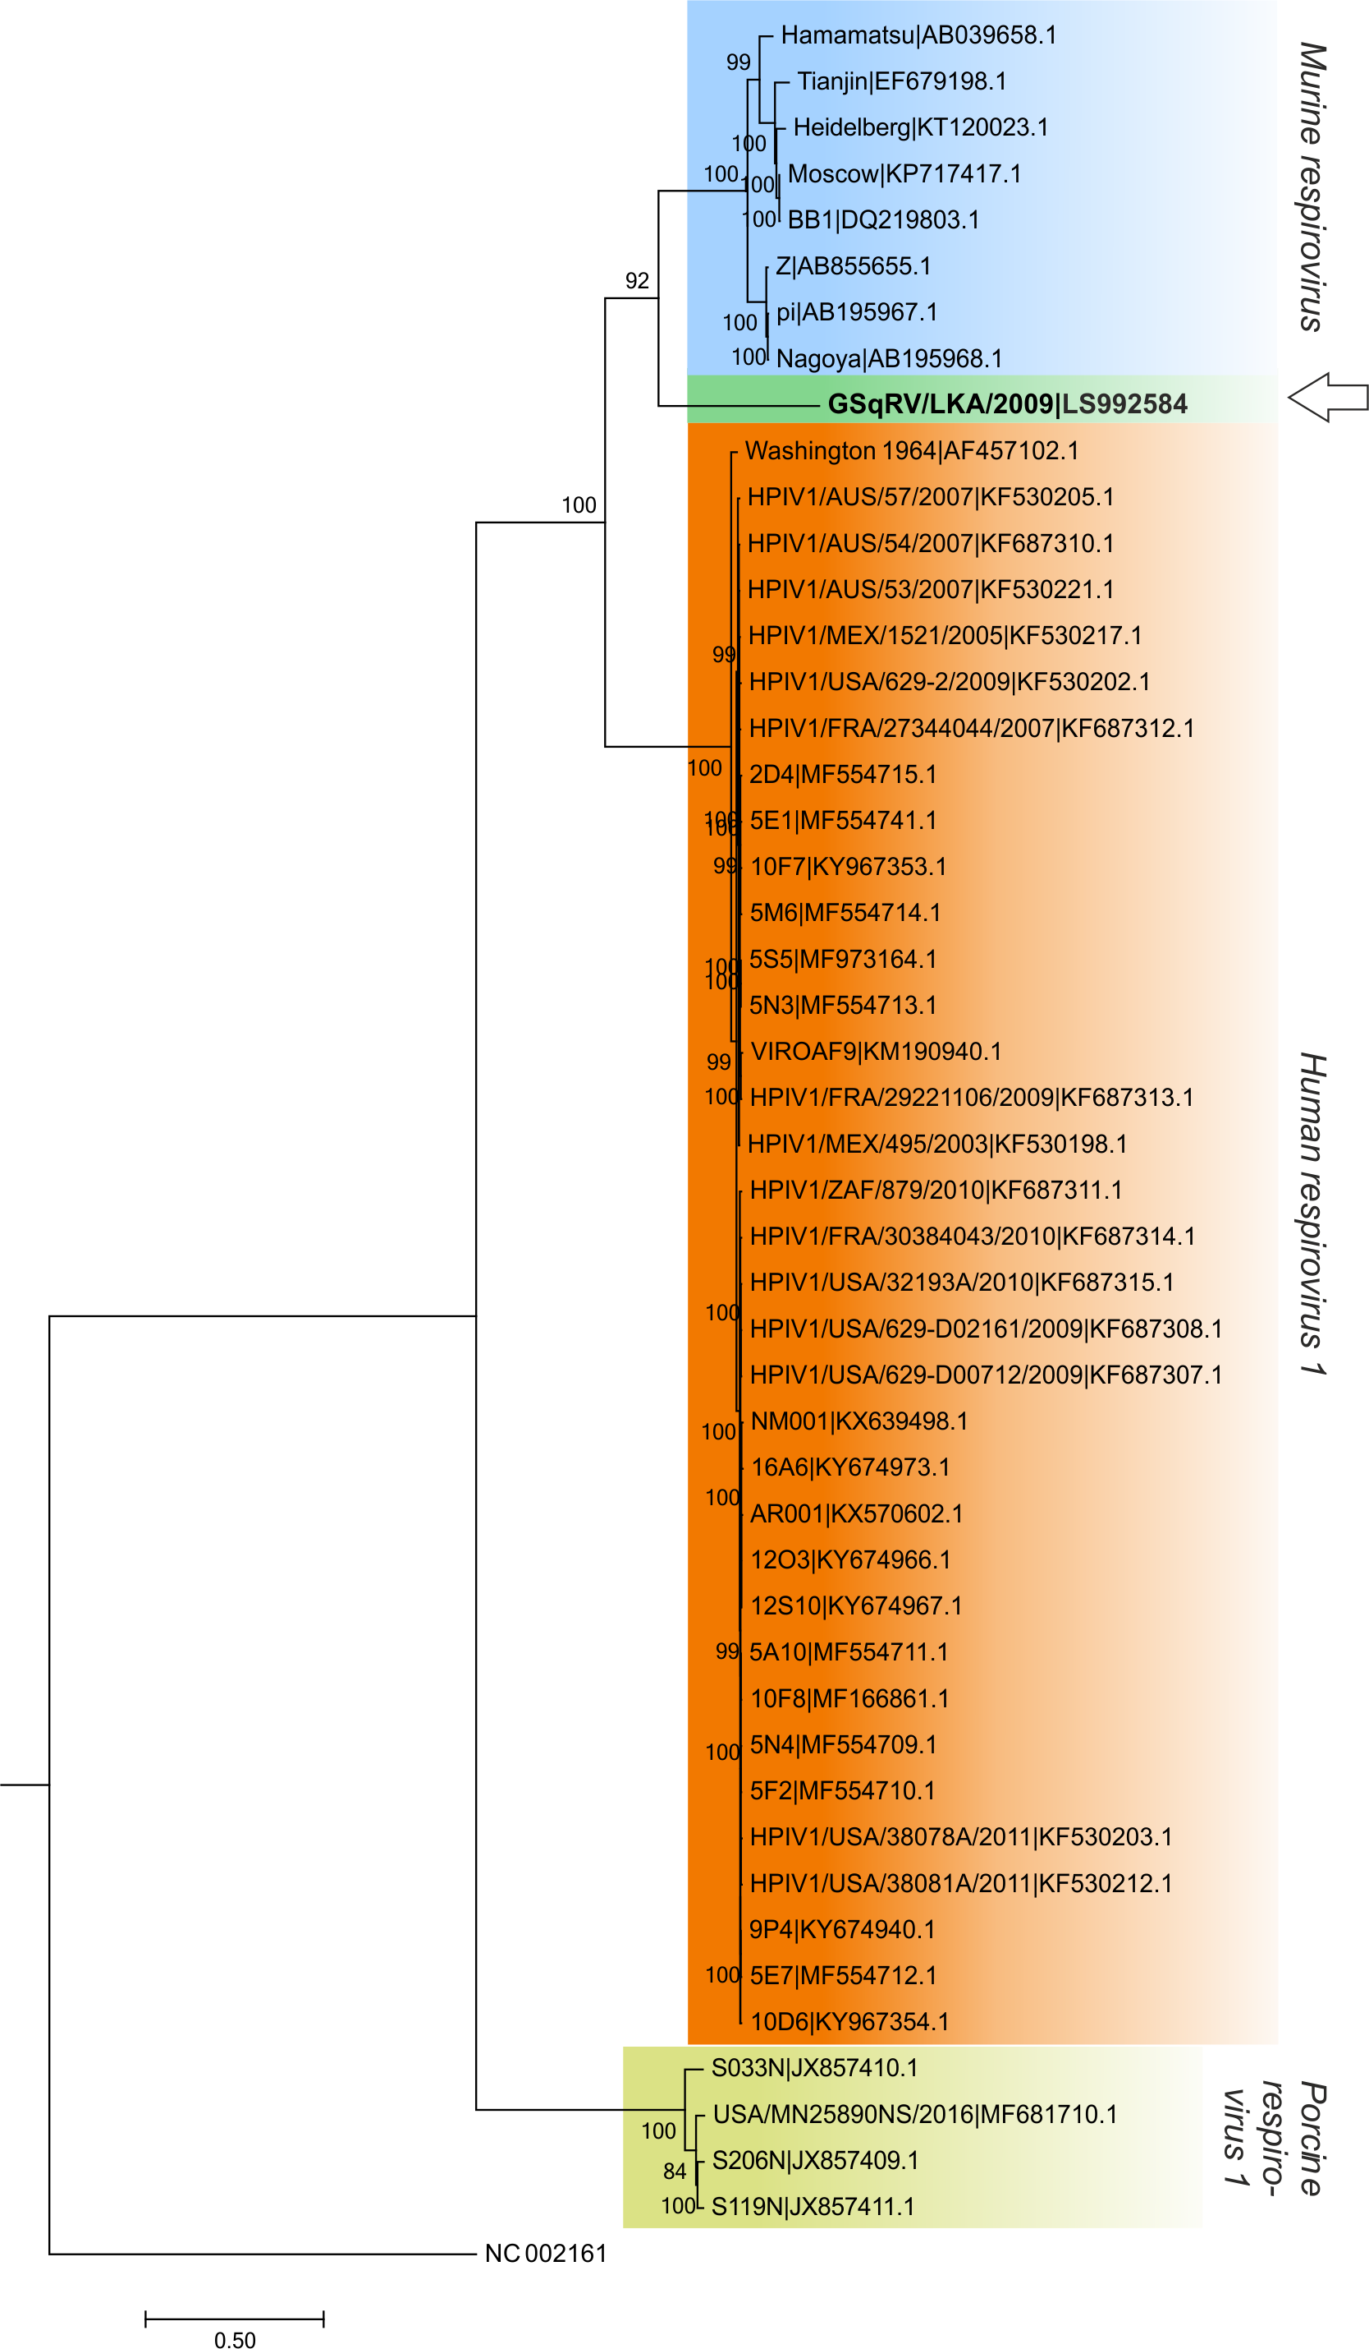
Figure 3. Phylogenetic tree of in the INDSC databases available complete genomes of the viruses classified as members of species Murine, Human and Porcine respirovirus 1 (database accession date: January 2017; genetically modified sequences were excluded), and GSqV. Annotation includes strain/isolate and accession number. Bovine parainfluenza virus 3 (NC002161) was included as an outgroup. Nucleotide alignment of full genomes was performed with MAFFT with subsequent phylogenetic tree construction using RAxML (model GTR GAMMA, bootstrap support of 1000 replicates). Adapted from: Forth et al, A Novel Squirrel Respirovirus with Putative Zoonotic Potential, Viruses, 2018 Jul 18; 10(7):373, doi: 10.3390/v10070373 under CC BY 4.0.

Table 1. Pairwise full genome sequence identities of up to three representatives of each species. The pairwise sequence identities within one species are highlighted in light grey. Pairwise sequence identities were computed with EMBOSS Needleall v6.3.1 applying the default settings for costs of gap opening (10) and extending (0.5).

Species | Strain/isolate | Acc. | KP717417 | AB195967 | AB195968 | LS992584 | KF687311 | KF530202 | KF687310 | JX857411 | JX857410 | JX857409
Murine respirovirus | Moscow | KP717417 | 100.0 | 87.9 | 87.9 | 70.3 | 68.9 | 68.5 | 68.6 | 63.8 | 64.2 | 63.9
Murine respirovirus | pi | AB195967 | 87.9 | 100.0 | 99.7 | 71.1 | 68.9 | 68.6 | 68.6 | 63.6 | 63.5 | 63.8
Murine respirovirus | Nagoya | AB195968 | 87.9 | 99.7 | 100.0 | 71.1 | 68.9 | 68.6 | 68.6 | 63.5 | 63.6 | 63.7
Squirrel respirovirus 1 | GSqV/LKA/2009 | LS992584 | 70.4 | 71.0 | 71.1 | 100.0 | 68.1 | 68.4 | 68.3 | 65.1 | 65.5 | 65.2
Human respirovirus 1 | HPIV1/ZAF/879/2010 | KF687311 | 68.9 | 68.9 | 68.9 | 68.1 | 100.0 | 97.4 | 97.5 | 65.1  64.9 | 65.0 | 65.3
Human respirovirus 1 | HPIV1/USA/629-2/2009 | KF530202 | 68.5 | 68.6 | 68.6 | 68.4 | 97.4 | 100.0 | 99.0 | 65.1  64.9 | 65.0 | 65.3
Human respirovirus 1 | HPIV1/AUS/54/2007 | KF687310 | 68.6 | 68.6 | 68.7 | 68.3 | 97.5 | 99.0 | 100.0 | 64.9 | 65.0 | 65.6
Porcine respirovirus 1 | S119N | JX857411 | 63.8 | 63.6 | 63.5 | 65.0 | 65.1 | 64.9 | 64.9 | 100.0 | 91.5 | 96.7
Porcine respirovirus 1 | S033N | JX857410 | 64.2 | 63.4 | 63.5 | 65.4 | 64.9 | 65.0 | 65.0 | 91.5 | 100.0 | 91.5
Porcine respirovirus 1 | S206N | JX857409 | 63.9 | 63.8 | 63.7 | 65.2 | 65.2 | 65.2 | 65.5 | 96.7 | 91.5 | 100.0

References:
Forth LF, Konrath A, Klose K, Schlottau K, Hoffmann K, Ulrich RG, Höper D, Pohlmann A, Beer M. A Novel Squirrel Respirovirus with Putative Zoonotic Potential. Viruses. 2018 Jul 18; 10(7):373, doi: 10.3390/v10070373.
- Publication on the identification and characterization.

Loeffelholz MJ, Fenwick BW. Taxonomic Changes for Human and Animal Viruses, 2016 to 2018. Journal of Clinical Microbiology. 2019 Jan 30;57(2). pii: e01457-18. doi: 10.1128/JCM.01457-18.
- GSqV mentioned for classification.

