
This Word module should be used for all taxonomic proposals.
Please complete Part 1 and:
either Part 3 for proposals to create new taxa or change existing taxa
or Part 2 for proposals of a general nature.
Submit the completed Word module, together with the accompanying Excel module named in Part 3, to the appropriate ICTV Subcommittee Chair.
For guidance, see the notes written in blue, below, and the help notes in file Taxonomic_Proposals_Help_2018.
Part 1: TITLE, AUTHORS, etc

Code assigned: | 2019.005M |  | (to be completed by ICTV officers)
Short title: Create one new species in the genus Mammarenavirus, family Arenaviridae
Author(s):
Fernandes, Jorlan (jorlan@ioc.fiocruz.br)
Guterres, Alexandro (guterres@ioc.fiocruz.br)
Oliveira, Renata Carvalho (reolivira@ioc.fiocruz.br)
Chamberlain, John (john.chamberlain@phe.gov.uk)
Hewson, Roger (roger.hewson@phe.gov.uk)
Lemos, Elba Regina Sampaio (elemos@ioc.fiocruz.br)
Corresponding author with e-mail address:
Jorlan Fernandes, jorlan@ioc.fiocruz.br ; Elba R S de Lemos, elemos@ioc.fiocruz.br
List the ICTV study group(s) that have seen this proposal:
A list of study groups and contacts is provided at http://www.ictvonline.org/subcommittees.asp . If in doubt, contact the appropriate subcommittee chair (there are six virus subcommittees: animal DNA and retroviruses, animal ssRNA-, animal ssRNA+, fungal and protist, plant, bacterial and archaeal) |  | ICTV Arenaviridae Study Group
ICTV Study Group comments (if any) and response of the proposer:
Date first submitted to ICTV: |  |  | 09/24/2018
Date of this revision (if different to above):

ICTV-EC comments and response of the proposer:
All 13 members of the ICTV Arenaviridae Study Group approved this proposal.

Part 3: PROPOSED TAXONOMY

Name of accompanying Excel module: 2019.005M.A.v1.Mammarenavirus_sp_XAPV.xlsx
The taxonomic changes you are proposing should be presented on an accompanying Excel module, 2017_TP_Template_Excel_module. Please enter the file name of the completed module in this box.
Supporting material:
additional material in support of this proposal

Xapuri virus (XAPV) was detected in a Musser’s neacomys (Neacomys musseri) sampled in Brazilian Amazon in 2015 (Fernandes et al. 2018b). XAPV is phylogenetically related to New World Clade B and Clade C viruses and may represent the first natural mammarenavirus reassortant and a new unrecognized clade within the Tacaribe serocomplex group.
Delineating species in the Arenaviridae family follows multiple criteria, including the association with a main host or group of sympatric hosts, the presence in a defined geographical area, and significant protein sequence differences, such as a variance of at least 12.0% in the aa sequence of the NP compared to that of other species in the genus (Salvato et al. 2005, Radoshitzky et al. 2015). In addition, a recent update from the ICTV also includes as classifiable “virus coding-complete genomic sequences for both S and L segments even in the absence of a culturable isolate” and recommends the use of the PASC tool for the assessment of novel arenaviruses. Cut-off values selected for classifying arenaviruses belonging to the same species using this tool are >80.0 and >76.0% regarding nucleotide sequence identity in the S and L segments, respectively (Radoshitzky et al. 2015). The closest PASC hit for the XAPV S segment (GenBank MG976578) is Latino virus (Latino mammarenavirus, New World Clade C virus, GenBank AF485259.1) with 62.84% pairwise identity. For the XAPV L (GenBank MG976577) segment 57.35% pairwise identity was found with Amaparí virus (Serra do Navio mammarenavirus, New World Clade B virus, GenBank AY924389.1), thereby justifying the creation of a novel mammarenavirus species.
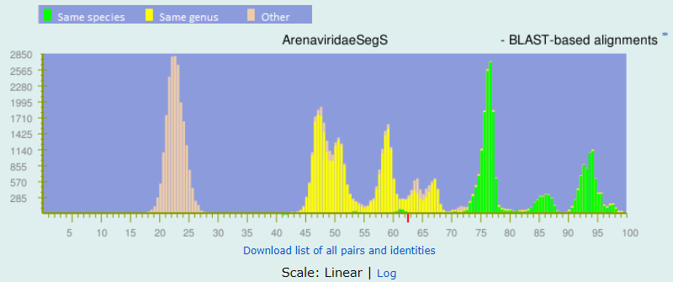

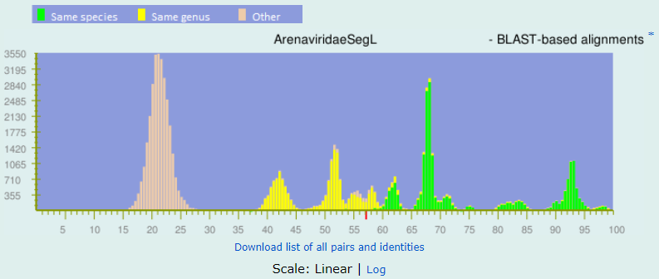
Figure 1. PASC analysis of S and L segments from Xapuri virus.

XAPV is the first mammarenavirus detected in Musser’s neacomys, the only mammarenavirus isolated from Acre State, and the fourth from the Brazilian Amazon (Pinheiro et al. 1977, Fernandes et al 2018a). Furthermore, the sequence of this virus also meets the nucleoprotein aa sequence identities and PASC requirements detailed by the ICTV as being novel; thus, we named it XAPV (Xapuri - portuguese pronunciation: [ʃapuˈɾi]) after the municipality where it was detected. The city is located between two rivers; accordingly, we believe the name is suitable for XAPV’s genetic characteristics, standing as it does between Clade B and Clade C New World mammarenaviruses.

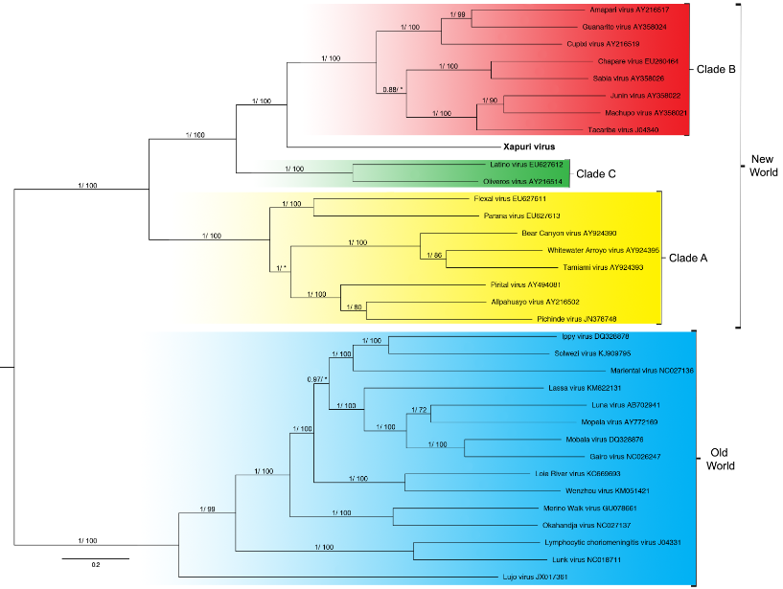
Figure 2. Phylogenetic tree based on the mammarenavirus complete L segments, with ML and Bayesian methods, using the evolutionary model GTR + G + l. Numbers (≥0.7/≥70) above branches indicate node probabilities or bootstrap values (MrBayes/ML). Asterisks indicate values below 0.7/70. Sequences from this study are highlighted in bold.

Figure 3. Phylogenetic tree based on the mammarenavirus complete S segments, with ML and Bayesian methods, using the evolutionary model GTR + G + l. Numbers (≥0.7/≥70) above branches indicate node probabilities or bootstrap values (MrBayes/ML). Asterisks indicate values below 0.7/70. Sequences from this study are highlighted in bold.

Figure 4. Phylogenetic trees based on the complete NP, GPC, Z, and L mammarenavirus proteins, using ML and Bayesian methods, (Z protein) complete Z, using the evolutionary model RtREV + G + I, complete L, GPC and NP proteins, using the evolutionary model LG + G + I, evolutionary model. Numbers (≥0.7/≥70) above branches indicate node probabilities or bootstrap values (MrBayes/ML). Asterisks indicate values below 0.7/70. †Exhibited a difference between ML and MrBayes tree-building method topologies. Sequences from this study are highlighted in bold.

References:
Fernandes J, et al. Detection of Latino virus (Arenaviridae: Mammarenavirus) naturally infecting Calomys callidus. Acta Trop. 2018a;179:17–24.

Fernandes J, et al. Xapuri virus, a novel mammarenavirus: natural reassortment and
increased diversity between New World viruses. Emerg Microbes Infect. 2018b; 7(1):120.

Pinheiro F, Webber JP, Da Rosa Travassos APA. Studies of arenaviruses in Brazil. Med. (B. Aires) 1977;37:175–181.

Radoshitzky SR, et al. Past, present, and future of arenavirus taxonomy. Arch. Virol. 2015;160:1851–1874. doi: 10.1007/s00705-015-2418-y.

Salvato, M. S. et al. in Taxonomy, Eighth report of the International Committee on Taxonomy of Viruses (eds Van Regenmortel, M. H. V. et al.) (Academic Press, New York, 2005).

