
This form should be used for all taxonomic proposals. Please complete all those modules that are applicable.
For guidance, see the notes written in blue and the separate document “Help with completing a taxonomic proposal”

Please try to keep related proposals within a single document.

Part 1: TITLE, AUTHORS, etc

Code assigned: | 2017.006M |  |  |  | (to be completed by ICTV officers)
Short title: Megataxonomy of negative-sense RNA viruses
Modules attached  (Modules 1, 4 and either 2 or 3 are required. |  | 1 2 3 4
Author(s):
Wolf, Yuri; wolf@ncbi.nlm.nih.gov
Krupovic, Mart; mart.krupovic@pasteur.fr
Zhang, Yong Zhen; zhangyongzhen@icdc.cn
Maes, Piet; piet.maes@kuleuven.be
Dolja, Valerian: valerian.dolja@nih.gov
Koonin, Eugene V.; koonin@ncbi.nlm.nih.gov
Kuhn, Jens H.; kuhnjens@mail.nih.gov
Corresponding author with e-mail address:
Jens H. Kuhn, kuhnjens@mail.nih.gov
List the ICTV study group(s) that have seen this proposal:
A list of study groups and contacts is provided at http://www.ictvonline.org/subcommittees.asp . If in doubt, contact the appropriate subcommittee chair (there are six virus subcommittees: animal DNA and retroviruses, animal ssRNA-, animal ssRNA+, fungal and protist, plant, bacterial and archaeal) |  |  | ICTV Arenaviridae, Bornaviridae, Bunyaviridae, Emaravirus, Filoviridae, Mononegavirales, Nyamiviridae, Ophioviridae, Orthomyxoviridae, Paramyxoviridae, Rhabdoviridae, Tenuivirus, and Tospovirus Study Groups
ICTV Study Group comments (if any) and response of the proposer:
Date first submitted to ICTV: |  |  |  | June 8, 2017
Date of this revision (if different to above): |  |  |  | August 21, 2017

ICTV-EC comments and response of the proposer:

Part 2: PROPOSED TAXONOMY
Present the proposed new taxonomy on accompanying spreadsheet
Name of accompanying spreadsheet: 2017.006M.N.v1.Negarnaviricota
Please display the taxonomic changes you are proposing on the accompanying spreadsheet module 2017_TP_Template_Excel_module. Submit both this and the spreadsheet to the appropriate ICTV Subcommittee Chair.

Part 4: APPENDIX: supporting materialadditional material in support of this proposal
Negative-sense RNA viruses, informally grouped in “Baltimore Class V” (1), are currently officially classified into the orders Bunyavirales and Mononegavirales, the unassigned families Arenaviridae, Ophioviridae, and Orthomyxoviridae, and the unassigned genus Deltavirus (https://talk.ictvonline.org/taxonomy/). In addition, numerous novel negative-sense RNA viruses have been described recently. These viruses either fall into existing taxa or appear to require the establishment of new taxa at ranks of order or higher (“chǔviruses”, “qínviruses”, and “yuèviruses”) or at the family level or lower (numerous) (2, 3). With the exception of hepatitis D virus (the sole member of the genus Deltavirus) and possibly some “chǔviruses”, all negative-sense RNA viruses possess mostly linear (segmented or non-segmented) genomes and can be phylogenetically linked via their RNA-dependent RNA polymerase (RdRp, L) core domains. Here we propose to unify all negative-sense RNA viruses, with the exception of hepatitis D virus, into a high-rank taxon at the level of “phylum” to replace the unofficial Baltimore Class. We base this proposal on several previous studies demonstrating the monophyly of various subsets of negative-sense RNA viruses (2-4) and on a global phylogenetic analysis of RdRp core domains of all major RNA virus clades represented in GenBank (Figure 1).

Figure 1. Global RNA virus phylogenetic tree based on a complete alignment of the conserved polymerase palm (core) domains in a non-redundant (at ≈90% identity level) set of ≈5,000 RNA-dependent RNA polymerases of positive-sense RNA viruses, negative-sense RNA viruses, and dsRNA viruses as well as reverse transcriptases from group II bacterial introns and non-LTR retroelements. Sequences of the core domains were extracted from the NCBI RefSeq database (5) and clustered using UCLUST (6) with a similarity cutoff of 0.5. The median length of the individual palm domain sequences included in this analysis was 476 aa. Poorly aligned sections were trimmed, hence the alignment that was used infer the phylogenetic tree ultimately contained 274 aligned positions. For the negative-sense RNA virus subtree (Figure 2), the respective numbers are 442 aa and 371 aa. Sequences within clusters were aligned using the MUSCLE program (7) and aligned further using the following iterative procedure: First, all alignments and single sequences were converted to HMM profiles and an all-against-all search was performed using the HHSEARCH toolkit (8). HHSEARCH scores for profile-profile alignments covering at least 2/3 of the sequence length were used to construct a UPGMA tree (9). Shallow tips of the tree were used to guide pairwise profile-profile alignments using the HHALIGN program (8). The resulting alignments were used in the next round of HHSEARCH comparison, and the process was repeated until all ≈5,000 sequences were aligned. Sites with a large fraction of gaps (>50%) and low homogeneity (<0.1) were removed from the resulting alignment, and an approximate Maximum likelihood tree was constructed using the FastTree (10) with the WAG evolutionary model and gamma-distributed site rates. The sequence set was split into tree-defined clades, followed by a repeat of the alignment procedure within each clade separately and then between the clades. The final tree was reconstructed using the same procedure. Pink: negative-sense RNA viruses (proposed phylum; bootstrap support value 0.99), with two clearly separated subphyla (bootstrap support values 0.89 and 0.90, respectively). Black: all other RNA viruses and retroelements.

The global phylogenetic analysis shown in Figure 1 validates the long-suspected monophyly of negative-sense RNA viruses and confirms the basic composition of major established negative-sense RNA virus taxa (orders and families), as well as of newly proposed taxa (other 2017 TaxoProps) (Figure 2). Most importantly, the phylogenetic tree shows that the strongly supported clade encompassing all negative-sense RNA viruses can be confidently divided into two major subclades: Subclade 1 includes viruses of the order Bunyavirales together with the families Arenaviridae, Orthomyxoviridae, and the unassigned genus Tilapinevirus. Subclade 2 includes viruses of the order Mononegavirales, the family Ophioviridae, and the recently identified “chǔviruses”, “qínviruses”, and “yuèviruses”. As the highest officially recognized rank used, at present, for negative-sense RNA viruses is that of “order” (Bunyavirales, Mononegavirales), a higher rank (or ranks) will have to be introduced to reflect the evolutionary relationships between the two orders as well as with the other groups of negative-sense RNA viruses. The next higher available principal rank would be “class”. However, the present analysis confirmed a clear sister relationship between mononegaviruses and the unclassified and uncultivated “chǔviruses” (2, 3). Consequently, “chǔviruses” should form a new order and be united with mononegaviruses in a class that is then united with the remaining viruses. We therefore propose to unite negative-sense RNA viruses in a phylum including two subphyla. Subphylum 1 would include two classes, one for the emended order Bunyavirales+Arenaviridae, and another one including an order unifying two families: one for Orthomyxoviridae and one for Tilapinevirus. Subphylum 2 would include 4 classes: one for the two orders Mononegavirales + “chǔviruses”, one for Ophioviridae, one for “qínviruses”, and one for “yuèviruses”. Because “chǔviruses”, “qínviruses”, and “yuèviruses” are not yet characterized beyond the sequence level (Figure 3), we propose to create only a single monogeneric family in each taxon including individual species for each currently known member virus that is represented in GenBank with a (presumably) coding-complete genome.
This proposal, if accepted, will replace the currently unofficial but heavily used “Baltimore Class V” with an official phylum, with a ranking structure loose enough to accommodate future virus discoveries. An outline of the proposed taxonomy is shown in Figure 4.

Figure 2. Same tree as in Figure 1 magnified for negative-sense RNA viruses.

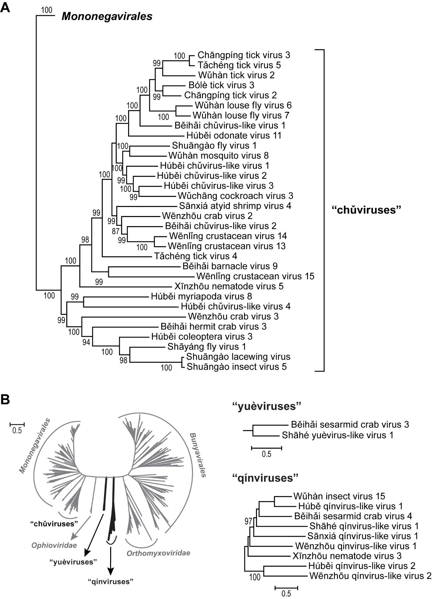
Figure 3. Maximum likelihood phylogeny of RdRp domain of negative-sense RNA viruses as described in (3). A) “Chǔvirus” diversity. Note that additional chǔviruses have been discovered since the initial description in (3), in particular Imjin River virus 1, lonestar tick chǔvirus 1, and Suffolk virus. B) “Qínvirus” and “yuèvirus” diversity.

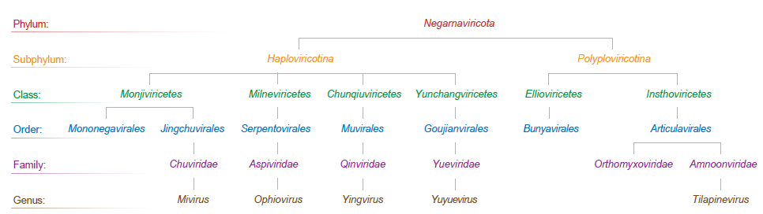
Figure 4. Summary of the proposed phylum taxonomy.

Etymology of proposed taxon names:
- Amnoonviridae: Amnoon: Hebrew אַמְנוּן for tilapia; viridae: suffix for a family
- Articulavirales: Articula: from Latin articulata (segmented); virales: suffix for an order
- Aspiviridae: Aspi from Latin aspis “viper, snake”, resembling the morphology of virions; viridae: suffix for a family
- Ellioviricetes: Ellio: a contraction of Elliott (Richard), the late pioneer of bunyavirus molecular virology; viricetes: suffix for a class
- Haploviricotina: Haplo from Ancient Greek ἁπλόος for “simple”; viricotina: suffix for a subphylum
- Chunqiuviricetes: Chunqiu for Chūnqiū Shídài (春秋时代) = Spring and Autumn Period in which Qín and Yuè were states; viricetes: suffix for a class
- Chuviridae: Chu after the ancient Chinese Chǔ (楚) State during the Spring and Autumn Period; viridae: suffix for a family
- Goujianvirales: Goujian: Gōujiàn (勾踐) was the king of Yuè State, the ancient state during the Spring and Autumn Period; virales: suffix for an order
- Insthoviricetes: Instho: contraction of influenza, isa, thogoto; viricetes: suffix for a class
- Jingchuvirales: Jingchu: Jīngchǔ (荆楚)) is a synonym for Chǔ (楚) in Chinese
- Mivirus: Mi: Mǐ (芈) is the ancestral name of King Zhuang of Chǔ State during the Spring and Autumn Period; virus: suffix for a genus
- Milneviricetes: Milne was last author of first paper describing ophioviruses; viricetes: suffix for a class
- Monjiviricetes: Monji: contraction of Mononega and Jingchu; viricetes: suffix for a class
- Muvirales: Mu: Mù (穆) was the Duke of Qín, the ancient state during the Spring and Autumn Period; virales: suffix for an order
- Negarnaviricota: Nega from Latin negative; rna for RNA; viricota: suffix for a phylum
- Polyploviricotina: Polyplo from Ancient Greek πολύπλοκος for “complex”; viricotina: suffix for a subphylum
- Qinviridae: Qin after the ancient Chinese Qín (秦) State during the Spring and Autumn Period; viridae: suffix for a family
- Serpentovirales: Serpento for the serpent-like appearance of virions; virales: suffix for an order
- Yingvirus: Ying: Yíng ((嬴) was the ancestral name of Mù, the Duke of the ancient Qín State during the Spring and Autumn Period; virus: suffix for a genus
- Yueviridae: Yue after the ancient Chinese Yuè (越) State during the Spring and Autumn Period; viridae: suffix for a family
- Yunchangviricetes: Yunchang: Yǔncháng (允常) was the father of Gōujiàn, the King of Yuè, the ancient state during the Spring and Autumn Period; viricetes: suffix for a class
- Yuyuevirus: Yuye: Yúyuè (於越) is a synonym for Yuè, the ancient Chinese State during the Spring and Autumn Period; virus: suffix for a genus.

References:
1. Baltimore D. 1971. Expression of animal virus genomes. Bacteriol Rev 35:235-241.
2. Li CX, Shi M, Tian JH, Lin XD, Kang YJ, Chen LJ, Qin XC, Xu J, Holmes EC, Zhang YZ. 2015. Unprecedented genomic diversity of RNA viruses in arthropods reveals the ancestry of negative-sense RNA viruses. Elife 4:e05378.
3. Shi M, Lin XD, Tian JH, Chen LJ, Chen X, Li CX, Qin XC, Li J, Cao JP, Eden JS, Buchmann J, Wang W, Xu J, Holmes EC, Zhang YZ. 2016. Redefining the invertebrate RNA virosphere. Nature 540:539-543.
4. Tordo N, Poch O, Ermine A, Keith G, Rougeon F. 1988. Completion of the rabies virus genome sequence determination: highly conserved domains among the L (polymerase) proteins of unsegmented negative-strand RNA viruses. Virology 165:565-576.
5. O'Leary NA, Wright MW, Brister JR, Ciufo S, Haddad D, McVeigh R, Rajput B, Robbertse B, Smith-White B, Ako-Adjei D, Astashyn A, Badretdin A, Bao Y, Blinkova O, Brover V, Chetvernin V, Choi J, Cox E, Ermolaeva O, Farrell CM, Goldfarb T, Gupta T, Haft D, Hatcher E, Hlavina W, Joardar VS, Kodali VK, Li W, Maglott D, Masterson P, McGarvey KM, Murphy MR, O'Neill K, Pujar S, Rangwala SH, Rausch D, Riddick LD, Schoch C, Shkeda A, Storz SS, Sun H, Thibaud-Nissen F, Tolstoy I, Tully RE, Vatsan AR, Wallin C, Webb D, Wu W, Landrum MJ, Kimchi A, Tatusova T, DiCuccio M, Kitts P, Murphy TD, Pruitt KD. 2016. Reference sequence (RefSeq) database at NCBI: current status, taxonomic expansion, and functional annotation. Nucleic Acids Res 44:D733-745.
6. Edgar RC. 2010. Search and clustering orders of magnitude faster than BLAST. Bioinformatics 26:2460-2461.
7. Edgar RC. 2004. MUSCLE: a multiple sequence alignment method with reduced time and space complexity. BMC Bioinformatics 5:113.
8. Soding J. 2005. Protein homology detection by HMM-HMM comparison. Bioinformatics 21:951-960.
9. Sokal R, Michener C. 1958. A statistical method for evaluating systematic relationships. Univ Kansas Sci Bull 38:1409–1438.
10. Price MN, Dehal PS, Arkin AP. 2010. FastTree 2--approximately maximum-likelihood trees for large alignments. PLoS One 5:e9490.

Annex:
Please explain the reasons for the taxonomic changes you are proposing and provide evidence to support them. The following information should be provided, where relevant:
- Species demarcation criteria: Explain how new species differ from others in the genus and demonstrate that these differences meet the criteria previously established for demarcating between species. If no criteria have previously been established, and if there will now be more than one species in the genus, please state the demarcation criteria you are proposing.
- Higher taxa:
  - There is no formal requirement to state demarcation criteria when proposing new genera or other higher taxa. However, a similar concept should apply in pursuit of a rational and consistent virus taxonomy.
  - Please indicate the origin of names assigned to new taxa at genus level and above.
  - For each new genus a type species must be designated to represent it. Please explain your choice.
- Supporting evidence: The use of Figures and Tables is strongly recommended (note that copying from publications will require permission from the copyright holder). For phylogenetic analysis, try to provide a tree where branch length is related to genetic distance.

In this proposal, we adhere to the Rules used in many other taxonomies, including BioCode. Accordingly, filling the primary/principal ranks (kingdom, phylum, class, order, family and genus, and species) is non-optional, meaning that each taxon included within the proposed phylum has to be simultaneously ascribed to all included principal ranks.

