

The International Committee on Taxonomy of Viruses
Taxonomy Proposal Form, 2025

Part 1a: Details of taxonomy proposals

Title: | Abolition of a subfamily, establishment of four new subfamilies and classifying 39 new species in the Parvoviridae family
Code assigned: | 2025.005D.Ac.v4.Parvoviridae_1absf_4nsf_39ns

Author(s), affiliation and email address(es):
Given name (+middle initial(s)) | Surname | Affiliation | Email address | Corr. author(s)
Judit J | Penzes | Department of Entomology, Texas A&M University, College Station, TX, USA | Judit.penzes@ag.tamu.edu | X
Marta | Canuti | Department of Veterinary and Animal Sciences, University of Copenhagen, Denmark | marta.canuti@gmail.com
Maria | Söderlund-Venermo | Department of Virology, University of Helsinki, Finland | maria.soderlund-venermo@helsinki.fi
Sarah | Francois | DGIMI, Univ Montpellier, INRAE, Montpellier, France | sarah.francois@inrae.fr
Peter | Tijssen | INRS Armand-Frappier Santé Biotechnologie Research Centre, Laval, QC Canada | tijssenpc@gmail.com
Jianming | Qiu | Department of Microbiology,  Molecular Genetics and Immunology  University of Kansas Medical Center | jqiu@kumc.edu
Anna M | Eis-Hübinger | Institute of Virology, University Hospital Bonn, Germany | anna-maria.eis-huebinger@ukbonn.de

Part 1b: Taxonomy Proposal Submission
ICTV Subcommittee:
Animal DNA Viruses and Retroviruses | X | Bacterial viruses
Animal minus-strand and dsRNA viruses |  | Fungal and protist viruses
Animal positive-strand RNA viruses |  | Plant viruses
Archaeal viruses |  | General -

List the ICTV Study Group(s) that have seen or have been involved in creating this proposal:
Parvoviridae SG

Optional – complete only if formally voted on by an ICTV Study Group:
Study Group | Number of members
Study Group | Votes in support | Votes against | No vote

Submission date: | 07/06/2025

Part 1c: Feedback from ICTV Executive Committee (EC) meeting
Executive Committee Meeting Decision code: | X
A – Accept
Ac – Accept subject to revision by relevant subcommittee chair. No further vote required | X
U – Accept without revision but with re-evaluation and email vote by the EC
Uc – Accept subject to revision and re-evaluation and email vote by the EC
Ud – Deferred to the next EC meeting, with an invitation to revise based on EC comments
J - Reject
W - Withdrawn

Comments from the Executive Committee:
AV requests Ac: for JP to double-check some of the changes and edits that were requested from the SCC

Part 1d: Revised Taxonomy Proposal Submission
Response of proposer:
Revision date:

Part 2: GENERAL PROPOSAL

Abstract for General Proposal:
Brief description of current situation:

Proposed changes:

Justification:

Text of General Proposal:
Background:

Proposed changes:

Justification:

References:

Accompanying files:
Filename | Description of contents

Tables, Figures:
<Start here>

Part 3: TAXONOMIC PROPOSAL
https://ictv.global/taxonomy/templates
Taxonomic changes proposed:
Establish new taxon | X | Split taxon
Abolish taxon | X | Merge taxon
Move taxon |  | Promote taxon
Rename taxon |  | Demote taxon
Move and rename | X

Etymology (origin) of proposed taxonomic names:
Taxon name | Etymology of the term
Hamavirinae | Hama – together in ancient Greek. This is the only currently known lineage of the Parvoviridae to be associated with both vertebrate and invertebrate hosts, hence called “together”
Penbrevirinae | Portmanteau of the first syllables of the two former genus names included, Penstylparvovirus and Brevihamaparvovirus (proposed Shripenbrevirus and Brevipenbrevirus)
Hepanvirinae | Hepan – from Latin “hepar” for liver. Members of this proposed monotypic subfamily are noted for their hepatopancreatic tropism
Metallovirinae | Penaeus monodon metallodensovirus, the only member of this proposed subfamily, possesses a metal ion-driven endosomal egress mechanism
Ichthamavirus | Ichthys – Greek for fish. All members thus far derive from fish hosts within this genus
Chaphamavirus | Chap – acronym of the first letters of the three host names in which these viruses were first detected, i.e. Chiropteran, avian, porcine.
Embehamavirus | The only member of this proposed genus was derived from the passerine bird Emberiza chrysophrys.
Coluhamavirus | From Columbiformes, the order of pigeons and doves. The host of the single member of this monotypic genus is a dove.
Protohepanvirus | Proto - first. This is the first genus within its subfamily
Protometallovirus | Proto - first. This is the first genus within its subfamily
Shripenbrevirus | Shri - from English “shrimp”. Members of this genus infect various species of penaeid shrimp.

Permission for use of names derived from a living person:
Taxon name | Full name of person from whom the name is derived | Attached

Abstract of Taxonomy Proposal:
Taxonomic rank(s) affected:
Subfamily, genus, species

Description of current taxonomy:
The Parvoviridae is currently composed of three subfamilies. Two of these, the Parvovirinae and the Densovirinae, are clearly monophyletic and are united by biological synapomorphies. The subfamily Hamaparvovirinae was established in 2019, albeit even at that time it was regarded as an extremely heterogenous subfamily, especially in comparison to the other two subfamilies. This heterogeneity has now matured to be characterized in more detail and recognize the individual lineages it has been keeping together.

Proposed taxonomic change(s):
Here, we suggest the abolition of the subfamily Hamaparvovirinae and the establishment of three subfamilies in its wake, designated Hamavirinae, Penbrevirinae, encompassing two of the current Hamaparvovirinae genera each, and the monotypic Hepanvirinae. We also propose the elevation of the currently floating genus, Metalloincertoparvovirus, to the subfamily rank, with a single monotypic genus. Furthermore, we propose the establishment of two new monotypic genera within the newly founded Hamavirinae, which would be called Embehamavirus and Coluhamavirus, respectively. Lastly, we propose the establishment of 36 new species in the newly established Chaphamavirus genus and one new species within the Diciambidensovirus genus of the Densovirinae subfamily. We will also retrospectively apply the binomial nomenclature to the Miniambidensovirus species, containing Acheta domesticus mini ambidensovirus.

Justification:
The proposed changes will result in six monophyletic subfamilies within the Parvoviridae, which are also supported with biological traits, including their non-structural and structural protein sequence homology, virion surface morphology and structural protein fold. Furthermore, this classification system will create a more flexible framework, which has the capability of adopting future novel divergent entries.

- Text of Taxonomy proposal:

Taxonomic rank(s) affected:
Subfamily, genus, species

Description of current taxonomy:
The Parvoviridae is currently composed of three subfamilies. Two of these, the Parvovirinae and the Densovirinae, are clearly monophyletic and harbor members of exclusively vertebrate and invertebrate animal host origin, respectively [2]. Their monophyly is supported not only by SF3 helicase-based phylogenetic evidence, but also by sequence-based homology of their NS and VPs, along with similar virion surface morphology and fold architecture of their subunit shell domains [1-3]. The third subfamily, the Hamaparvovirinae, is of heterogenous host affiliation and was established to accommodate parvoviruses, which (i) clustered as a monophyletic branch based on their SF3 helicase domains, (ii) exhibited a clearly distinct genome organization and capsid structure from that of the Densovirinae or the Parvovirinae, (iii) displayed a primary absence of the canonical PLA2 domain, and (iv) their capsid subunits lacked additional βA strands and N-terminal extensions to their luminal BDIG sheets of the jelly roll core [2]. The Hamaparvovirinae currently unites the genera Brevivirus, Chapvirus, Hepanvirus, Ichtvirus, and Penstylhamaparvovirus. However, it was apparent even at the time of its establishment that this subfamily is extremely heterogenous and encompasses several clearly distinct lineages. Consequently, as more biological evidence was expected to gather on these lineages, the Hamaparvovirinae was bound to become outdated and obsolete.

Proposed taxonomic change(s):
- Abolition of the Hamaparvovirinae subfamily
- Establishment of four new subfamilies:
1. Establish a new subfamily Hamavirinae with four genera
a. Move genus Chaphamaparvovirus (currently within the Hamaparvovirinae) to the proposed Hamavirinae as genus Chaphamavirus
- concurrently moving the 37 species included in the genus
b. Move genus Ichtchaphamaparvovirus (currently within the Hamaparvovirinae) to the proposed Hamavirinae as genus Ichthamavirus
- concurrently moving the 1 species included in the genus
c. Establish a new genus - Embehamavirus - within the proposed Hamavirinae subfamily with one species:
- Emberiza chrysophrys MAG ybb150par04 as species Embehamavirus passeriform1 with 32% NS1 identity and 40% query coverage to Chaphamavirus ungulate1 (current Chaphamaparvovirus ungulate1) of the same subfamily. This virus was derived from the wild bird cloacal metavirome in a virus discovery study of Chinese birds [4]
d. Establish a new genus - Coluhamavirus - within the proposed Hamavirinae subfamily with one species:
- Streptopelia turtur MAG zfwcb07par1 as species Coluhamavirus columbiform1 with 33% NS1 identity and 55% query coverage on Chaphamavirus primate1 (current Chaphamaparvovirus primate1). This virus is derived from the same study as the previous entry [4]
2. Establish a new subfamily, the Penbrevirinae, with two genera:
a. Move genus Penstylhamaparvovirus as genus Shripenbrevirus to the proposed subfamily Penbrevirinae
- concurrently moving the one species currently in the genus
b. Move genus Brevihamaparvovirus to the proposed subfamily Penbrevirinae as genus Brevipenbrevirus
- concurrently moving the three species currently in the genus
3. Establish a new subfamily, the Hepanvirinae, with one genus:
a. Move genus Hepanhamaparvovirus to the proposed subfamily Hepanvirinae as genus Protohepanvirus
- concurrently moving the one species currently in the genus
4. Establish a new subfamily, the Metallovirinae, with one species
a. Move the floating genus Metalloincertoparvovirus to the proposed subfamily Metallovirinae as genus Protometallovirus
- concurrently moving the one species currently in the genus

- Establishment of 33 new species within the newly moved genus Chaphamavirus in the new subfamily Hamavirinae
1. The following viral sequences were published by Shan et al., 2022 [4] and were derived from a comprehensive bird metagenomic study, sampling the cloacal virome of 10 bird orders in China. All these viruses demonstrate over 95% query coverage of the NS1 protein sequence to the representative of the species with the highest NS1 protein sequence identity. The most identical virus species to the proposed new species are also listed under their new proposed names, which they will receive if this TP is accepted.

- Egretta garzetta MAGzftegr01par2 as species Chaphamavirus pelecaniform1 with 49.02% NS1 protein sequence identity to Chaphamavirus galliform4 of the same genus
- Pavo cristatus MAG xftpec96par1 as species Chaphamavirus galliform8 with 43.41%NS1 protein sequence identity to Chaphamavirus galliform4 of the same genus
- Tadorna ferruginea MAG xftots60par1nc as species Chaphamavirus anseriform7 with 51.73% NS1 protein sequence identity to Chaphamavirus galliform4 of the same genus
- Anser albifrons MAG cftwhg05par1as species Chaphamavirus anseriform8 with 47.25% NS1 protein sequence identity to Chaphamavirus anseriform6 of the same genus
- Anser albifrons MAG cftwhg09par1nc as Chaphamavirus anseriform9 with 70% NS1 protein sequence identity to Chaphamavirus anseriform2 of the same genus
- Anser indicus MAG zftwig06par1 as Chaphamavirus anseriform10 with 61.16% NS1 protein sequence identity to Chaphamavirus anseriform2 of the same genus
- Anser albifrons MAG cftwhg07par1 as Chaphamavirus anseriform11 with 43.61% NS1 protein sequence identity to Chaphamavirus anseriform6 of the same genus
- Fringilla montifringilla MAG MT138217 as Chaphamavirus passeriform1 with 79.31% NS1 protein sequence identity to Chaphamavirus galliform4 of the same genus
- Carpodacus erythrinus MAG rfi063par2 as Chaphamavirus passeriform2 with 47.62% NS1 protein sequence identity to Chaphamavirus galliform4 of the same genus
- Luscinia sibilans MAG rtr167par1 as Chaphamavirus passeriform3 with 46.88% NS1 protein sequence identity to Chaphamavirus galliform4 of the same genus
- Turdus naumanni MAG thr146par1 as Chaphamavirus passeriform4 with 45.98% NS1 protein sequence identity to Chaphamavirus strigiform1 of the same genus
- Fringilla montifringilla MAG brb024par1 as Chaphamavirus passeriform5 with 45.78% NS1 protein sequence identity to Chaphamavirus galliform4 of the same genus
- Emberiza chrysophrys MAG ybb150par03 as Chaphamavirus passeriform6 with 45.45% NS1 protein sequence identity to Chaphamavirus galliform4 of the same genus
- Luscinia cyanura MAG rfb200par2 as Chaphamavirus passeriform7 with 46.72 % NS1 protein sequence identity to Chaphamavirus galliform3 of the same genus
- Coccothraustes coccothraustes MAG hwf061par1 as Chaphamavirus passeriform8 with 50.15% NS1 protein sequence identity to Chaphamavirus psittacine2 of the same genus
- Cecropis daurica MAG swa134par2 as Chaphamavirus passeriform9 with 51.18% NS1 protein sequence identity to Chaphamavirus psittacine2 of the same genus
- Phoenicurus auroreus MAG dar170par1 as Chaphamavirus passeriform10 with 51.24% NS1 protein sequence identity to Chaphamavirus galliform4 of the same genus
- Emberiza pusilla MAG lib042par1 as Chaphamavirus passeriform11 with 52% NS1 protein sequence identity to Chaphamavirus psittacine2 of the same genus
- Emberiza pusilla MAG rbu036par2 as Chaphamavirus passeriform12 with 48.51% NS1 protein sequence identity to Chaphamavirus psittacine2 of the same genus
- Emberiza rustica MAG rbu036par1 as Chaphamavirus passeriform13 with 50.67% NS1 protein sequence identity to Chaphamavirus psittacine2 of the same genus
- Emberiza pusilla MAG lib043par1 as Chaphamavirus passeriform14 with 51.10% NS1 protein sequence identity to Chaphamavirus psittacine2 of the same genus
- Tarsiger cyanurus MAG rfb199par1 as Chaphamavirus passeriform15 with 51% NS1 protein sequence identity to Chaphamavirus psittacine2 of the same genus
- Aegithalos caudatus MAG ltt163par3 as Chaphamavirus passeriform16 with 50.68% NS1 protein sequence identity to Chaphamavirus psittacine2 of the same genus
- Cercopis daurica MAG swa134par1 as Chaphamavirus passeriform17 with 50.44% NS1 protein sequence identity to Chaphamavirus psittacine2 of the same genus
- Psittacidae MAG par083par2 as Chaphamavirus psittacine3 with 51.18% NS1 protein sequence identity to Chaphamavirus galliform4 of the same genus
- Grus vipio MAG wftcra79par2 as Chaphamavirus gruiform5 with 44.66% NS1 protein sequence identity to Chaphamavirus gruiform1 of the same genus
- Egretta garzetta MAG zftegr01par1 as Chaphamavirus pelicaniform2 with 51.73% NS1 protein sequence identity to Chaphamavirus galliform4 of the same genus
- Grus grus MAG wftcra74par2 as Chaphamavirus gruiform6 with 54.04 % NS1 protein sequence identity to Chaphamavirus gruiform4 of the same genus

2. Bat parvovirus BtPV/CMR/2014 as Chaphamavirus chiropteran3. It was detected in the fecal virome of Cameroonian fruit bats (Eidolon helvum) [5]. The NS1 protein sequence is 63.3% identical with 100% coverage to that of Chaphamavirus carnivoran1.

3. Psittaciform chaphamaparvovirus 3 strain S9/AU as Chaphamavirus psittacine4. It was detected in the liver tissue of the little corella parrot (Cacatua sanguinea) [6]. Its NS1 protein sequence is 78.69% identical with 100% coverage to that of Chaphamavirus psittacine2

4. Hedgehog chapparvovirus as Chaphamavirus eulipotyphla1. It was detected as the potential pathogenic agent of an enteritis outbreak in European hedgehogs (Erinaceus europaeus) in Italy [7]. Its NS1 protein sequence is 61.88% identical with 100% coverage to that of Chaphamavirus rodent1

5. The following two viruses were collected from the high-altitude fecal virome of dogs in Tibet [8].
- Canine parvovirus isolate ParvoviridaeDogfe339C1 as Chaphamavirus carnivoran4 with 42.59% NS1 protein sequence identity to Chaphamavirus ungulate1 of the same genus with 99% coverage
- Canine parvovirus isolate ParvoviridaeDogfe355C1 as Chaphamavirus carnivoran5 with 54.29% NS1 protein sequence identity to Chaphamavirus rodent2 of the same genus with 100% coverage

6. Bearded dragon chapparvovirus as Chaphamavirus squamatid1. This virus was derived from metagenomics involving Australian bearded dragons (Pogona vitticeps), which died of respiratory distress [9] and displays 34.75% NS1 identity with 91% coverage to Chaphamavirus perciform1.

- Establishment of a new species in the moved Brevipenbrevirus genus of the proposed Penbrevirinae subfamily
1. Soybean thrips denso-like virus 1 as Brevipenbrevirus thysanopteran1. It was detected in a metagenomic virus discovery study of the soybean thrips virome [10] and its NS1 protein sequence displays 36.91% identity on 94% coverage with the Brevipenbrevirus dipteran1 members of the same genus.

- Establishment of a new species in the Diciambidensovirus genus of the Densovirinae subfamily
1. Parvoviridae sp. isolate rtr168par1 as Diciambidensovirus incertum2. It was detected in Chinese bird cloacal metagenomes [4] and displays 32.26% identity on 77% coverage with the species Diciambidensovirus hemipteran1 with strong monophyletic clustering into the genus, despite the otherwise low sequence identity.

- Applying the parvovirus binomial nomenclature, established in 2022, to Orthopteran miniambidensovirus 1, renaming it to Miniambidensovirus orthopteran1.

Members of the family Parvoviridae are ssDNA viruses with linear genomes, which are flanked by partially double-stranded, often complex, DNA secondary structures [1]. The viral genome consists of two major expression cassettes, each encoding a varied number of non-structural (NS) or structural (VP) proteins [1]. Canonically, the largest NS that includes an ~140-aa-long superfamily 3 (SF3) helicase domain in its protein sequence is designated as NS1 [1, 2]. Throughout the entire family, the SF3 helicase domain is the only region to exhibit protein sequence homology, hence only this domain can be utilized to reconstruct family-wide phylogenies, which is the basis of parvovirus taxonomy [2]. The parvovirus virion is non-enveloped and is composed of 60 identical VP shell domains, assembling a capsid of T=1 icosahedral symmetry. The VPs can be completely identical and extended by the same, mostly disordered, N-terminal domains throughout the capsid or can comprise minor capsid proteins with various N-terminal extensions [3]. Despite the absence of protein sequence-level homology, the VP shell exhibits a conserved basic structural fold throughout the family, i.e., long surface loops linking the β-strands of an eight-stranded jelly-roll core [3].

Demarcation criteria:

Virus definition:
For an agent to be classified in the family Parvoviridae, it must be judged to be an authentic parvovirus on the basis of having been sequenced from tissues, secretions, or excretions of its possible host or, failing this, from an additional biological source when the true viral host identity remains unknown. All such sequences must be reported in a credible peer-reviewed publication, in which insights into their host and biology, such as genome annotation, transcription strategy, epidemiology, serology, structure, trafficking, replication and evolution, are strongly encouraged. The sequence must contain the complete coding region of the large nonstructural protein (NS1), which must possess an SF3 helicase domain in its protein sequence, as well as the viral structural protein (VP) coding regions. If the genome is multipartite, evidence must be presented to confirm that these are indeed multiple genome segments of the same viral genome (e.g., corresponding termini, experimental evidence of concurrent replication). If additional ORFs are present in the sequenced genomes, the sequence must still meet the size constraints and/or motif patterns typical of the family (e.g., absence of a type-B DNA polymerase-encoding gene). Sequences derived from cDNA-based metatranscriptomes can be accepted only if a DNase treatment was not performed prior to reverse transcription and it is presumed that sequences originated from viral DNA. In case a presumed host cannot be assigned, the ambiguous host assignment must be indicated in species level nomenclature (indicating ‘incertum’ in the species specific epithet). This definition is designed to allow the inclusion of viruses identified by virus discovery approaches, including those with an unknown host, which typically lack reliable sequences from the telomeric hairpins, while avoiding viral sequence fragments integrated into the host genomes.

Demarcation criteria and nomenclature:
Species: two parvoviruses can be potentially classified in one species if their NS1 proteins share at least 85% protein sequence identity. Species must be designated under a binomial name, consisting of the genus name, within which given virus is classified, and a specific epithet. The epithet must mirror the order level affiliation of the virus host, or in case of multiple host involvement, the lowest taxonomy unit encompassing the affected host species. Failing this, if the exact host spectrum is unknown, the epithet will be indicated as “incertum”. A number in simple Arabic numeric may be added if more species are to share the same epithet within a given genus, e.g., Copiparvovirus ungulate2.
Genus: two parvoviruses can be potentially classified in one genus if they cluster as a robust monophyletic lineage based on their complete NS1 protein sequence in case of subfamily-level phylogeny and also based on their SF3 helicase domains in case of family-wide phylogenetic inference. Additionally, their NS1 proteins should share 35-40% protein sequence identity and display a coverage of at least 80% between two members of the genus in question. Flexibility in these numbers may apply. Failing the sequence-identity-based criteria, common genus affiliation can also be justified by similar genome organization, i.e., presence or absence of certain auxiliary protein encoding genes, genome length and/or transcription strategy, provided the criterion of the well-supported monophyly is still satisfied.

Justification:

- Abolition of the Hamaparvovirinae subfamily
- Phylogenetic evidence: as the number of novel parvoviral sequences has increased in the past six years and further novel, more divergent parvoviruses have been discovered and characterized, the monophyly of the Hamaparvovirinae is not supported anymore by the SF3-based, family-wide phylogenetic calculations (Fig. 1)
- Biological evidence: while both the Densovirinae and the Parvovirinae display clearly homologous NS1 and VP1 proteins within their respective subfamilies, the Hamaparvovirinae members exhibit protein sequence homology only at the SF3 helicase level (Fig. 1, 2, 3). Initially, structural evidence was believed to unite the current Hamaparvovirinae members, as their capsid monomers appeared to unanimously lack the additional βA strand, as opposed to the members of the other two subfamilies. New structural evidence has shown that this is not the case, as all parvoviruses derive from ancestors with capsids built by simple, eight-stranded jelly-roll cores, rendering additional β strands as derived traits as a strategy to construct larger capsids while still preserving the T=1 symmetry [3, 11-14] (Fig. 4). Lastly, virion surface morphologies are heterogenous in this subfamily, as opposed to the clear synapomorphy of the Densovirinae and Parvovirinae virion surfaces (Fig. 3). Members of the current Hamaparvovirinae also possess divergent fold architectures of their subunit shell domains, unlike the significantly more homogenous Parvovirinae and Densovirinae (Figure 4B).

- Establishment of four new subfamilies
In the wake of the abolition of the Hamaparvovirinae, we observed the existence of three distinct lineages, which will comprise the following three individual subfamilies.

1. Establish the subfamily Hamavirinae with four genera
- Two genera of the current Hamaparvovirinae, namely Ichtahamaparvovirus and Chaphamaparvovirus, whose members are collectively referred to as “chapparvoviruses”—are to be united by this proposed subfamily, along with two novel bird “chapparvoviruses” [4], comprising a total of four genera.This is justified by:
- Phylogenetic evidence: the two existing genera and two proposed monotypic genera form a well-supported, monophyletic clade in an SF3 helicase-based phylogenetic reconstruction (Fig. 1)
- Biological evidence: members of all four proposed genera display clear NS1- and VP1-sequence homology (Figures 1, 2). The capsid structure of Syngnathus scovelli chapparvovirus (Ichthamavirus) and subsequent homology modeling of various proposed Hamavirinae lineages has shown that “chapparvoviruses” unanimously lack the N-terminal extensions of their VP, which is, consequently, only composed of the shell domain [14] (Fig. 4A).

a. Move genus Chaphamaparvovirus to the new subfamily Hamavirinae as genus Chaphamavirus
- see justification above
b. Move genus Ichtchaphamaparvovirus to the new subfamily Hamavirinae as genus Ichthamavirus
- see justification above
c. Establish the new genus Embehamavirus within the proposed Hamavirinae subfamily with one species, Embehamavirus passeriform1.
- Justification: this single virus sequence fulfills the demarcation criteria for establishing both a new species and a new genus to accommodate it. Its phylogenetic position, as well as NS and VP sequence homology, justify its subfamily affiliation.
d. Establish the new genus Coluhamavirus within the proposed Hamavirinae subfamily with one species, Coluhamavirus columbiform1.
- Justification: this single virus sequence fulfills the demarcation criteria for establishing both a new species and a new genus to accommodate it. Its phylogenetic position, as well as NS and VP sequence homology, justify its subfamily affiliation.

2. Establish the subfamily Penbrevirinae with two genera
a. Move genus Penstylhamaparvovirus as genus Shripenbrevirus to new subfamily Penbrevirinae
b. Move genus Brevihamaparvovirus to new subfamily Penbrevirinae as genus Brevipenbrevirus
Justification:
- Phylogenetic evidence: both genera cluster as a strong monophyletic branch in the SF3-based family-wide phylogenetic calculations (Fig.1)
- Biological evidence: the shared ancestry of these two genera have been recognized by their shared transcription strategies and genome organization [15, 16]. Although a member with a unique bipartite genome, Acheta domesticus segmented densovirus, is an exception with a divergent transcription strategy, the genome organization of its NS segment clearly reflects the NS cassette of the dipteran, and newly proposed thysanopteran brevihamaparvoviruses (proposed brevipenbreviruses) [12]. Furthermore, it also demonstrates clear NS1 and VP1 protein sequence homology, similar capsid-surface morphology, and VP fold (Figures 1, 2, 3, 4).

3. Establish the subfamily Hepanvirinae with one genus
a. Move genus Hepanhamaparvovirus to the new subfamily Hepanvirinae as genus Protohepanvirus. Justification:
- phylogenetic evidence clearly separates this monotypic genus from all other lineages of the Parvoviridae (Fig. 1)
- The divergent biological nature of this virus has been noted since its discovery in 1995 [17-19]. These include the lack of sequence homology between its proteins to those of the rest of the family (Fig 1, 2) and its unusually large genome size of 6.3 kb with a unique genome organization. Although there are thus far 30 genotypic variants of this virus deposited to the NCBI GenBank, with a global distribution, their divergence is still within the species demarcation criteria, preserving the monotypic nature of this exclusively penaeid shrimp-infecting genus.
4. Establish the subfamily Metallovirinae with one species
a. Move the floating genus Metalloincertoparvovirus to the new subfamily Metallovirinae as genus Protometallovirus
Justification:
- Phylogenetic calculations revealed the divergent nature of this virus since its discovery; hence it was established as a floating genus without a subfamily affiliation [11]. This divergence is still supported by the latest calculations (Fig. 1).
- The only member eligible for classification, Penaeus monodon metallodensovirus, harbors a unique, metal cation-driven membrane-penetrating endosomal egress mechanism, which has not been seen anywhere else within the family thus far [11]. Furthermore, it lacks NS1 and VP protein sequence homology with the rest of the family, despite superficial resemblance of its capsid surface morphology to that of Penaeus stylirostris densovirus of the suggested Penstylpenbrevirus genus of the Penbrevirinae. These two viruses, however, infect the same host [11, 20].
- Unlike in case of the Hepanhamaparvovirus, the existence of closely related endogenous viral elements within amphipod genomes and transcripts from other decapod crustacean species suggest a non-monotypic nature of the proposed Metallovirinae, albeit these sequences are not eligible for classification [11]
- Establishment of 35 new species within the newly moved genus Chaphamavirus in subfamily Hamavirinae
Justification: all these viruses meet the demarcation criteria to be introduced as new species within the genus.

- Establishment of a new species in the Brevipenbrevirus genus of the Penbrevirinae subfamily
Justification: this virus meets the demarcation criteria to be introduced as new species within the genus.

- Establishment of a new species in Diciambidensovirus genus of the Densovirinae subfamily
Justification: this virus meets the demarcation criteria to be introduced as a new species within the genus at every level, except for the slightly lower sequence identity than the required cut-off. As these demarcation cut-offs were established on the basis of an observed average, outliers can occur. In this case, the Parvoviridae sp. isolate rtr168par1 genome reflects the size and organization of the Diciambidensovirus genus members, and clusters within this genus with significant support (Fig. 1).

- With this renaming all parvoviral species will comply with the universal binomial species nomenclature rule.

References:
1. Cotmore, S.F., et al., ICTV Virus Taxonomy Profile: Parvoviridae. J Gen Virol, 2019. 100(3): p. 367-368.
2. Pénzes, J.J., et al., Reorganizing the family Parvoviridae: a revised taxonomy independent of the canonical approach based on host association. Arch Virol, 2020. 165(9): p. 2133-2146.
3. Mietzsch, M., J.J. Penzes, and M. Agbandje-McKenna, Twenty-Five Years of Structural Parvovirology. Viruses, 2019. 11(4).
4. Shan, T., et al., Virome in the cloaca of wild and breeding birds revealed a diversity of significant viruses. Microbiome, 2022. 10(1): p. 60.
5. Yinda, C.K., et al., Cameroonian fruit bats harbor divergent viruses, including rotavirus H, bastroviruses, and picobirnaviruses using an alternative genetic code. Virus Evol, 2018. 4(1): p. vey008.
6. Sutherland, M. and S. Sarker, Liver virome of a Little Corella (Cacatua sanguinea) reveals coinfection with a novel parvovirus and two beak and feather disease viruses. Aust Vet J, 2023. 101(9): p. 366-372.
7. Lanave, G., et al., Novel parvovirus in an outbreak of fatal enteritis in European hedgehogs (Erinaceus europaeus), Italy, 2022. Microbiol Spectr, 2023. 11(5): p. e0249423.
8. Jiang, X., et al., Virome of high-altitude canine digestive tract and genetic characterization of novel viruses potentially threatening human health. mSphere, 2023. 8(5): p. e0034523.
9. Chang, W.S., et al., Meta-Transcriptomic Discovery of a Divergent Circovirus and a Chaphamaparvovirus in Captive Reptiles with Proliferative Respiratory Syndrome. Viruses, 2020. 12(10).
10. Thekke-Veetil, T., et al., Soybean Thrips (Thysanoptera: Thripidae) Harbor Highly Diverse Populations of Arthropod, Fungal and Plant Viruses. Viruses, 2020. 12(12).
11. Pénzes, J.J., et al., Molecular biology and structure of a novel penaeid shrimp densovirus elucidate convergent parvoviral host capsid evolution. Proc Natl Acad Sci U S A, 2020. 117(33): p. 20211-20222.
12. Pénzes, J.J., et al., Bipartite genome and structural organization of the parvovirus Acheta domesticus segmented densovirus. Nature Communications, 2023. 14(1): p. 3515.
13. Penzes, J.J., et al., Cryo-EM-based discovery of a pathogenic parvovirus causing epidemic mortality by black wasting disease in farmed beetles. Cell, 2024. 187(20): p. 5604-5619.e14.
14. Penzes, J.J. and J.T. Kaelber, Capsid Structure of the Fish Pathogen Syngnathus Scovelli Chapparvovirus Offers a New Perspective on Parvovirus Structural Biology. Viruses, 2025. 17(5): p. 679.
15. Pham, H.T., et al., Expression strategy of Aedes albopictus densovirus. J Virol, 2013. 87(17): p. 9928-32.
16. Tijssen, P., et al., Diversity of small, single-stranded DNA viruses of invertebrates and their chaotic evolutionary past. J Invertebr Pathol, 2016. 140: p. 83-96.
17. Bonami, J.R., et al., Characterization of hepatopancreatic parvo-like virus, a second unusual parvovirus pathogenic for penaeid shrimps. J Gen Virol, 1995. 76 ( Pt 4): p. 813-7.
18. La Fauce, K.A., J. Elliman, and L. Owens, Molecular characterisation of hepatopancreatic parvovirus (PmergDNV) from Australian Penaeus merguiensis. Virology, 2007. 362(2): p. 397-403.
19. Sukhumsirichart, W., et al., Complete nucleotide sequence and genomic organization of hepatopancreatic parvovirus (HPV) of Penaeus monodon. Virology, 2006. 346(2): p. 266-77.
20. Kaufmann, B., et al., Structure of Penaeus stylirostris densovirus, a shrimp pathogen. J Virol, 2010. 84(21): p. 11289-96.

Accompanying files:
Filename | Description of contents
2025.005D.v4.Parvoviridae_1absf_4nsf_39ns.xlsx | Accompanying Excel sheet

Tables, Figures:
<Start here>
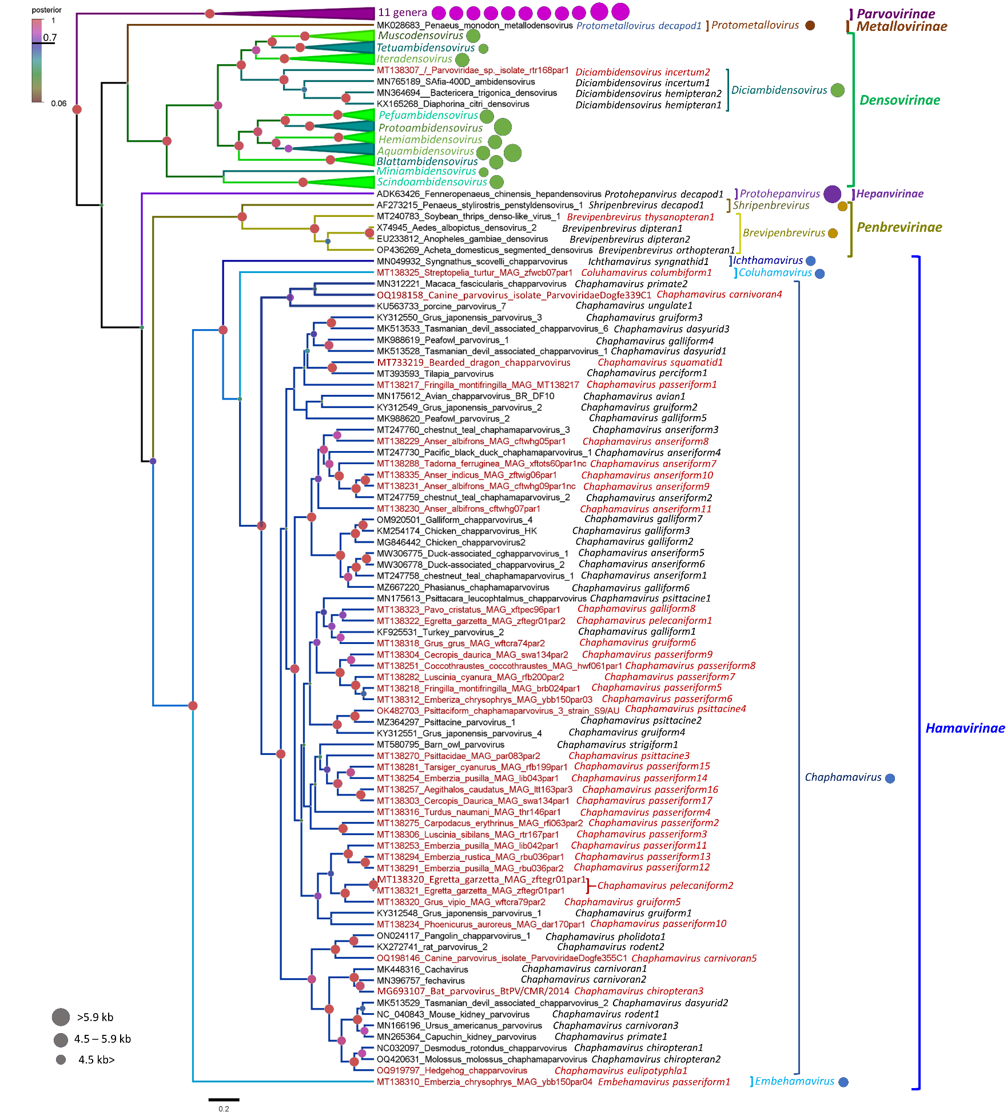
Figure 1. Bayesian inference of the entire Parvoviridae family, based on the SF3 helicase of the NS1 protein (by the BEAST v.1.10.4 suite using the LG+I+G4 substitution model, with a lognormal relaxed clock and Yule speciation model through 100 million generations). The posterior probability values are represented by the node shapes, which are colored according to the key in the left upper corner. The higher the support is for a given node, the larger the circles are. All proposed subfamilies - are supported by the maximum posterior probability values of 1. All genera are supported by significant values (>0.7). The colored circles reflect capsid protein sequence homology of each genus, with the same colors representing homologous entries (defined by the ability of the position-specific iterated BlastP to be able to identify them as similar sequences). The circles are sized according to the size of the packaged genome of the given genus. Species and viruses introduced in this proposal are highlighted red.

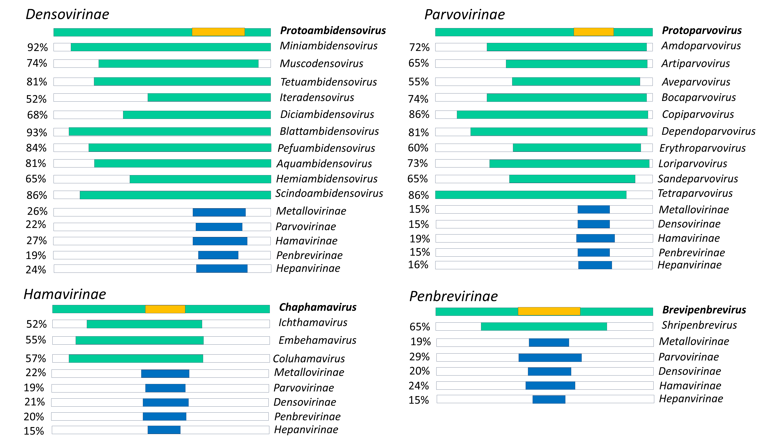
Figure 2. Sequence similarity and coverage of the NS1 proteins of the Parvoviridae, broken down by genera, using the type species of each genus and (proposed) subfamily. The yellow bar indicates the SF3 helicase domain. The region exhibiting positive coverage as per a BlastP search (within subfamily) or PSI BlastP search (outside of subfamily) are colored in green if over 30% identity is detected, or in blue, if the identity is lower.

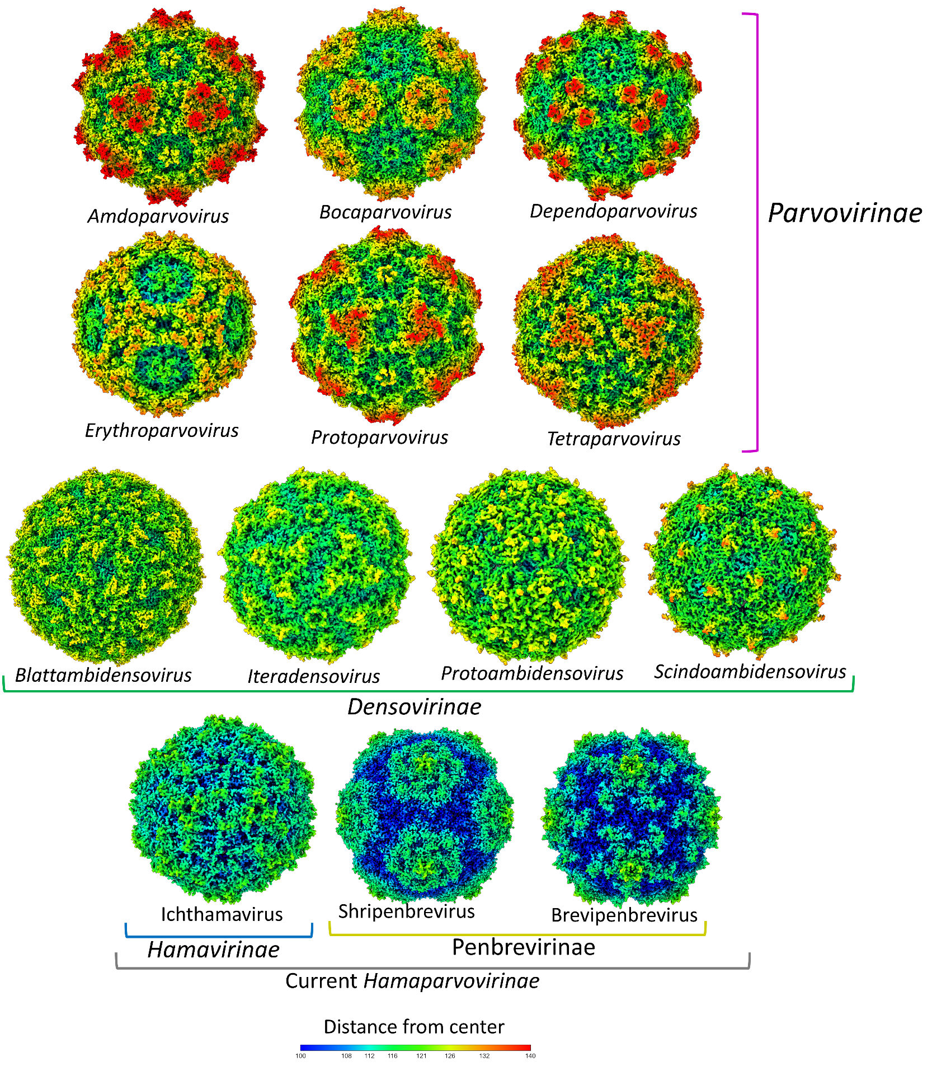
Figure 3. Capsid surface morphologies of experimentally resolved virion structures throughout the Parvoviridae. Note the similar surface architecture within the established and proposed subfamilies.
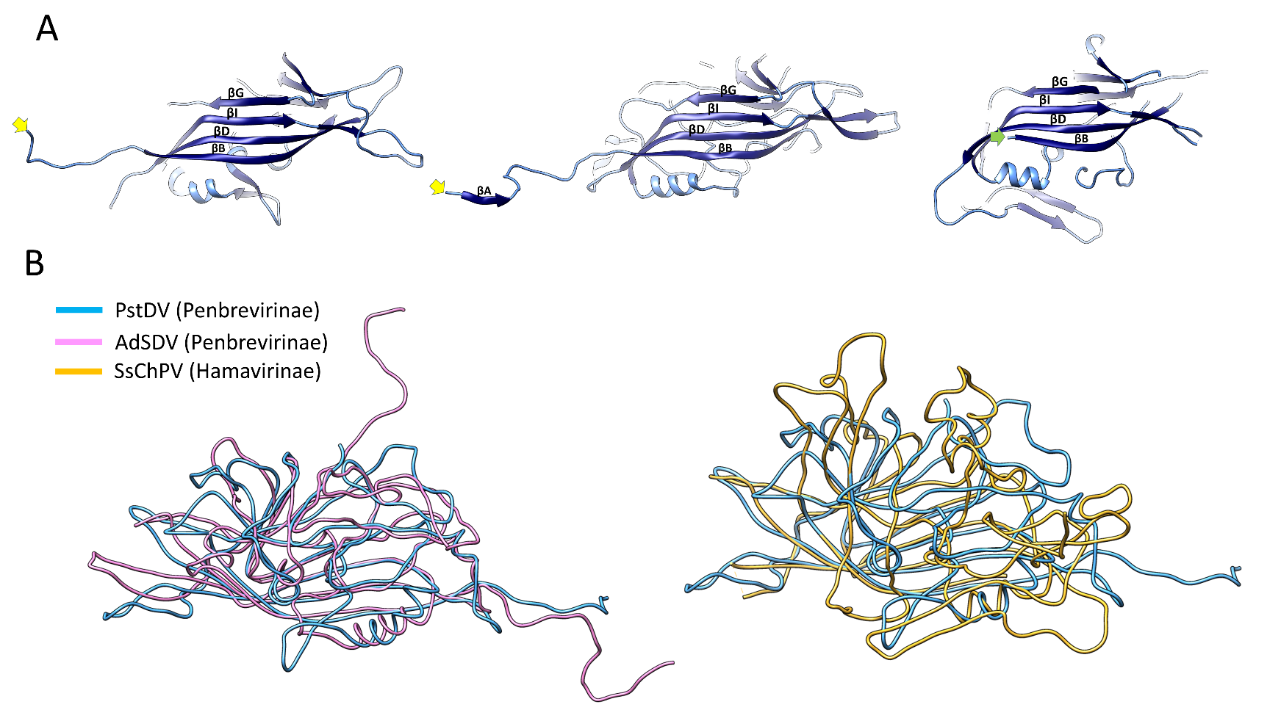
Figure 4. The fundamentally different capsid protein fold architectures between two distinct lineages within the current Hamaparvovirinae subfamily, each of which are proposed to be elevated to a subfamily rank in this proposal. Panel A shows the internal β-sheet of the shell domain and the adjacent ordered region of the N-terminal domain (with ~30 residues missing due to a disordered disposition). The yellow arrows indicate the first ordered residue of the Penaeus stylirostris densovirus (PstDV) of the current Penstylhamaparvovirus, proposed Penstylpenbrevirus genus, and of Acheta domesticus segmented densovirus (AdSDV) of the same proposed subfamily (current genus Brevihamaparvovirus, proposed genus Brevipenbrevirus), from left to right. The green arrow points to the actual first methionine residue of the Syngnathus scovelli chapparvovirus (SsChPV) subunit structure, indicating the complete absence of the N-terminal domain, which is otherwise ubiquitously present in all parvoviral subunit structures thus far. This unique architecture was found to be characteristic for all known “chapparvoviruses”, using homology modeling (current genera Ichtchaphamaparvovirus and Chaphamaparvovirus, proposed Hamavirinae subfamily of genera Embevirus, Chapvirus, Coluvirus, and Ichthamavirus) (Penzes). Panel B shows the superimposed ribbon structures of two members of the two genera of the proposed Penbrevirinae (left) and PstDV (Penbrevirinae) superimposed on a chapparvovirus, SsChPV of the proposed Hamavirinae (right), all currently members of the Hamaparvovirinae.

