

The International Committee on Taxonomy of Viruses
Taxonomy Proposal Form, 2025

Part 1a: Details of taxonomy proposals

Title: | Create four new species and abolish one current species in family Baculoviridae
Code assigned: | 2025.001D.v3.Baculoviridae_4nsp_1absp

Author(s), affiliation and email address(es):
Given name (+middle initial(s)) | Surname | Affiliation | Email address | Corr. author(s)
Monique M | van Oers | Laboratory of Virology, Wageningen University and  Research, Wageningen, the Netherlands | monique.vanoers@wur.nl | X
Adly M. M. | Abd-Alla | Joint FAO/IAEA Programme of Nuclear Techniques in Food  and Agriculture, Vienna International Centre, Vienna, Austria | A.M.M.Abd-Alla@iaea.org
Kelly S. | Bateman | European Community Reference Laboratory for Crustacean Diseases, Center for Environment, Fisheries and Aquaculture Science (CEFAS), Dorset. UK | kelly.bateman@cefas.co.uk
Jaime | Bojko | School of Health and Life Sciences, Teesside University, Middlesbrough, UK | j.bojko@tees.ac.uk
Robert L. | Harrison | Invasive Insect Biocontrol and Behavior Laboratory, USDAARS,  10300 Baltimore Avenue,  Beltsville, MD, USA | robert.l.harrison@usda.gov | X
Elisabeth A. | Herniou | Institut de Recherche sur la Biologie de l’Insecte,  CNRS - University of Tours, Tours, France | elisabeth.herniou@univ-tours.fr
Johannes A. | Jehle | Institute for Biological Control, Julius Kühn-Institut, Dossenheim, Germany | Johannes.Jehle@julius-kuehn.de
Peter J. | Krell | Department of Molecular and Cellular Biology, University of  Guelph, Guelph, Canada | pkrell@uoguelph.ca
Bergmann M | Ribeiro | Laboratory of Baculovirus, Cell Biology Department,  University of Brasília, Brasília, Brazil | bergmann@unb.br
Xiulian | Sun | State Key Laboratory of Virology, Wuhan Institute of  Virology, Chinese Academy of Sciences, Wuhan,  P. R. China | sunxl@wh.iov.cn

Part 1b: Taxonomy Proposal Submission
ICTV Subcommittee:
Animal DNA Viruses and Retroviruses | X | Bacterial viruses
Animal minus-strand and dsRNA viruses |  | Fungal and protist viruses
Animal positive-strand RNA viruses |  | Plant viruses
Archaeal viruses |  | General -

List the ICTV Study Group(s) that have seen or have been involved in creating this proposal:
Baculoviridae and Nudiviridae Study Group
Optional – complete only if formally voted on by an ICTV Study Group:
Study Group | Number of members
Study Group | Votes in support | Votes against | No vote

Submission date: | 26/05/2025

Part 1c: Feedback from ICTV Executive Committee (EC) meeting
Executive Committee Meeting Decision code: | X
A – Accept
Ac – Accept subject to revision by relevant subcommittee chair. No further vote required
U – Accept without revision but with re-evaluation and email vote by the EC
Uc – Accept subject to revision and re-evaluation and email vote by the EC
Ud – Deferred to the next EC meeting, with an invitation to revise based on EC comments
J - Reject
W - Withdrawn

Comments from the Executive Committee:

Part 1d: Revised Taxonomy Proposal Submission
Response of proposer:
The minor text edit suggestions have been accepted

Revision date: | 26-5-2025

Part 3: TAXONOMIC PROPOSAL
https://ictv.global/taxonomy/templates
Taxonomic changes proposed:
Establish new taxon | X | Split taxon
Abolish taxon | X | Merge taxon
Move taxon |  | Promote taxon
Rename taxon |  | Demote taxon
Move and rename

Etymology (origin) of proposed taxonomic names:
Taxon name | Etymology of the term
Alphabaculovirus calabietis | Epithet derived from the host moth species Calliteara abietis
Alphabaculovirus mysequacis | Epithet derived from the host moth species Mythimna sequax
Alphabaculovirus plidaeusalis | Epithet derived from the host moth species Platynota idaeusalis
Betabaculovirus plidaeusalis | Epithet derived from the host moth species Platynota idaeusalis

Permission for use of names derived from a living person:
Taxon name | Full name of person from whom the name is derived | Attached

Abstract of Taxonomy Proposal:
Taxonomic rank(s) affected: Species

Description of current taxonomy: There are currently 68 species in the genus Alphabaculovirus and 29 species in the genus Betabaculovirus of the family Baculoviridae

Proposed taxonomic change(s): We propose to create three new species in the genus Alphabaculovirus, create one new species in the genus Betabaculovirus, and abolish one species in the genus Betabaculovirus

Justification: Analysis of recently sequenced baculovirus genomes have identified four viruses that each represent a previously undescribed baculovirus species, in accordance with the species demarcation criteria defined for the family Baculoviridae. Nucleotide sequences derived from isolates of Betabaculovirus trini and Betabaculovirus myunipunctae are almost completely identical, indicating that one of these species should be abolished. We have chosen to abolish Betabaculovirus trini due to the significant place that the exemplar isolate of Betabaculovirus myunipunctae occupies in the history of baculovirus research.

Text of Taxonomy proposal:
Taxonomic rank(s) affected: Species

Description of current taxonomy: The family Baculoviridae currently contains 101 species in 4 genera [1]. Most of the species are classified into the genera Alphabaculovirus and Betabaculovirus, which contain 68 and 29 species, respectively. Baculoviruses are classified into one of these two genera if they conform to the following criteria:

- Host species of the insect order Lepidoptera
- Circular double-stranded DNA genome ranging in size from 80 to 180 kbp with a gene content characteristic of other alphabaculoviruses or betabaculoviruses;
- Relationships to other alphabaculoviruses or betabaculoviruses as inferred by molecular phylogeny;
- Occlusion bodies formed within the nucleus (Alphabaculovirus) or the nucleocytoplasmic milieu formed after degradation of the nuclear envelope (Betabaculovirus), with a shape and size characteristic for the genus;
- Rod-shaped virions consisting of enveloped nucleocapsids, with single (Betabaculovirus) or multiple (Alphabaculovirus) virions contained in each occlusion body.

Baculovirus isolate names usually include the genus and species of the host of origin. For example, Autographa californica multiple nucleopolyhedrovirus was originally isolated from larvae of Autographa californica, a moth known as the alfalfa looper. Specific epithets for member species of Baculoviridae are Latinized words formed by merging the first two to four letters of the host genus name with the genitive form of the host specific epithet [2]. For example, the species for alphabaculovirus Autographa californica multiple nucleopolyhedrovirus is Alphabaculovirus aucalifornicae.

Proposed taxonomic change(s):
We propose to create the following species for classification in Alphabaculovirus or Betabaculovirus genera:

1) Alphabaculovirus calabietis
Exemplar isolate: Calliteara abietis nucleopolyhedrovirus, isolate IOZ-23MG (CaabNPV-IOZ-23MG) [3]
Etymology: The host epithet “abietis” is already the genitive of “abies”, meaning “fir”, although in this case it refers to the Norway spruce (Picea abies), one of the primary plant hosts of Calliteara abietis larvae (https://lepidoptera.eu/species/781; last accessed 28 April 2025).

2) Alphabaculovirus mysequacis
Exemplar isolate: Mythimna sequax nucleopolyhedrovirus, isolate CNPSo-98 (MysqNPV-CNPSo-98) [4]
Etymology: “Sequax” is the Latin word for "following", which refers to the behavior of the Mythimna sequax host larvae (https://bugguide.net/node/view/379966; last accessed 28 April 2025). The genitive form is sequacis, thus we’ve adapted mysequacis as the epithet for this species.

3) Alphabaculovirus plidaeusalis
Exemplar isolate: Platynota idaeusalis nucleopolyhedrovirus, isolate 2680 (PlidNPV-2680) [5]
Etymology: “Idaeusalis” possibly refers to the red raspberry, Rubus idaeus, which is one of host plants of Platynota idaeusalis (https://bugguide.net/node/view/25808; last accessed 28 April 2025). The genitive of the suffix -alis is -alis, so we have adapted plidaeusalis as the epithet for this baculovirus species.

4) Betabaculovirus plidaeusalis
Exemplar isolate: Platynota idaeusalis granulovirus, isolate 2683 (PlidGV-2683) [5]
Etymology: As described above for Alphabaculovirus plidaeusalis, with a betabaculovirus from the same host.

We also propose to abolish species Betabaculovirus trini.

Demarcation criteria:
Species demarcation criteria for baculoviruses are based on pairwise nucleotide distances estimated from alignments of parts of three conserved genes [6] or all 38 core genes of family Baculoviridae [7]. With the three-gene alignment, a cut-off value of >0.050 substitutions/site indicates that the viruses being compared belonged to different species, while distances <0.015 indicated that they belonged to the same species. For K2P distances between these two cut-off points, additional evidence is required to support the classification of the isolates being compared into different species. Cut-off points for distances based on a concatenated 38-core gene alignment are <0.021 (same species) and >0.072 (different species) substitutions/site.

Justification:
Phylogenetic inference based on core gene amino acid alignments placed exemplar isolates of the proposed new species in clades with other alphabaculoviruses (Figure 1) or betabaculoviruses (Figure 2). Analysis of their nucleotide sequences yielded K2P distances above the cut-off point for new species in pairwise three-gene alignments, with distances of >0.289 (CaabNPV-IOZ-23MG), >0.072 (MysqNPV-CNPSo-98), >0.33 (PlidNPV-2680), and >0.38 (PlidGV-2683) [3-5]. These values confirm that these viruses represent previously undescribed species in their respective genera.

All the nucleotide sequences for viruses of Betabaculovirus trini and Betabaculovirus myunipunctae are identical or almost identical [8,9], indicating that these two species are redundant and one of them should be abolished. Although the addition of Betabaculovirus trini to the ICTV catalog precedes that of Betabaculovirus myunipunctae, the genome sequence for the Betabaculovirus myunipunctae exemplar isolate, Pseudaletia unipuncta granulovirus-Hawaiian (PsunGV-H), was released first on GenBank. PsunGV-H was featured in a lot of pioneering work on baculovirus enhancins [10], and we feel that the species for it deserves to be retained in the ICTV catalog.

References:
- Harrison RL, Herniou EA, Jehle JA, Theilmann DA, Burand JP, Becnel JJ, Krell PJ, van Oers MM, Mowery JD, Bauchan GR (2018) ICTV Virus Taxonomy Profile: Baculoviridae. Journal of General Virology 99:1185-1186. PMID: 29947603 DOI: 10.1099/jgv.0.001107
- van Oers MM, Herniou EA, Jehle JA, Krell PJ, Abd-Alla AMM, Ribeiro BM, Theilmann DA, Hu Z, Harrison RL (2023) Developments in the classification and nomenclature of arthropod-infecting large DNA viruses that contain pif genes. Archives of Virology 168:182. PMID: 37322175 DOI: 10.1007/s00705-023-05793-8.
- Jin W, Byambasuren M, Ganbold U, Shi H, Liang H, Li M, Wang H, Qin Q, Zhang H (2024) Sequencing, analysis and organization of the complete genome of a novel baculovirus Calliteara abietis nucleopolyhedrovirus (CaabNPV). Viruses 16: 252. PMID: 38400028 DOI 10.3390/v16020252.
- Peterson L, dos Santos ER, Ribeiro BM, Sosa-Gomez D, Ardisson-Araújo DMP (2024)
Genomic analyses of a new baculovirus isolated from the wheat armyworm, Mythimna sequax (Franclemont) (Lepidoptera: Noctuidae). Journal of Invertebrate Pathology 204:
108127. PMID: 38729296 DOI: 10.1016/j.jip.2024.108127
- Harrison RL, Jansen MA, Fife AN, Rowley DL (2025) The genome sequences of baculoviruses from the tufted apple bud moth, Platynota idaeusalis, reveal recombination between an alphabaculovirus and a betabaculovirus from the same host. Viruses 17: 202. PMID: 40006957 PMCID: PMC11861948 DOI: 10.3390/v17020202
- Jehle JA, Lange M, Wang H, Hu Z, Wang Y, Hauschild R (2006) Molecular identification and phylogenetic analysis of baculoviruses from Lepidoptera. Virology 346:180-193. PMID: 15215679 DOI: 10.1023/B:VIRU.0000032784.03761.e2
- Wennmann JT, Keilwagen J, Jehle JA (2018) Baculovirus Kimura two-parameter species demarcation criterion is confirmed by the distances of 38 core gene nucleotide sequences. Journal of General Virology 99:1307-1320. PMID: 30045782 DOI: 10.1099/jgv.0.001100
- de los Ángeles Bivian-Hernández M, López-Tlacomulco J, Mares-Mares E, Ibarra JE, del Rincon-Castro MC (2017) Genomic analysis of a Trichoplusia ni betabaculovirus (TnGV) with three different viral enhancing factors and two unique genes. Archives of Virology 162: 3705–3715. PMID: 28856619 DOI: 10.1007/s00705-017-3506-y
- Li Y, Liu X, Tang P, Zhang H, Qin Q, Zhang Z (2021) Genome sequence and organization of the Mythimna (formerly Pseudaletia) unipuncta granulovirus Hawaiian strain. Scientific Reports 11: 414. PMCID: PMC7801670 PMID: 33432025 DOI: 10.1038/s41598-020-80117-3
- Tanada Y (1985) A synopsis of studies on the synergistic property of an insect
baculovirus: A tribute to Edward A. Steinhaus. Journal of Invertebrate Pathology 45: 125-138. DOI: 10.1016/0022-2011(85)90001-1
- Silvestro D, MIchalak I (2012) raxmlGUI: a graphical front-end for RAxML. Organisms Diversity & Evolution 12:335-337. DOI: 10.1007/s13127-011-0056-0
- Le SQ, Gascuel O (2008) An improved general amino acid replacement matrix. Molecular Biology andEvolution 25:1307-1320. PMID: 18367465 DOI: 10.1093/molbev/msn067
- Théze J, Lopez-Vaamonde C, Cory JS, Herniou EA (2018) Biodiversity, evolution and ecological specialization of baculoviruses: A treasure trove for future applied research. Viruses 10(7):366. PMID: 29997344 PMCID: PMC6071083 DOI: 10.3390/v10070366
- Miele SA, Garavaglia MJ, Belaich MN, Ghiringhelli PD. (2011) Baculovirus: molecular insights on their diversity and conservation. International Journal of Evolutionary Biology 2011:379424. PMID: 21716740 DOI: 10.4061/2011/379424

Accompanying files:
Filename | Description of contents
2025.001D.Nv1.Baculovirdae_4nsp_1absp.xlsx | Accompanying Excel sheet

Tables, Figures:

See next pages 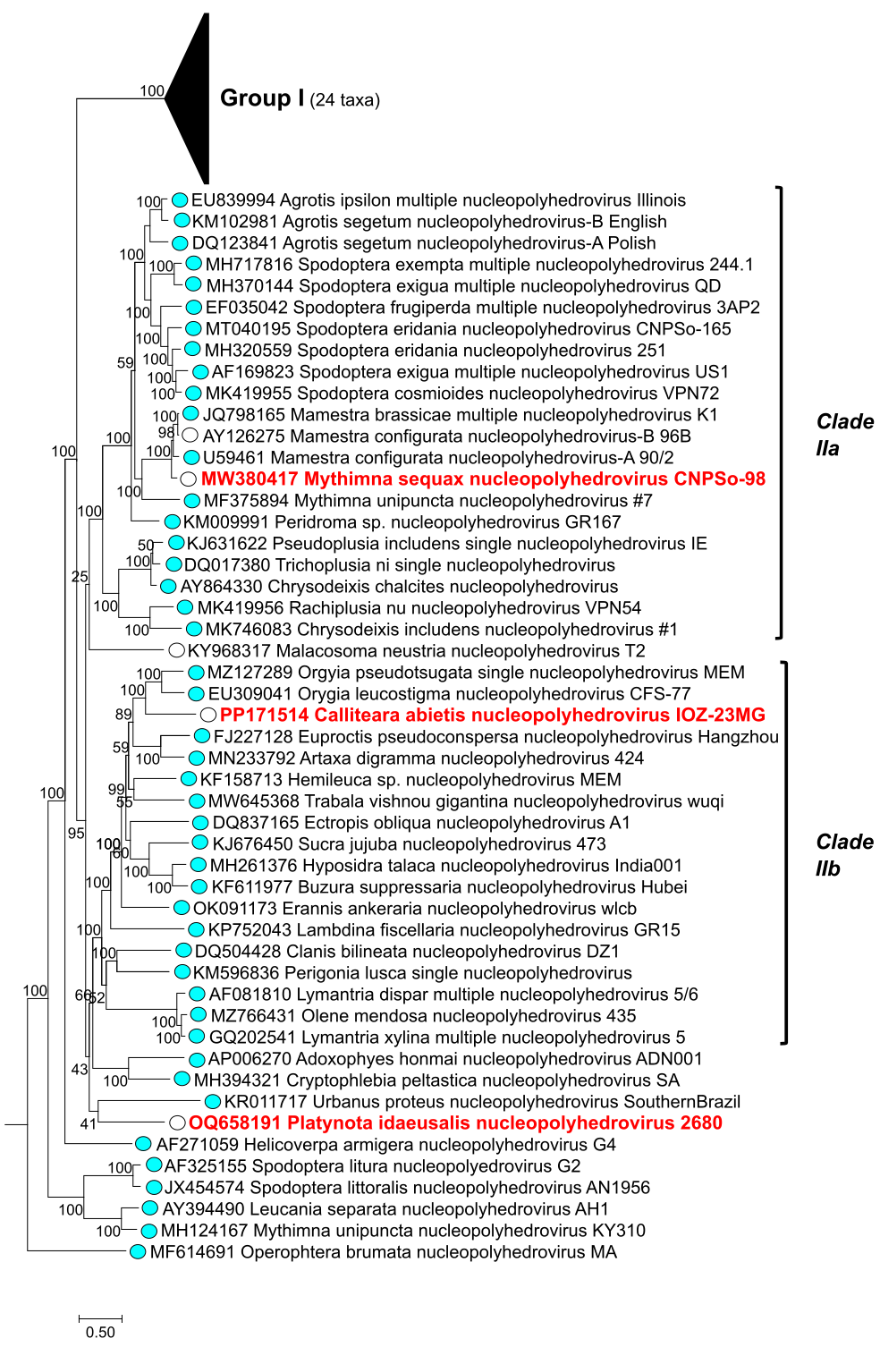Figure 1. Phylogeny showing the relationships of baculoviruses belonging to group II of the genus Alphabaculovirus (Lefavirales: Baculoviridae). Shown is a maximum likelihood tree inferred from the concatenated alignments of 38 baculovirus core gene amino acid sequences with RAxML [11] using the Le and Gascuel (LG) substitution model [12]. GenBank accession numbers for genome sequences precede each virus name. Reliability of the tree was assessed with 100 rapid bootstrap replicates, with bootstrap support shown for each node. Clade IIa and clade IIb of the group II alphabaculoviruses are indicated with brackets [13]. Exemplar viruses of currently existing alphabaculovirus species are denoted by blue circles. Currently unclassified viruses are indicated by open circles. Exemplar viruses of proposed alphabaculovirus species are indicated with red bold type.

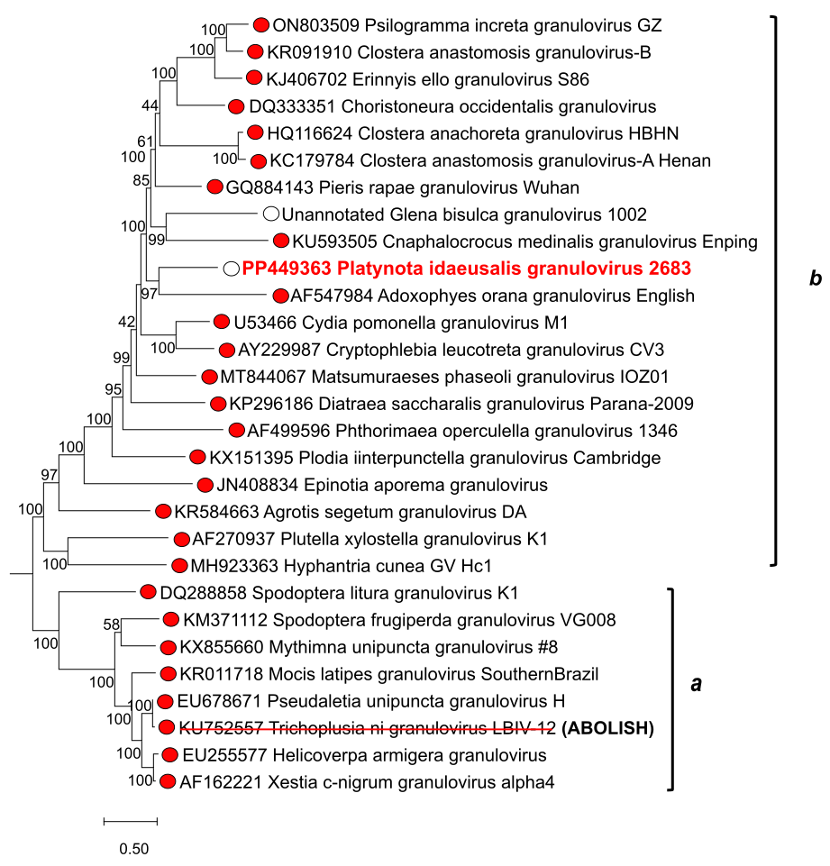

Figure 2. Phylogeny showing the relationships of baculoviruses belonging to genus Betabaculovirus (Lefavirales: Baculoviridae). Shown is a maximum likelihood tree inferred as described for Figure 1, with bootstrap support shown for each node and genome sequence GenBank accession numbers preceding each virus name. The two basal clades in which betabaculoviruses occur, clade a and clade b [14] are indicated with brackets. Exemplar viruses of currently existing betabaculovirus species are denoted by red circles. Currently unclassified viruses are indicated by open circles. The exemplar virus of the proposed betabaculovirus species are indicated with red bold font. The exemplar virus of the species proposed to be abolished is also indicated by a strikethrough red line.

