

The International Committee on Taxonomy of Viruses
Taxonomy Proposal Form, 2024

Part 1a: Details of taxonomy proposals

Title: | Reorganization of the realm Varidnaviria
Code assigned: | 2024.010D.N.v1.Varidnaviria_reorg

Author(s), affiliation and email address(es):
Name | Affiliation | Email address | Corresponding author(s) X
Koonin EV | National Center for Biotechnology Information, National Library of Medicine, NIH, Bethesda, MD, USA | koonin@ncbi.nlm.nih.gov | X
Fischer MG | Department of Biomolecular Mechanisms, Max Planck Institute for Medical Research, Heidelberg, Germany | Matthias.Fischer@mpimf-heidelberg.mpg.de
Yutin N | National Center for Biotechnology Information, National Library of Medicine, NIH, Bethesda, MD, USA | yutin@ncbi.nlm.nih.gov
Kuhn JH | Integrated Research Facility at Fort Detrick, National Institute of Allergy and Infectious Diseases, National Institutes of Health, Fort Detrick, Frederick, MD, USA | kuhnjens@mail.nih.gov
Krupovic M | Institut Pasteur, Université Paris Cité, Archaeal Virology Unit, Paris, France | mart.krupovic@pasteur.fr | X

Part 1b: Taxonomy Proposal Submission
ICTV Subcommittee:
Animal DNA Viruses and Retroviruses | X | Bacterial viruses
Animal minus-strand and dsRNA viruses |  | Fungal and protist viruses
Animal positive-strand RNA viruses |  | Plant viruses
Archaeal viruses |  | General - | X

List the ICTV Study Group(s) that have seen or have been involved in creating this proposal:
None (there is currently no Study Group for the realm Varidnaviria).
Optional – complete only if formally voted on by an ICTV Study Group:
Study Group | Number of members
Study Group | Votes in support | Votes against | No vote

Submission date: | 21/06/2024

Part 1c: Feedback from ICTV Executive Committee (EC) meeting
Executive Committee Meeting Decision code: | X
A – Accept
Ac – Accept subject to revision by relevant subcommittee chair. No further vote required | X
U – Accept without revision but with re-evaluation and email vote by the EC
Uc – Accept subject to revision and re-evaluation and email vote by the EC
Ud – Deferred to the next EC meeting, with an invitation to revise based on EC comments
J – Reject
W - Withdrawn

Comments from the Executive Committee:
Remove the species Livvievirus viph1044o from the excel module, because this species is renamed in a different proposal.

Part 1d: Revised Taxonomy Proposal Submission
Response of proposer:
Species removed.

Revision date: | 04/10/2024

Part 3: TAXONOMIC PROPOSAL

Name of accompanying Excel module:
2024.010D.N.v1.Varidnaviria_reorg.xlsx

Taxonomic changes proposed:
Establish new taxon | X | Split taxon
Abolish taxon |  | Merge taxon
Move taxon | X | Promote taxon
Rename taxon | X | Demote taxon
Move and rename | X

Is any taxon name used here derived from that of a living person: |  | N
Taxon name | Person from whom the name is derived | Attached X

Abstract of Taxonomy Proposal:
Taxonomic rank(s) affected: Varidnaviria

Description of current taxonomy: Realm currently including two kingdoms: Bamfordvirae (two phyla with a total of six classes and one unassigned family) and Helvetiavirae (one phylum including one class)

Proposed taxonomic change(s): Create a new realm to accommodate Helvetiavirae; create a new varidnavirian kingdom to accommodate five previously bamfordviraen orders; create two subphyla in bamfordviraen phylum Preplasmiviricota; assign Tectiliviricetes to one and the remaining taxa to the other, which is also expanded by three new classes to accommodate polinton-like viruses and Adenoviridae.

Justification: A thorough genomic and proteomic analysis revealed previously unrecognized evolutionary relationships among the various varidnaviraen taxa.

- Text of Taxonomy proposal:
Taxonomic rank(s) affected: Varidnaviria

Description of current taxonomy:
The realm Varidnaviria, proposed in 2019 and ratified in 2020, includes two kingdoms, Helvetiavirae and Bamfordvirae, for viruses with vertical single jelly-roll (SJR) and double jelly-roll (DJR) major capsid proteins (MCP), respectively. Bamfordvirae includes two phyla, Nucleocytoviricota and Preplasmiviricota, and one “floating” family, Yaraviridae, currently unassigned to any of the intermediate taxa. Phylum Nucleocytoviricota consists of eukaryotic viruses with large and giant double-stranded DNA (dsDNA) genomes, whereas Preplasmiviricota includes bacterial, archaeal, and eukaryotic viruses with small and moderately sized single-stranded DNA (ssDNA) and dsDNA genomes.

Proposed taxonomic change(s):
During the five years that elapsed since Varidnaviria was proposed, major advances in structural bioinformatics and comparative genomics as well as expansion of the virus databases, have transformed our understanding of the evolution of these viruses. To reconcile the reconstructed evolution of varidnaviruses with their taxonomy, refinement of the Varidnaviria taxonomy is needed. The major proposed changes include:
- Split the realm Varidnaviria, moving kingdom Helvetiavirae into a separate realm.
- Create a new kingdom, ‘Abadenavirae’ and move most of the prokaryotic viruses with DJR MCPs into this kingdom.
- Refine the taxonomy of Preplasmiviricota, including creation of new taxa and renaming of the existing ones.
- Move family Yaraviridae into a new class within the phylum Nucleocytoviricota.

Justification:
Creation of a new realm ‘Singelaviria’
At the time when then realm Varidnaviria was proposed, the prevailing hypothesis was that DJR MCPs characteristic of members of the kingdom Bamfordvirae have evolved from fusion of the two SJR MCPs encoded by viruses within the kingdom Helvetiaviriae. However, recent evidence suggests that fusion of the SJR domains to produce a DJR protein has occurred in cellular organisms and that viruses exapted cellular SJR (Helvetiaviriae) or DJR (Bamfordvirae) proteins for capsid formation on independent occasions (Krupovic et al 2022). This scenario is supported by structural comparisons of the cellular and viral SJR and DJR proteins (Fig. 1A,B), which showed that viral DJR MCPs cluster with cellular glucoside hydrolases of the GH172 family (DUF2961). Importantly, similar to viral DJR MCPs, cellular DJR proteins form trimers (Fig. 1B), which is a key property of the DJR MCPs. Given the apparent independent origin of the MCPs encoded by viruses in Helvetiairiae and Bamfordvirae, it is proposed to move Helvetiaviriae from Varidnaviria into a separate realm to be named ‘Singelaviria’ (Koonin et al., 2024), from Latin singulus, meaning single, and gelata, meaning jelly (a reference to single jelly-roll capsid protein).

Creation of a new kingdom “Abadenavirae”
Currently, prokaryotic viruses with DJR-MCPs, including tectivirids, and eukaryotic DJR-MCP viruses with shorter genomes, including the currently classified, adenovirids, and maveriviricetes (virophages) are classified within the bamfordviraen phylum Preplasmiviricota, whereas eukaryotic ‘giant viruses’ are unified within the bamfordviraen phylum Nucleocytoviricota, the sister group to preplasmiviricots. Within Preplasmiviricota, polintoviricetes (Adintoviridae) and ‘maveriviricetes constitute distinct classes. Tectivirids and adenovirids are assigned to two orders (Kalamavirales and Rowavirales, respectively) within class Tectiliviricetes, which also includes four other orders and one unassigned family of bacterial and archaeal DJR-MCP viruses. The fourth preplasmiviricot class, Ainoaviricetes, includes bacterial ssDNA viruses encoding DJR-MCPs.

Recent detailed analysis of the DNA replication proteins encoded by preplasmiviricots provided evidence of the monophyly of tectivirids, adenovirids, adintovirids, maveriviricetes and currently unclassified ‘polinton-like’ viruses, to the exclusion of other bacterial and archaeal preplasmiviricots (Krupovic et al., 2024). In particular, all these viral groups encode a protein-primed family B DNA polymerase (pPolB) or its derivatives (Fig. 2A). In most eukaryotic viruses in this assemblage, the pPolB is fused to a terminal protein (TP) (Fig. 2A, 2B), which is responsible for priming the initiation of DNA replication by pPolBs. Importantly, the TP encoded by eukaryotic preplasmiviricots is specifically related to the terminal protein of PRD1-like tectivirids, but distinct from the TPs of Bam35-like tectivirids and phi29-like phages (Fig. 2C; Krupovic et al., 2024). Previous phylogenetic analyses based on the pPolB sequences placed tectivirids at the base of eukaryotic preplasmiviricots, suggesting that the latter have evolved from within the diversity of bacterial tectivirids (Krupovic et al., 2015; Redrejo-Rodríguez et al., 2017). To reflect this evolutionary relationship, we propose moving all prokaryotic DJR-MCP viruses with dsDNA genomes, except for Kalamavirales, to a new phylum, ‘Produgelaviricota’, with a new class ‘Belvinaviricetes’, of a new kingdom, ‘Abadenavirae’, sister to Bamfordvirae. Within this new kingdom, Ainoaviricetes should be included as a sister to ‘Belvinaviricetes’. The closer similarity between the eukaryotic members of Preplasmiviricota and Nucleocytoviricota is supported by the conservation of the capsid maturation vUlp1 protease and structural similarities between the DJR-MCPs (Koonin et al., 2024), further justifying the unification of Preplasmiviricota and Nucleocytoviricota within Bamfordvirae.

Refinement of the Preplasmiviricota taxonomy
Within the remaining Preplasmiviricota, the ancestral form of the pPolB is found in members of the family Adintoviridae. Adintovirids are nearly exclusively referred to in the literature as polintons or mavericks. Thus, to maintain the continuity with the literature, we propose to rename this virus family ‘Eupolintoviridae’ within a renamed order ‘Amphintovirales’. In the multidomain pPolBs of ‘eupolintovirids’, the TP domain is followed by a cysteine protease domain of the viral ovarian tumor (vOTU) deubiquilase superfamily (Fig. 2A,D), which is predicted to cleave off the TP domain from the rest of the pPolB following the initiation of DNA replication (Krupovic et al., 2024). Other eukaryotic preplasmiviricots display variations of this arrangement, which help to reconstruct the evolution of this virus assemblage (Fig. 3). In particular, in adenovirids, the TP is encoded by a separate gene, whereas the vOTU protease domain is present but inactivated. In mavirus-like maveriviricetes, the replication enzyme carries the palm domain of the pPolB as well as the TP and vOTU domains, but lacks the exonuclease domain, unequivocally indicating that this polymerase is a derived form. Many polinton-like viruses encode a replication protein containing the TP, vOTU and the polymerization Palm domain of pPolB, but the exonuclease domain is replaced by a Pif1-like superfamily 1 helicase domain, again indicating that this domain arrangement evolved from the ancestral state found in ‘eupolintovirids’ (Fig. 3).

‘Polinton-like viruses’ represent a vast, environmentally widespread group of viruses, most of which have been described through metagenomics (Yutin et al., 2015; Bellas and Sommaruga, 2021; Bellas et al., 2023). However, none of these viruses have been classified thus far. Here we propose creating a family ‘Phypoliviridae’ for classification of Tetraselmis viridis virus S1 (TvV-S1), one of the few viruses in this group which have been cultivated. Given the vast diversity of these viruses, it is expected that multiple families will have to be created for their classification in the future. Thus, we propose placing ‘Phypoliviridae’ into a separate new order, ‘Archintovirales’ (Koonin et al., 2024).

As mentioned above, tectivirids and adenovirids are currently assigned to two orders (Kalamavirales and Rowavirales, respectively) within the same class, Tectiliviricetes. Given that adenovirids do not represent a sister group to tectivirids in any of the reported analyses, and indeed, appear to have evolved from within the diversity of ‘amphintovirals’, we propose to move family Adenoviridae into a separate new class, ‘Pharingeaviricetes’ (Koonin et al., 2024).

The fact that pPolBs of all eukaryotic preplasmiviricots, namely, Polintoviricetes/‘Aquintoviricetes’/Maveriviricetes /‘Pharingeaviricetes’, are fused to the TP and/or vOTU domains testifies to their monophyly, with the fusion taking place following their divergence from a tectivirid ancestor (Fig. 3). Thus, we propose splitting Preplasmiviricota into two subphyla, ‘Polisuviricotina’ and ‘Prepoliviricotina’, to include viruses of eukaryotes and prokaryotes, respectively.

To retain the connection to the widely-spread use of the term “virophage”, we propose to rename Maverivircietes as ‘Virophaviricetes’.

Creation of a new class within Nucleocytoviricota for inclusion of Yaraviridae
Family Yaraviridae was created for classification of a yaravirus isolate infecting Acanthamoeba castellanii (de Miranda Boratto et al., 2022; Borrato et al., 2020). At the time, the placement of this family within higher-rank taxonomy was not obvious due to high divergence of the corresponding virus and lack of information on other related viruses. Recently, a large number of viruses related to yaraviruses were discovered though mining of metagenomics datasets (Yutin et al., 2024). The discovered diversity could be split into at least two monophyletic sister groups, Yaraviridae and an assemblage referred to as ‘Gamadviridae’ (Fig. 4). In the absence of coding-complete genomes in GenBank for ’Gamadviridae’, this family will not be officially proposed at this time. However, dramatic expansion of the yaravirus-like viruses enabled a more comprehensive comparative genomics and phylogenetic analysis of these viruses. In particular, it was found that members of the extended Yaraviridae encompass some of the signature genes of nucleocytoviricots, namely, virus late transcription factors 2 and 3 (VLTF2 and VLTF3, respectively). In phylogenetic trees of the conserved DJR MCPs and DNA packaging ATPases, yaravirids and ‘gamadvirids’ consistently did not show affinity to any particular branch of the Nucleocytoviricota (Fig. 4) and accordingly would comprise a new class. Comparison of the DJR MCP structures placed yaravirids and gamadvirids basal to the nucleocytoviricots, between the latter and preplasmiviricots (Yutin et al., 2024). Thus, we propose creating a new class, ‘Mriyaviricetes’, to accommodate the currently “floating” family Yaraviridae.

Such reorganization of virus megataxonomy would resolve all outstanding incongruences with the current scenarios of the evolution of varidnavirians. The proposed taxonomy is summarized in Figure 5.

Etymologies of all proposed taxon names are provided in the excel module.

References:
Bellas CM, Sommaruga R. Polinton-like viruses are abundant in aquatic ecosystems. Microbiome. 2021; 9(1):13. doi: 10.1186/s40168-020-00956-0. PMID: 33436089

Bellas C, Hackl T, Plakolb MS, Koslová A, Fischer MG, Sommaruga R. Large-scale invasion of unicellular eukaryotic genomes by integrating DNA viruses. Proc Natl Acad Sci U S A. 2023; 120(16):e2300465120. doi: 10.1073/pnas.2300465120. PMID: 37036967

Boratto PVM, Oliveira GP, Machado TB, Andrade ACSP, Baudoin JP, Klose T, Schulz F, Azza S, Decloquement P, Chabrière E, Colson P, Levasseur A, La Scola B, Abrahão JS. Yaravirus: A novel 80-nm virus infecting Acanthamoeba castellanii. Proc Natl Acad Sci U S A. 2020; 117(28):16579-16586. doi: 10.1073/pnas.2001637117. PMID: 32601223
Koonin EV, Fischer MG, Kuhn JH, Krupovic M. The ‘polinton supergroup’ of viruses: evolution, molecular biology, and taxonomy. Microbiol Mol Biol Rev. 2024; In press.

Krupovic M, Koonin EV. Polintons: a hotbed of eukaryotic virus, transposon and plasmid evolution. Nat Rev Microbiol. 2015; 13(2):105-15. doi: 10.1038/nrmicro3389. PMID: 25534808

Krupovic M, Makarova KS, Koonin EV. Cellular homologs of the double jelly-roll major capsid proteins clarify the origins of an ancient virus kingdom. Proc Natl Acad Sci U S A. 2022; 119(5):e2120620119. doi: 10.1073/pnas.2120620119. PMID: 35078938

Krupovic M, Kuhn JH, Fischer MG, Koonin EV. Natural history of eukaryotic DNA viruses with double jelly-roll major capsid proteins. Proc Natl Acad Sci U S A. 2024; 121(23):e2405771121. doi: 10.1073/pnas.2405771121. PMID: 38805295

de Miranda Boratto PV, Oliveira GP, Abrahão JS. "Yaraviridae": a proposed new family of viruses infecting Acanthamoeba castellanii. Arch Virol. 2022; 167(2):711-715. doi: 10.1007/s00705-021-05326-1. PMID: 35000005

Redrejo-Rodríguez M, Ordóñez CD, Berjón-Otero M, Moreno-González J, Aparicio-Maldonado C, Forterre P, Salas M, Krupovic M. Primer-Independent DNA Synthesis by a Family B DNA Polymerase from Self-Replicating Mobile Genetic Elements. Cell Rep. 2017; 21(6):1574-1587. doi: 10.1016/j.celrep.2017.10.039. PMID: 29117562

Yutin N, Shevchenko S, Kapitonov V, Krupovic M, Koonin EV. A novel group of diverse Polinton-like viruses discovered by metagenome analysis. BMC Biol. 2015; 13:95. doi: 10.1186/s12915-015-0207-4. PMID: 26560305

Yutin N, Mutz P, Krupovic M, Koonin EV. Mriyaviruses: small relatives of giant viruses. mBio. 2024 Jun 4:e0103524. doi: 10.1128/mbio.01035-24. PMID: 38832788

Tables, Figures:
<Start here>
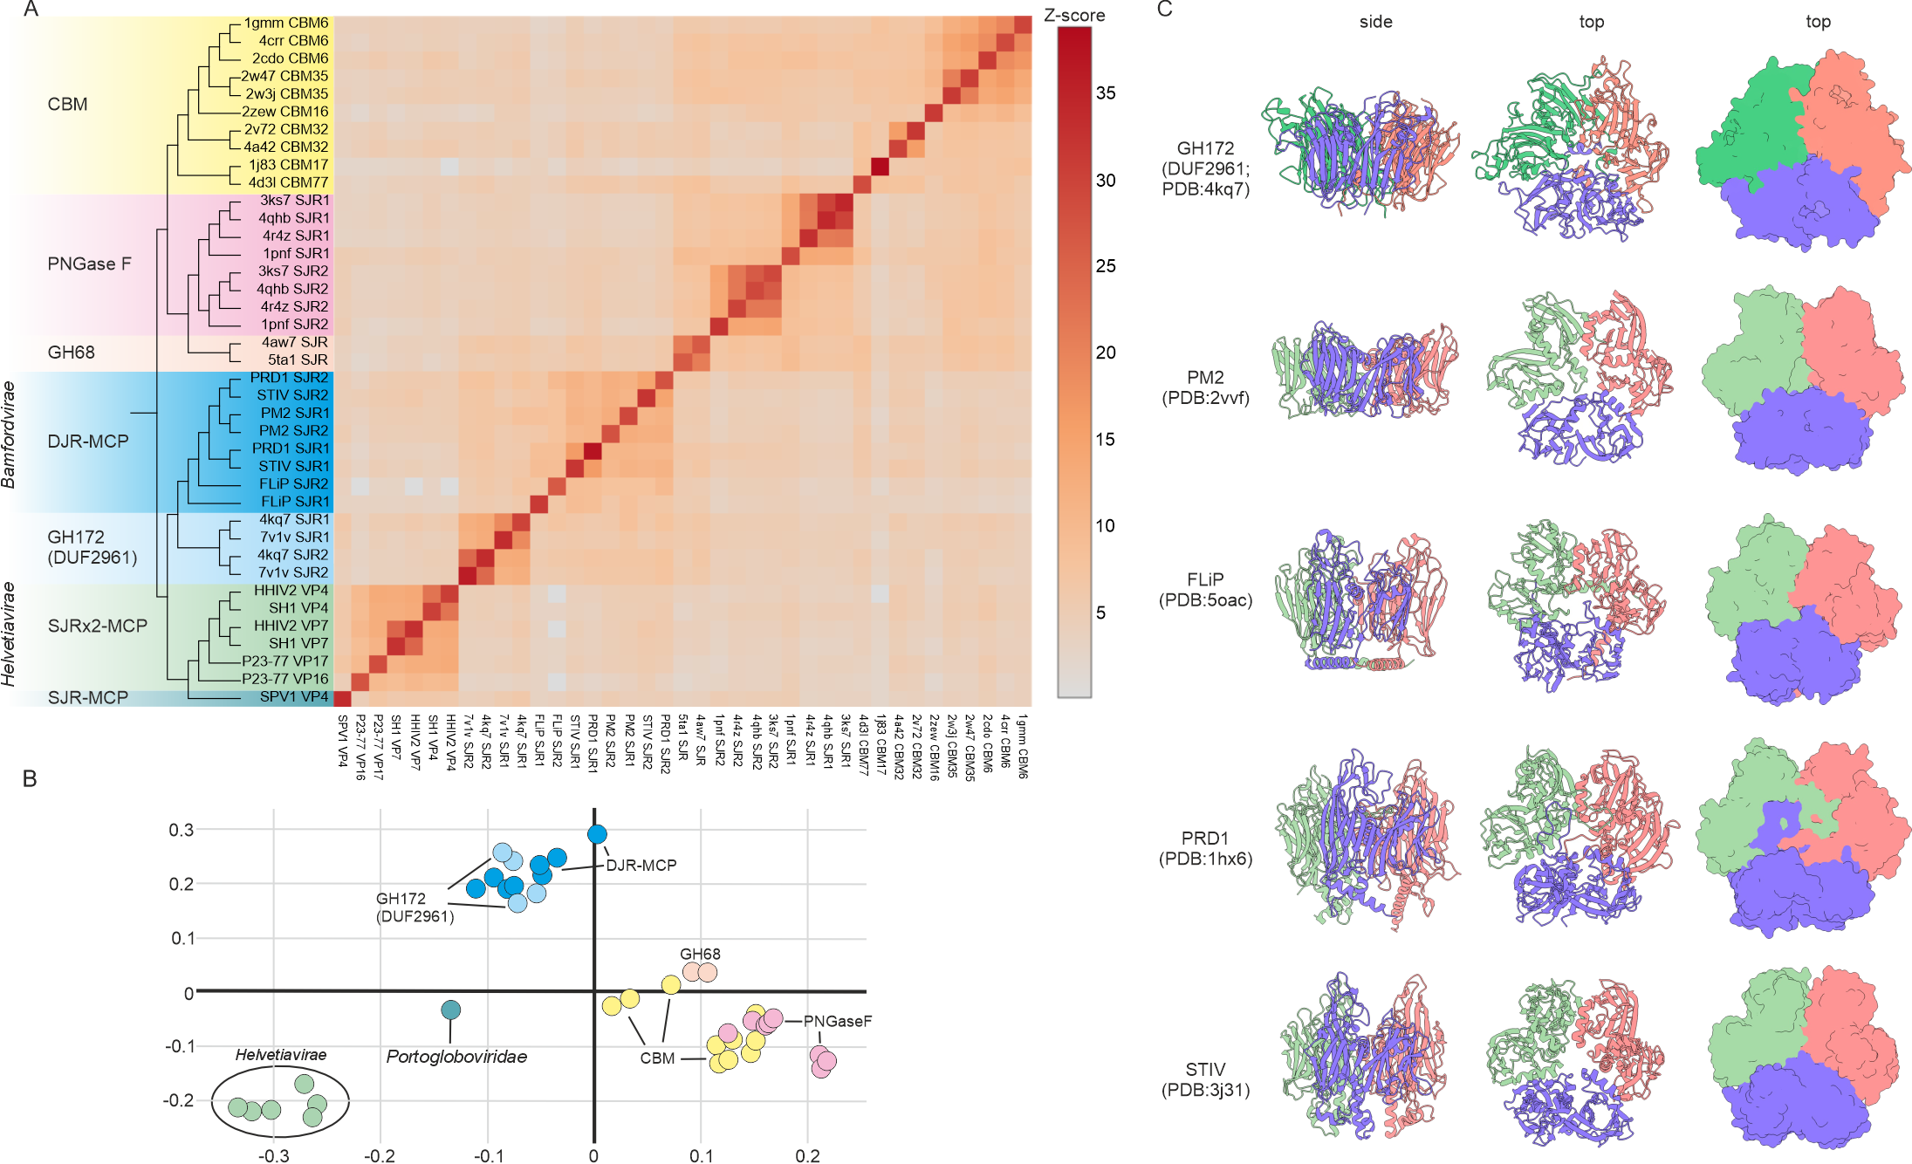
Figure 1. Relationships between cellular and viral SJR proteins. (A) The matrix and cluster dendrogram are based on the pairwise Z score comparisons calculated using DALI. Different protein families are highlighted with different background colors on the dendrogram. The color scale indicates the corresponding Z scores. The DJR proteins have been manually split and the individual N-terminal and C-terminal SJR domains were labeled as SJR1 and SJR2, respectively. (B) Correspondence analysis of the cellular and viral SJR domains calculated using DALI. The data points corresponding to the SJR domains are positioned with respect to each other according to the similarity of their structural neighborhoods. The color code is the same as in A. (C) Structural comparison of the DUF2961 trimer with the trimeric capsomers of the DJR-MCPs. Individual subunits in each trimer are colored differently. The first and second columns show ribbon representations, whereas in the third column the structures are depicted using surface rendering. PDB accession numbers are provided in the figure. The C-terminal α-helix of DUF2961 is omitted for the purpose of visualization.

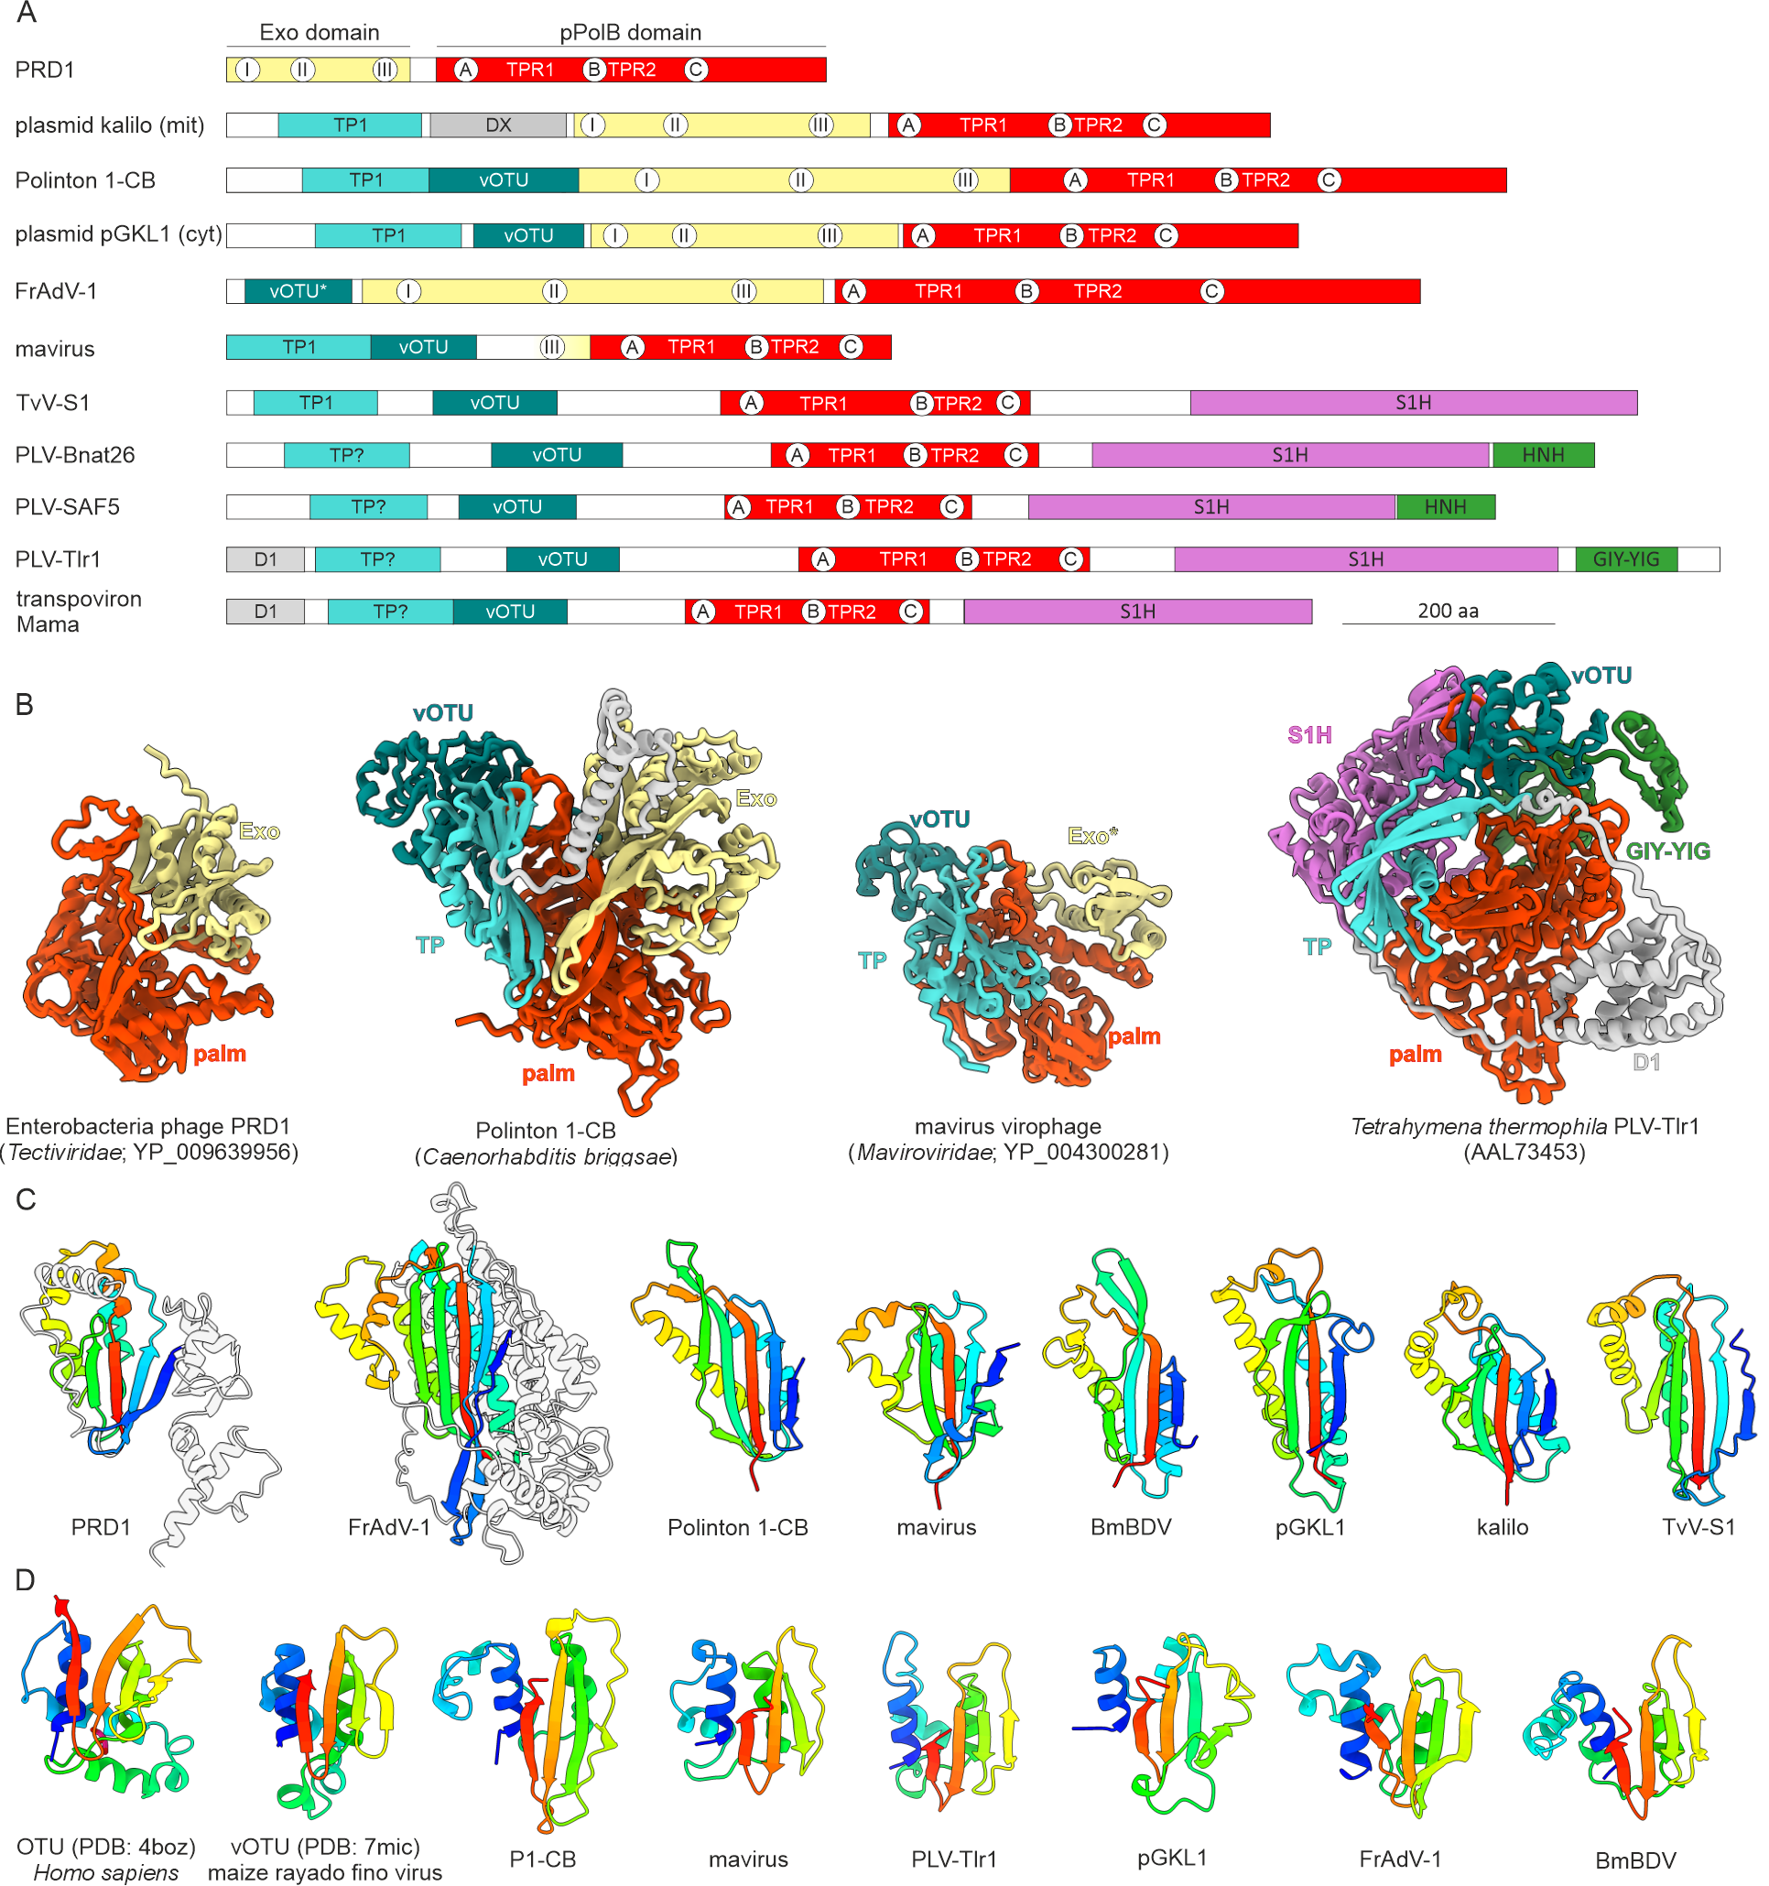

Figure 2. Domain architectures of the pPolB domain-containing proteins of ‘polisuviricotines’. A. Schematic domain organization of pPolBs and Tlr1-like helicases with homologous domains shown with matching colors. The locations of conserved motifs of the exonuclease and polymerization domains are indicated within the corresponding circles. The locations of the TPR1 and TPR2 subdomains are also shown. B. Structural models of representative pPolBs and Tlr1-like helicase encoded by different groups of viruses, with distinct domains colored using the same scheme as in panel A. C. Structural comparison of the terminal proteins (TPs) of Enterobacteria phage PRD1 and frog adenovirus 1 (FrAdV-1) with the N-terminal domains of pPolBs encoded by eukaryotic viruses and plasmids. Models are colored using the rainbow scheme from N-terminus (blue) to C-terminus (red). Non-conserved regions of the Enterobacteria phage PRD1 and FrAdV-1 TPs are shown in grey. D. Structural comparison of structures of OTU from humans (PDB: 4BOZ) and vOTU from an RNA virus, maize rayado fino virus (PDB: 7MIC), with the vOTU domains present in pPolBs. Models are colored using the rainbow scheme from N-terminus (blue) to C-terminus (red).
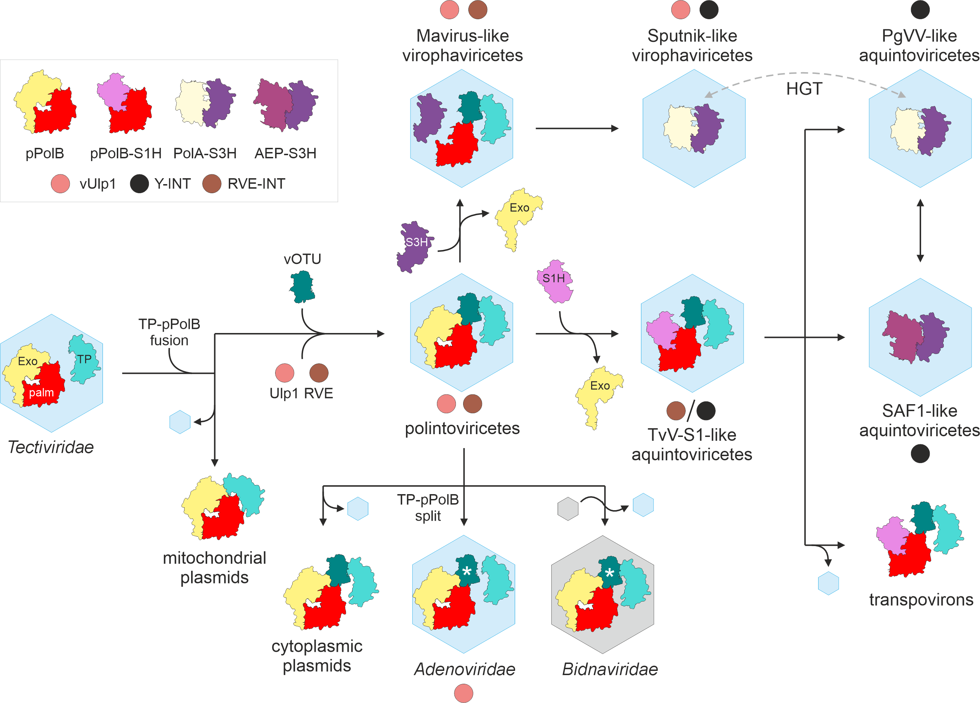
Figure 3. Evolutionary scenario for ‘polisuviricotines’ and derived mobile genetic elements. A scenario for the evolution of eukaryotic preplasmiviricots and related elements from a bacterial tectivirid ancestor is shown. Hexagons represent icosahedral capsids built from double jelly-roll fold major capsid proteins (DJR-MCPs). The grey hexagon indicates replacement of the DJR-MCP with an unrelated capsid protein in bidnavirids. Black and grey arrows indicate evolution and horizontal gene transfer (HGT), respectively. Asterisks indicate inactivation of vOTU domains. AEP, archaeo-eukaryotic primase-polymerase; Exo, exonuclease; PLV, polinton-like virus; PolA, family A DNA polymerase; pPolB, protein-primed B-family DNA polymerase; RVE-INT, retrovirid-like integrase; S1H, superfamily 1 helicase; S3H, superfamily 3 helicase; TP, terminal protein; TvV-S1, Tetraselmis viridis virus S1; (v)Ulp1, (viral) Ulp1-like cysteine protease; Y-Int, tyrosine superfamily integrase.

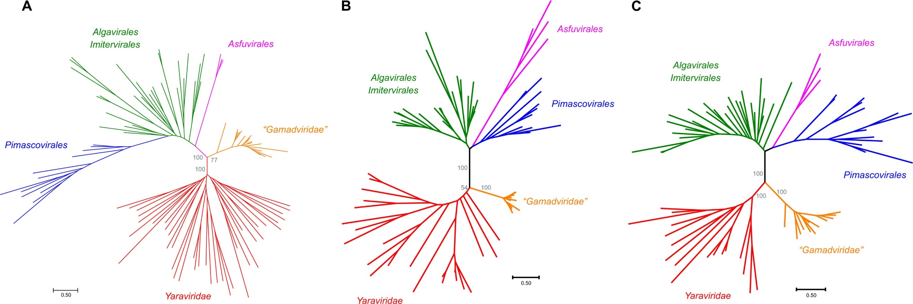

Figure 4. Phylogenetic trees of proteins conserved in mriyaviruses and the rest of the members of Nucleocytoviricota. (A) Major capsid protein (MCP); (B) DNA packaging ATPase; and (C) virus late transcription factor 3 (VLTF3). A phylogenetic tree was constructed from this alignment using Fasttree with a WAG evolutionary model and Gamma-distributed site rates. Phylogenetic trees of MCP, packaging ATPase (ATPase), and viral late transcription factor 3 (VLTF3) were built using IQ-TREE, with the following models chosen according to BIC by the built-in model finder: Q.pfam + F + R4 for MCP, Q.pfam + F + R6 for ATPase, and VT + F + R5 for VLTF3. The IQ-Tree bootstrap values are indicated for the key branches.

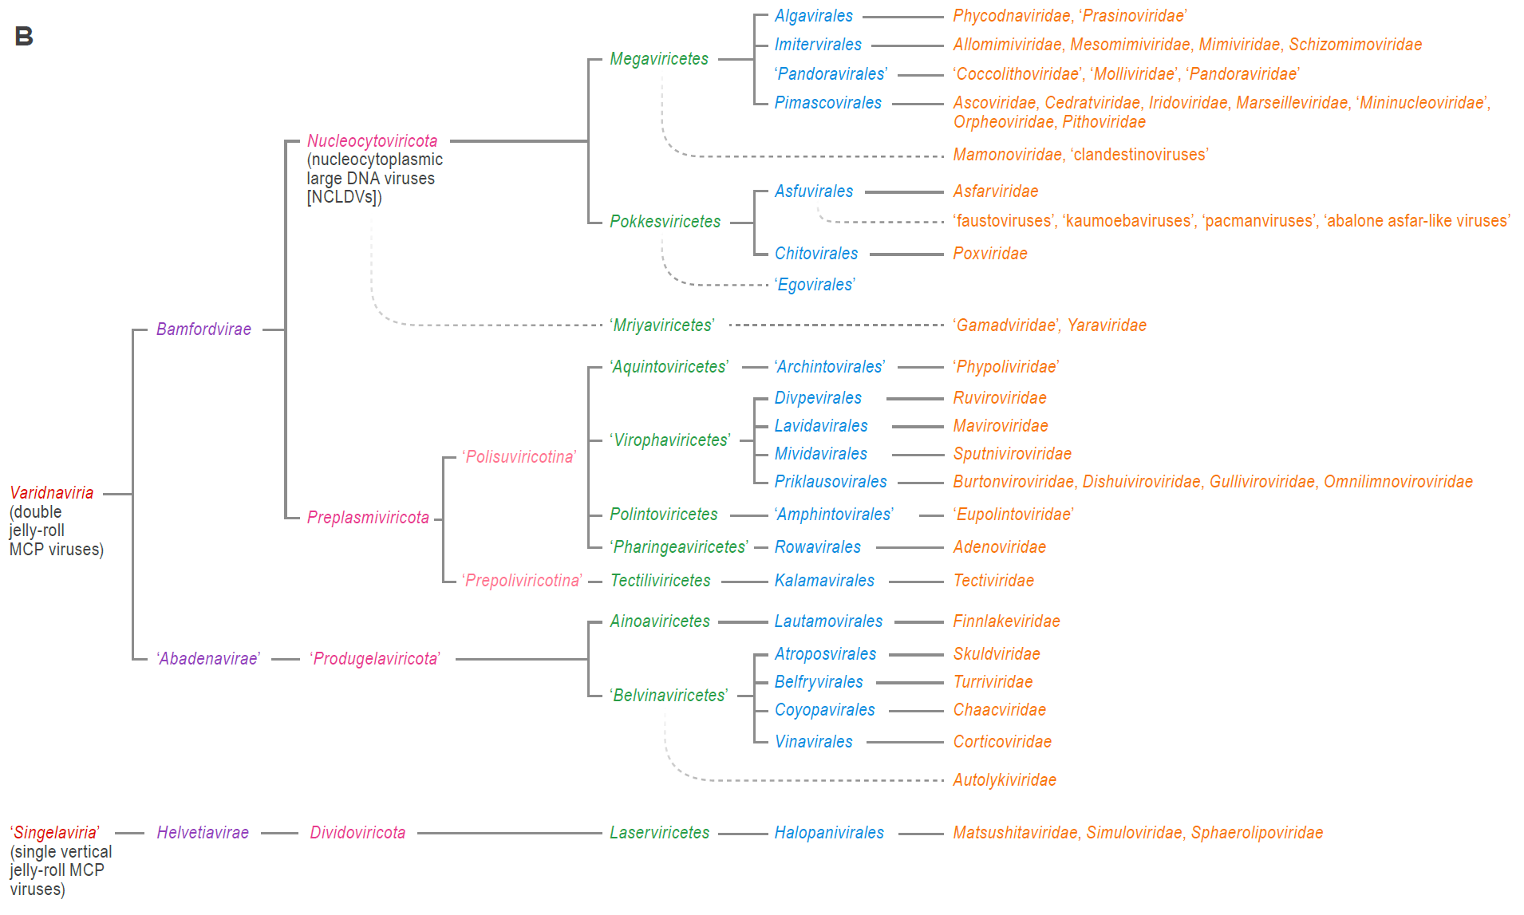
Figure 5. Proposed realm reorganization.

